Creating Accessible Digital STEM Content

Complete Process from PDF to MathML or MathJax
The process outlined in this guide:
- OCR a PDF containing STEM content with InftyReader.
- Export InftyReader results to .xml
- Open .xml in Word with MathType.
- Convert equations to MathML in MathType.
- Edit document for accuracy as needed.
- Export to usable format depending on the preferred software.
Note: If you are creating the content manually instead of converting from an existing file, start with Word and MathType. (Skip the InftyReader section.)

OCR with InftyReader
InftyReader does not process PDF files well (even though it is an option). It is better to convert the PDF to TIFF before OCR’ing.
- Scan to PDF at 600 DPI (if not starting with a PDF)
- Open the scanned or downloaded PDF in Acrobat Professional
  - File > Save as Other > Image > TIFF
  - Click on the Settings button in the Save As dialog.
  - For the Conversion dropdown menus, select Colorspace: Monochrome and Resolution: 600 pixels/inch.
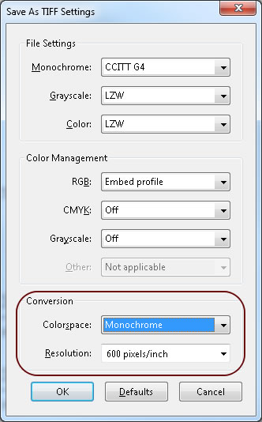

- Using InftyReader, open the TIFF file.
  - Keep the defaults for input – TIFF and 600 dpi
  - Keep the default output format (IML) if you want to do basic editing with InftyEditor.
    - Or choose Microsoft Word (XML) to go straight to editing in Word with MathType. (Skip to Step 6 after the file is created.)
  - Click on Start OCR.
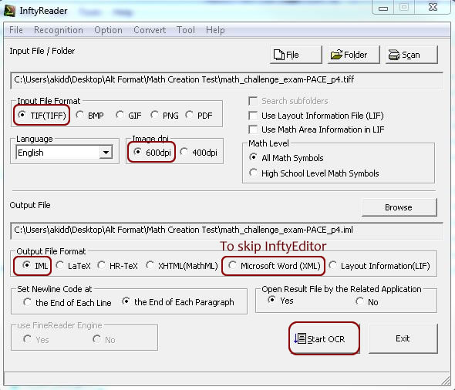

- The resulting IML file opens automatically in InftyEditor. Make initial edits as desired (find & replace, basic equation editing).
- Export from InftyEditor to XML format for editing in Word. File > Export > Word2007.

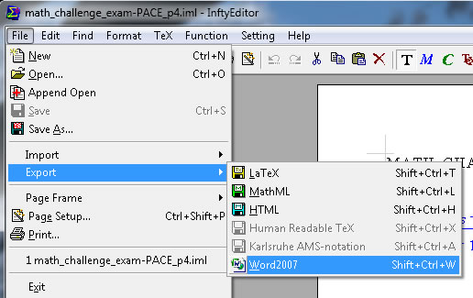
- Make a copy of the resulting .xml file so you can keep the original one as a backup.
- Open the newly saved .xml in Word + MathType (MathType should show up in the ribbon).
  - Important! Check to make sure the document has a name showing up at the top in Word. (If it is ‘untitled’ or similar, changes could be lost or the math could fail to convert.)

Edit the Document with MathType
- Always save the document before working on equations – then save often as you work.
- First, convert equations to MathML. On the MathType Ribbon, click on Convert Equations.
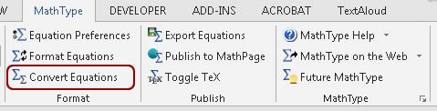
- In the conversion menu, check the box for Word 2007 and later (OMML) equations. Keep the other defaults and click on Convert. This may take a few minutes, depending on file size.

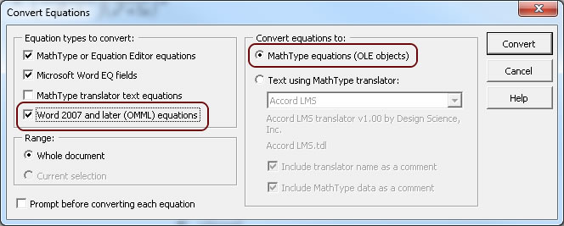

- Important! Save the file when conversion completes.
- Review the document for OCR errors and make any corrections needed (both text and math).
  - Some text may need to be retrieved from the original PDF if the TIFF was not OCR’d well. The text OCR engine is not great in InftyReader.
  - To edit the math, double-click on the selection box. A separate editing window will open. You will be prompted to save changes when you close the window.
  - You can also manually type equations as needed.

Export into a Compatible Format
- Save in an appropriate format for the student, depending on AT they will use (see table below).
  - To save as .docx, use the usual Word Menu – File > Save As. (For text-to-speech with Central Access Reader.)
  - For all other formats, click on Publish to MathPage on the MathType Ribbon
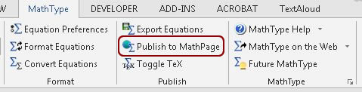
- Click on Browse to select the location where you want to save the file.
- Choose from the following two options for the MathML export:
  - XHTML + MathJax – preferred by CSU Math department for how math is verbalized. JAWS16 can read it natively.
  - XHTML + MathML – most widely compatible version, including NVDA and Voiceover.
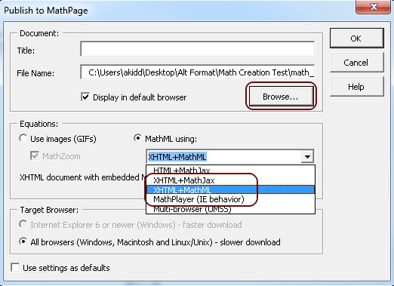

File Types and Software Requirements
Students should determine which format and AT they will be using with the ATRC. This will be included on the Alt Format Request form. Testing with formats produced by MathType indicated that the following combinations of AT and file types are compatible:

Software | Extras Required | File Type | Type of Access
JAWS 16 with IE | None | XHTML + MathJax | Screen Reader / Braille Display
NVDA 2015 with Firefox (free) | Firefox + MathPlayer 4 beta Plugin | XHTML + MathML | Screen Reader / Braille Display
Voiceover with Safari (Mac built-in) | None | XHTML + MathML | Screen Reader / Braille Display
Central Access Reader (CAR) (free) | None | .docx + MathML | Text-to-Speech / Export to mp3

