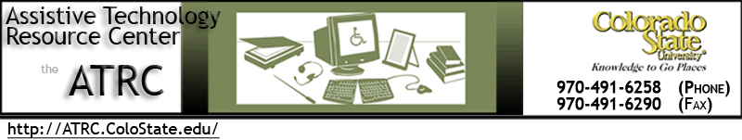

Alt Format Delivery - Quick Start Guide

Overview
Alternate Format texts are delivered to you electronically using the Google Drive associated with your @rams.colostate.edu Gmail address. This guide will walk you through activating and logging into your RAMS Google account, opening your email notifications, and downloading the files that have been created for you.

Logging into Google Apps for CSU

- When you request your texts from RDS, you will give them your Rams email account. You may have to activate the account with your eid the first time you login.
- Go to Google Apps for CSU using the following link: http://mail.rams.colostate.edu
Note: You must login to CSU’s version of Google Apps, not the main Google site.
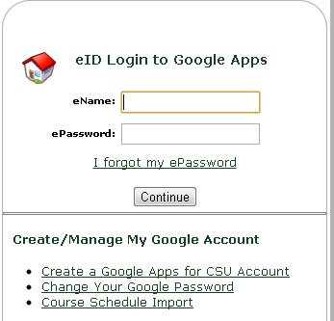
- Enter your EID and password into this box located in the top right corner of the screen.
- If your account is not recognized the first time, click on the link “Create a Google Apps for CSU Account” to activate your Rams Gmail account.
- After you logon, you should see your Gmail inbox, where you will receive an email notification when your text has been shared with you.

Finding Your Files in Google Drive
- Once your Alternate Format texts have been created, you will receive an email from Nico Gowdy at RDS. The subject of the email will be the corresponding textbook title.
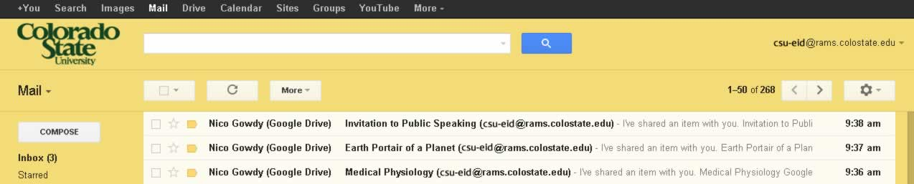
- Open E-mail and click the link to the shared text. The link is the title of the book.
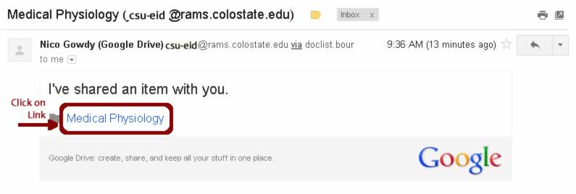

- Once opened, click the Open in Drive blue button in top right corner
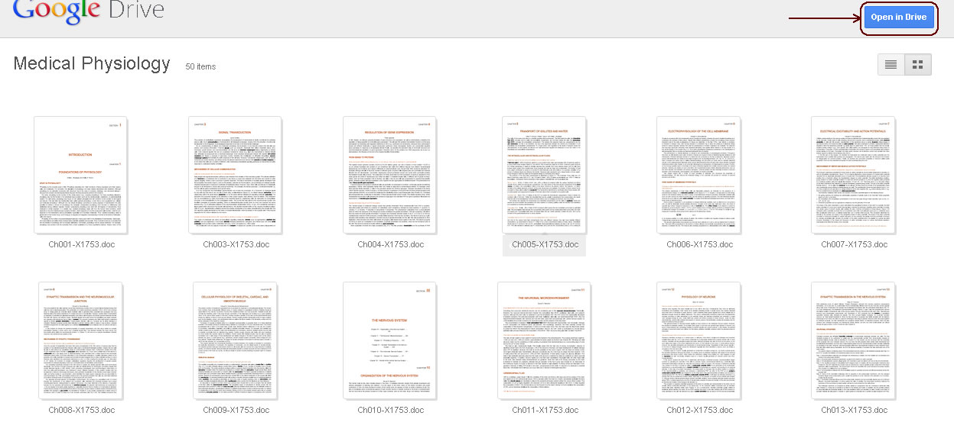

Downloading Chapters
- Check the “select all” check box to download the entire textbook, or select the appropriate chapters to download them individually.
Note: If you use Daisy format, each chapter is an entire folder that must be downloaded.
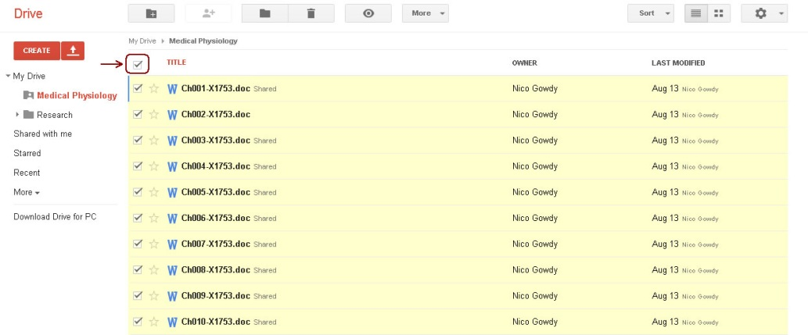
- Select the More drop-down menu at the top of the page and click Download
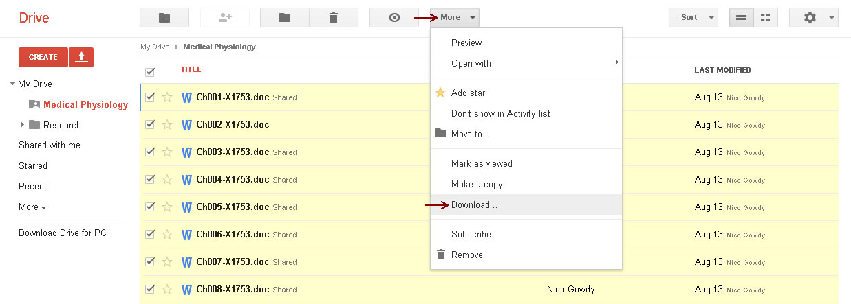
- A window pops up that says “Convert and Download.” Click Download. The files will be combined into a zip file for download if you selected multiple files.
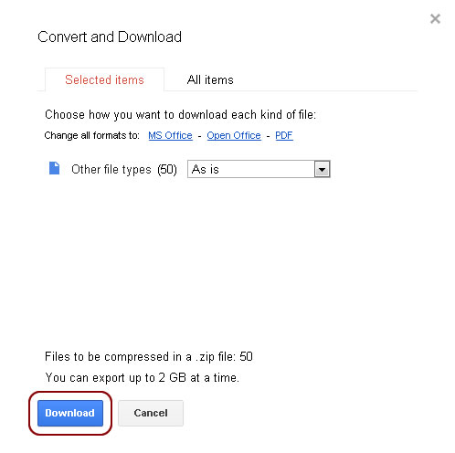

- Once downloaded, click on the link at the bottom of the browser that says “Show all downloads.” (then skip to #7)

- If the file does not download automatically click the click here to download hyperlink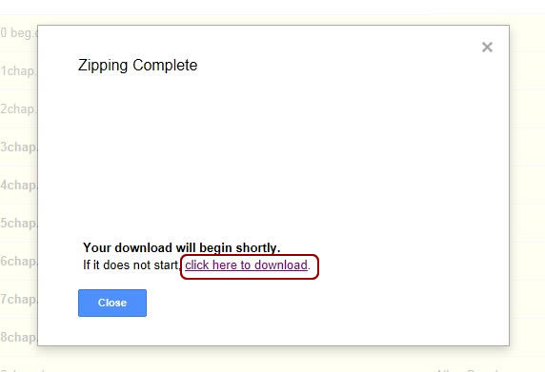
- Select Save As in the Save drop-down menu.
- Open the downloaded folder. You can now select files to open with your preferred software.

Going Directly to Google Drive
You can get to Google Drive without going through the link in an email. There are a couple reasons why this might be helpful:
- If you are having your CSU Gmail forwarded to another email address, as the direct links may not take you to the correct login page.
- If you deleted the email or it is buried in your inbox, you can go directly to your files.

- Log in to Google Apps for CSU with your eid using the same link listed above: http://mail.rams.colostate.edu
- Look for the “Drive” link in the Google Toolbar at the top of your browser.
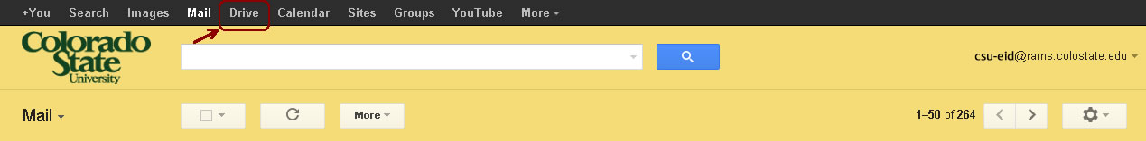
- Texts should appear in My Drive
*If your text is not in My Drive, check the Shared With Me folder / link on the left side of the screen.
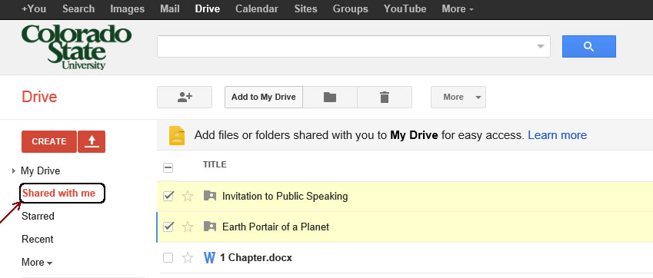
- Continue as instructed starting in the section titled “Downloading Chapters” on page 3 above to download files.

Getting Help
If you are having trouble downloading files from Google Drive, you can ask for help:
- Contact the ATRC staff at 970-491-6258.
- For more immediate assistance, the Helpdesk staff at Morgan Library is familiar with CSU Google Apps and can assist you if ATRC staff members are not available.

