Mac Built-in Accessibility (10.11 – El Capitan) Quick Start Guide

Overview
The Mac operating system has many helpful features to help users with a wide range of abilities access their computer. This Quickstart guide is divided into accessibility features for four areas: vision, hearing, physical and motor skills, and literacy and learning.

To Use

How it is Organized:
Many built-in accessibility features are accessed through Apple’s Universal Access. To locate Universal Access, go to Apple System Preferences Accessibility.
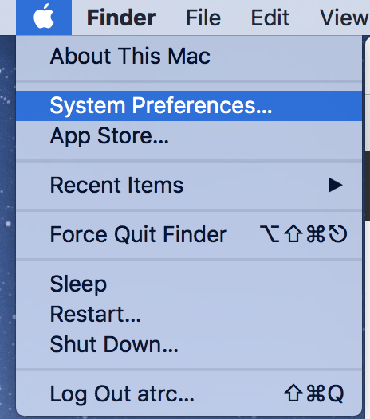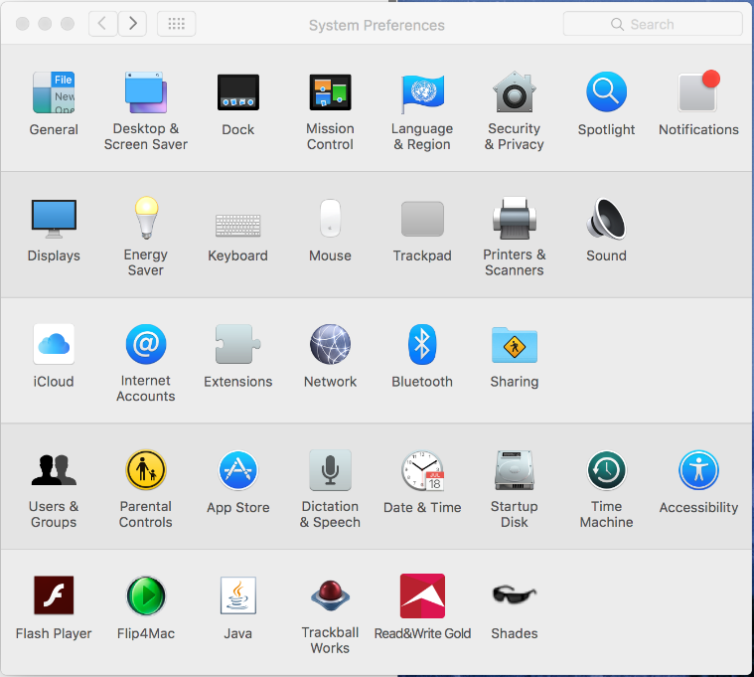

Features for Vision
Display: In the Display tab of the Accessibility pane, the user can adjust the display to different settings to accommodate a variety of visual preferences, including inverted colors, grayscale, increased contrast, and reduced transparency of windows. In the same window the size of the cursor can be adjusted making it easier to locate on the screen. 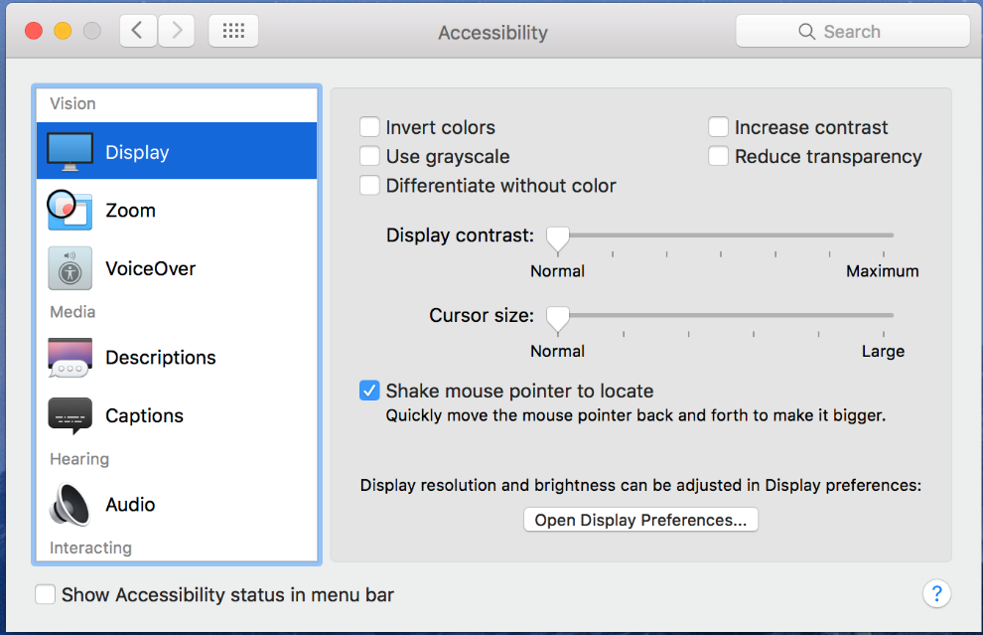
Zoom: The zoom function allows the user to magnify the screen from 1 to 20 times, allowing users with low vision to more easily see items on the screen.
Additional options can be found in the More options… feature, including maximum zoom, minimum zoom, and how the zoomed image interacts with the cursor.
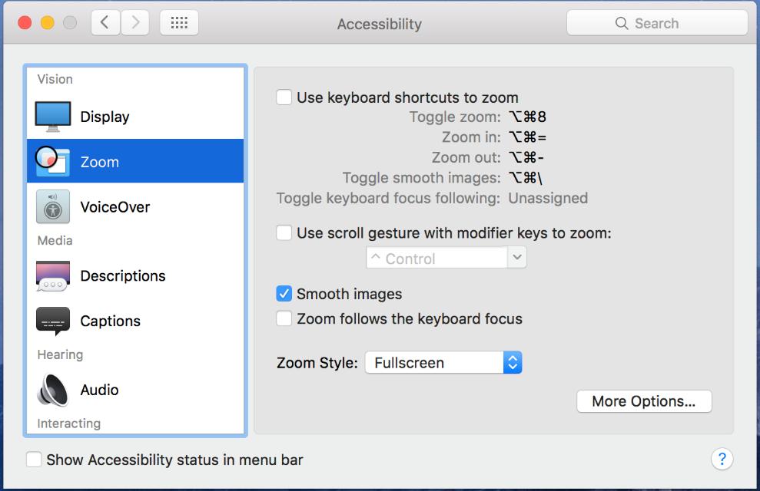
VoiceOver: VoiceOver is a built-in screen reader that allows users who are blind or have low vision to control their computer through keyboard input. VoiceOver can be turned on and off from the Accessibility pane (System Preferences Accessibility VoiceOver Enable VoiceOver) or by pressing the hotkey Command+Function+F5. 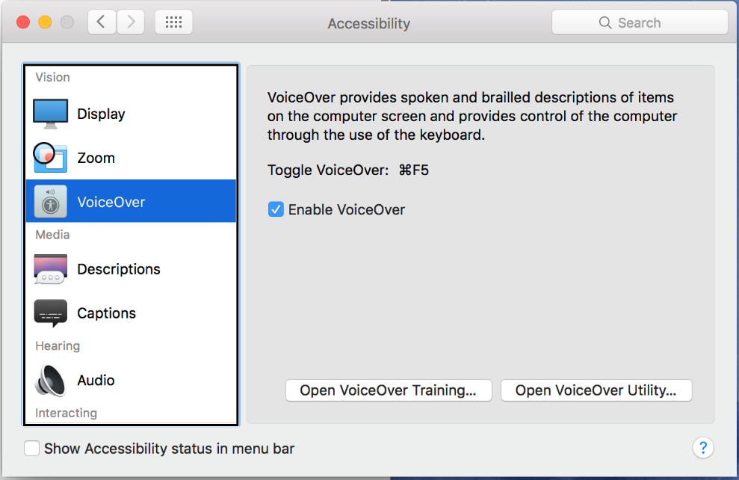
Many VoiceOver functions are accessed by first holding down the “control” and “option” buttons together (referred to as the VO keys) and then pressing another key. When VoiceOver is activated, the user can navigate through the computer’s windows and menus by holding down the VO keys and pressing the up, down, left, or right arrow. VoiceOver will speak aloud a description of the highlighted item. To select an item when highlighted in VoiceOver, press the space bar. For an in-depth VoiceOver tutorial, choose the Open VoiceOver Training button and complete the tutorial.
Changing the voice in VoiceOver: To change the voice in VoiceOver, hold down the VO keys (control + option) as well as the command key. While holding these three keys down, press the right arrow key.

Features Outside of the Accessibility Pane
Icon size and spacing: Click anywhere on the desktop and then press Command + J to change the size and spacing of desktop icons as well as enlarge the text below the icons. Alternatively, choose View → Show view options.
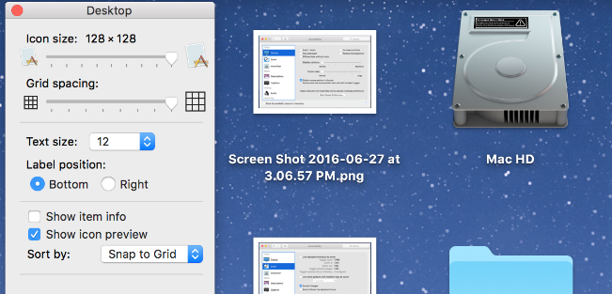
Text-to-speech: This feature will read any digital text aloud using the built-in voice. From the Systems Preferences menu, select “Dictation & Speech”, then select “Text to Speech”. From this pane, the user can change the Text to Speech hot key, the speaking rate, and the voice. The default key to read aloud any highlighted text is “Option+Esc”.
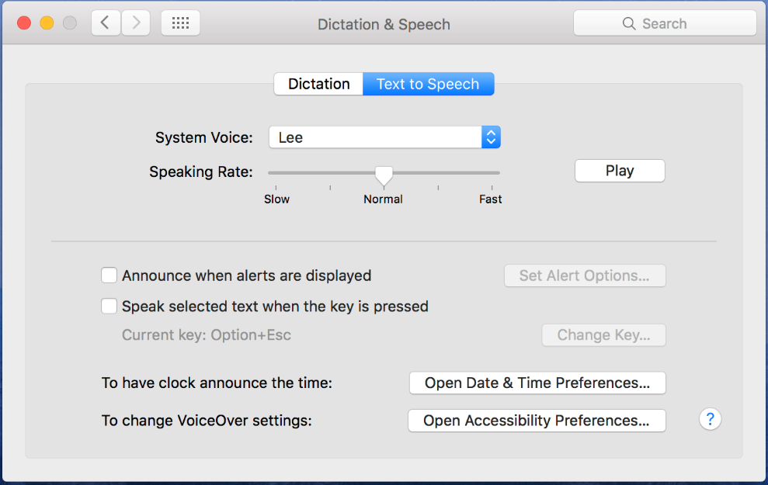
Safari minimum font size: Within Safari, the default web browser of Mac OS El Capitan, the user can adjust the minimum size font displayed when browsing. The minimum size font can be set from 9 to 24 points. To set a minimum font size, select Safari ⇒ Preferences ⇒ Advanced and check the box labeled “Never us font sizes smaller than” and select a minimum font size in the drop down menu.
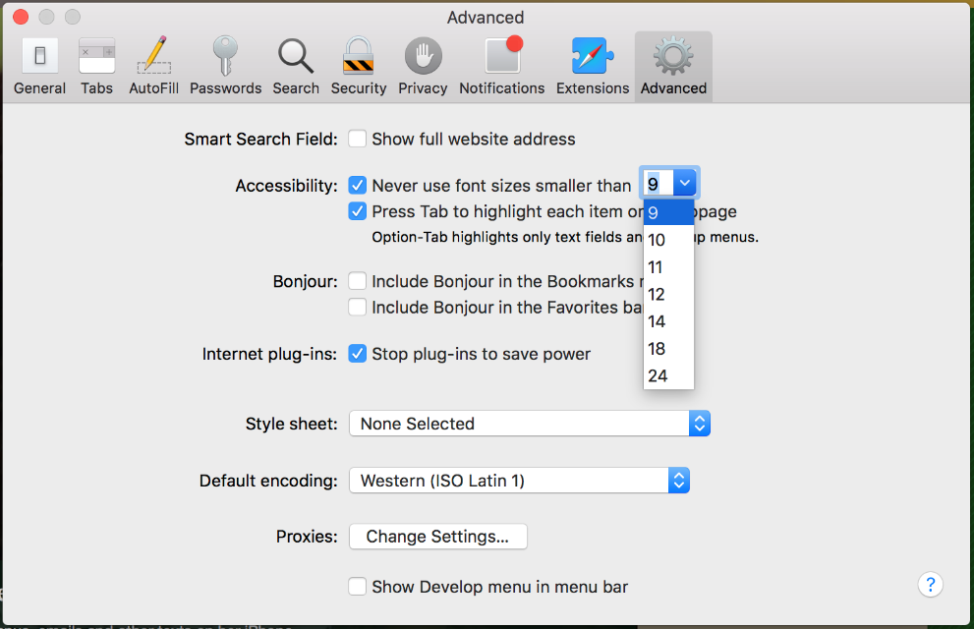

Features for Hearing
Screen flash: When the computer plays an alert sound (for example an when a new email arrives) the user can choose to have the screen flash. To turn on screen flash, open the Accessibility pane and choose Audio tab. Check the “Flash the screen when an alert sound occurs” box.
Mono audio: For those who are deaf or hard of hearing in one ear, choosing mono audio will ensure no sounds are missed because they are played only in the right or left channel. To turn on Mono Audio, open the Accessibility pane and choose Audio tab. Check the “Play stereo audio as mono” box.
Captions: When availalbe, subtitles or closed captions will be used for video instead of standard subtitles. The styles of subitles and captions can be customized. To enable, open the Accessibility pane and choose Captions tab under Media. Check the “Prefer closed captions and SDH” box.

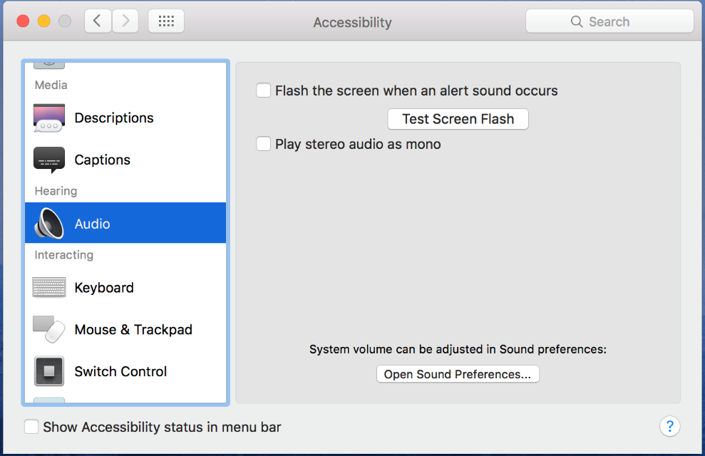

Features for Physical and Motor Skills
On-Screen Keyboard: This feature produces a keyboard on the computer screen, which can be accessed by a mouse or other pointing device in order to select the keys. Once the keyboard has been opened, it will remain in front of all other windows. To type, simply click into any text box or document and begin selecting keys on the on-screen keyboard. To turn on the keyboard, first open the System Preferences window and select Keyboard. Within the “Keyboard” tab check the box that says “Show Keyboard Emoji, & Symbol Viewers in menu bar.”

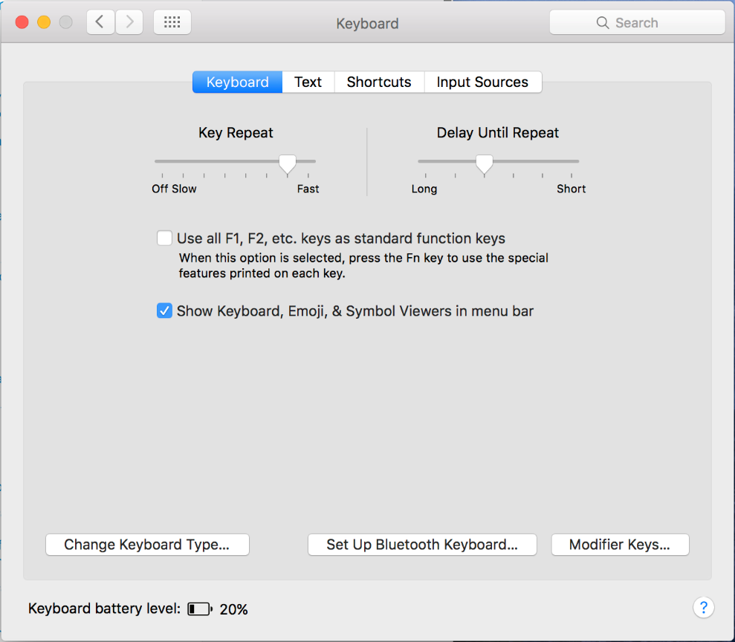
Once activated, a drop down keyboard menu will appear in the taskbar at the top of your desktop. Click on the menu and select “Show Keyboard Viewer.” A keyboard will appear on your screen. You can adjust the size of the keyboard by clicking and dragging the corners of the window.
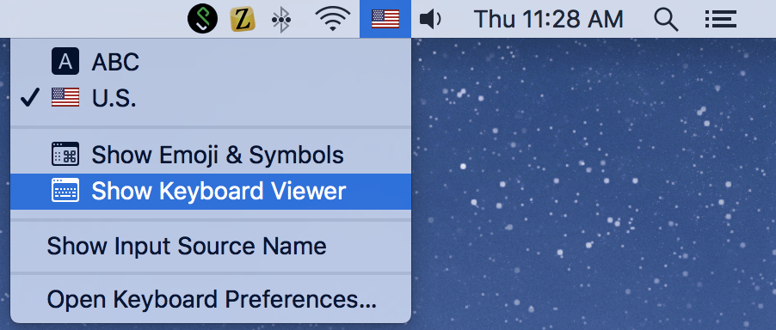
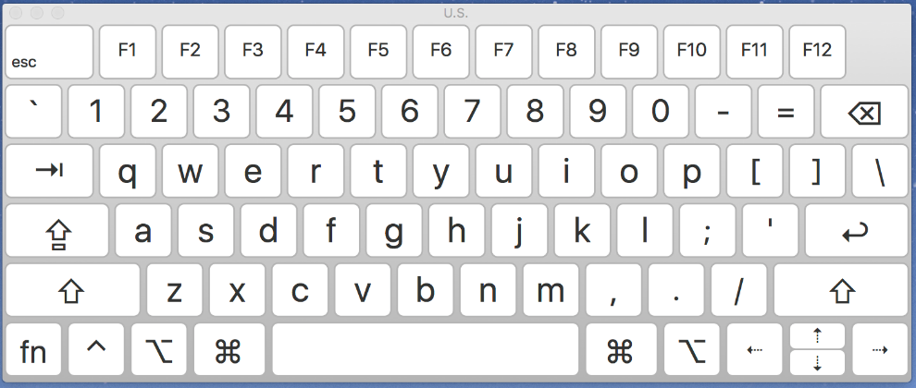
Sticky keys: When Sticky Keys are active, the user can press modifier keys (command, option, control, shift) one by one and the computer will respond as if the keys were all pressed simultaneously. When activated, modifier keys are displayed in the upper right corner of the screen when pressed. Sticky Keys is accessed through the Keyboard tab of the Accessibility pane. Select the Options… button to adjust the sounds and keyboard shortcut (pressing Shift key five times).
Slow keys: Turning on slow keys will change the sensitivity of the keyboard to filter out unintended multiple keystrokes. The delay is adjustable, and there is the option to have a sound played when a key is entered. Slow Keys is accessed through the Keyboard tab of the Accessibility pane. Select the Options… button to adjust sounds and delay time.
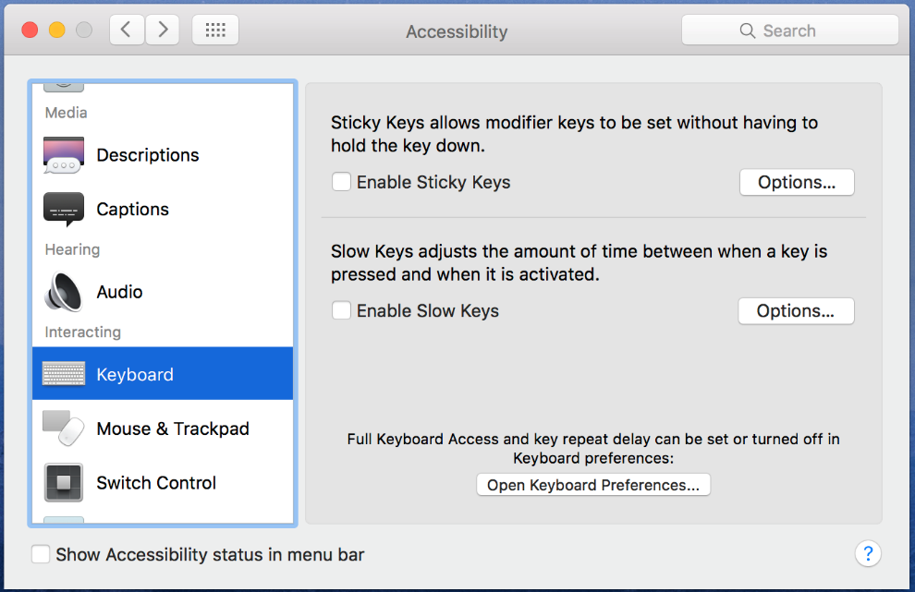
Mouse keys: For users who have difficulty using a mouse or trackpad, the mouse can be controlled using the keyboard. Mouse Keys is accessed through the Mouse & Trackpad tab of the Accessibility pane. The keys used to control the mouse will differ on a laptop and a desktop computer.
Double-click speed: For users who have difficulty quickly clicking the mouse twice in a row, this feature allows the time between clicks to be delayed. Double-click speed is accessed through the Mouse & Trackpad tab of the Accessibility pane.
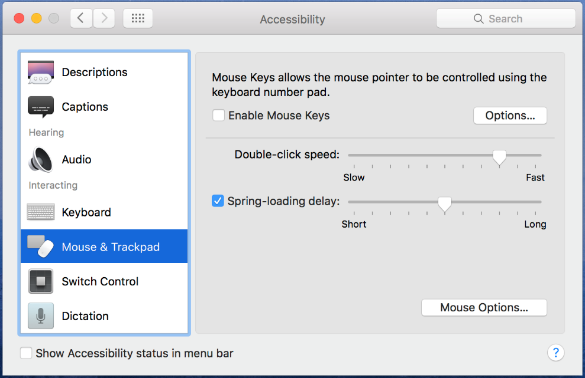
Switch Control: For users who access the computer through the use of switches, the functions of the computer can be assigned specific keyboard keys or dedicated switches. This function is accessed through the Switch Control tab of the Accessibility pane. Select the General option and check the “Enable Switch Control” box.
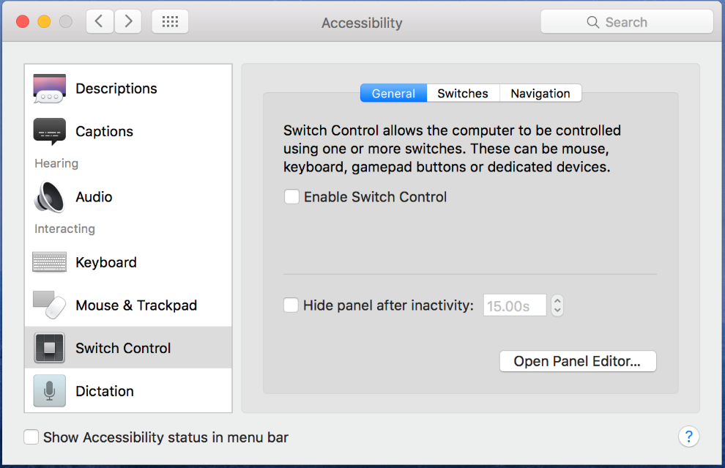
By choosing the Switches tab the user can create new switch functions and assign new commands to current switches.
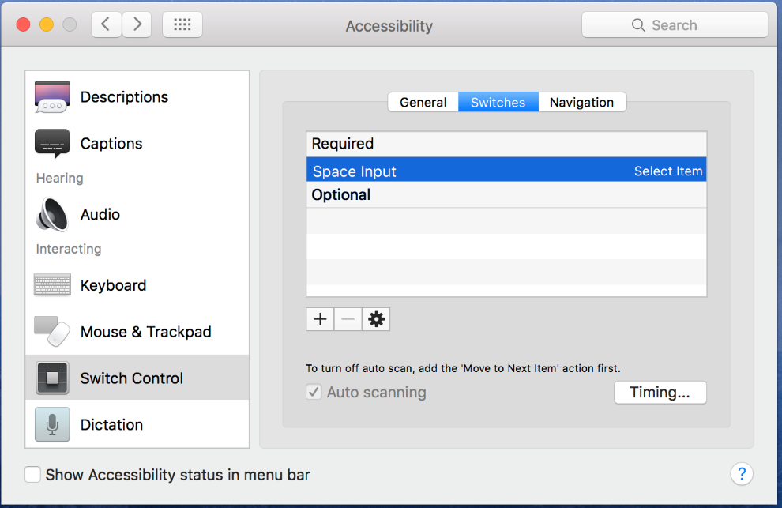
Dictation (Speech Recognition): Available from the “Dictation & Speech” pane in System Preferences is dictation, previously called speech recognition in early iOS versions. To enable, click the “On” and “Use Enhanced Dictation” buttons in the Dictation pane. This feature is activated by the shortcut key (Default: Press the Fn [Function] key twice). This feature will dictate the user’s speech through a built-in microphone or external microphone and enter the text into a text document. When activated, the user can control a variety of computer functions by speaking a command aloud. A list of possible commands can be shown by selecting the Dictation Commands… option within Dictation tab of the Accessibility pane.
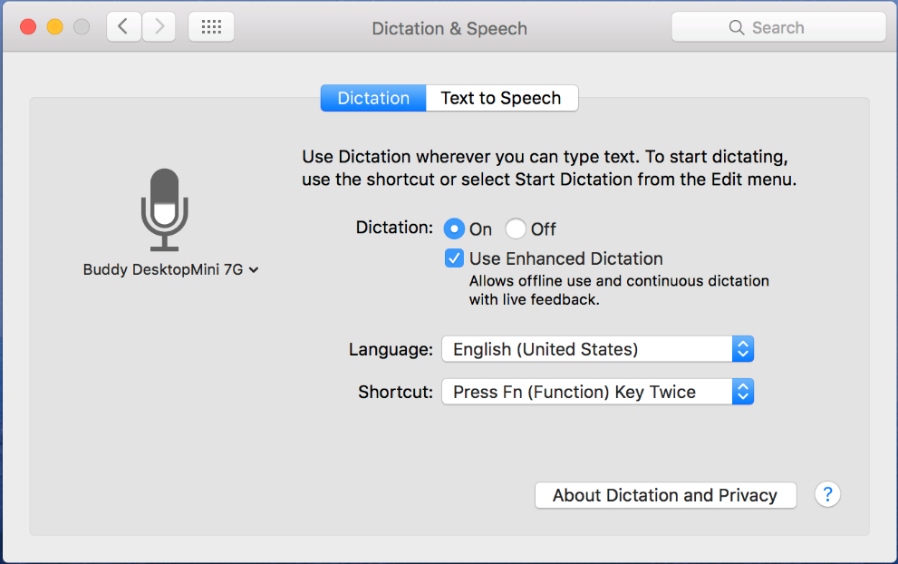

Features for Literacy and Learning
Simple finder: For users with cognitive and learning disabilities, the way a user interacts with the computer can be greatly simplified. Using Parental controls in System preferences, the number of applications a user can choose can be limited. The dock contains only three folders: applications, documents, and items to share. Items are opened with a single click rather than a double click. To turn on simple finder, choose System Preferences ⇒ Parental Controls and follow instructions to turn on Simple Finder.
Spotlight: Spotlight allows a user to quickly and easily search the contents of the computer for a key word or phrase, like a search engine for your computer. To use spotlight, click the magnifying glass icon in the upper right corner of the screen and enter a search word or phrase.
Text to speech: Within many applications (Mail, Safari, iChat, TextEdit, and more) the computer will read aloud selected text. To activate text to speech within a supported application, choose Edit ⇒ Speech ⇒ Start Speaking.

Program Manufacturer Contact Info
Apple Inc.
Apple's Accessibility Website (http://www.apple.com/accessibility/osx/)
Cost: Free - All features mentioned in this document are included in cost of Mac computer

