Grammarly - Quick Start Guide

Overview

Grammarly provides writing enhancement for spelling, grammar, proofreading, and plagiarism detection for papers in English. The program makes in-line suggestions for improvement and provides explanations and examples for proofreading and style suggestions. This program is designed for all users of all writing abilities.
Users can copy-and-paste text into an online editor, install a browser plug-in, install a plug-in for use with Microsoft Word and Outlook, and/or install a desktop app, depending on their operating system.

Grammarly Options

Grammarly’s editing function can be accessed via several methods, depending on your operating system and preferences:
- Online Editor: available for all operating systems and browsers
- Desktop Application: available for Windows and iOS
- Microsoft Office Plug-in: available for Windows only
- Browser Plug-ins: available for Chrome, Firefox, and Safari
The online editor and desktop application interface with each other and will retain copies of all files edited within the program. The plug-ins for Microsoft office and various browsers provide support for text within these applications, and do not interface with the online or desktop application. Users may choose to use one or all of the options for different needs.
All methods can be downloaded from the Apps menu in the online editor and will display according to the user’s set-up. For example, a Windows Chrome user will see a download for the Windows desktop app, Microsoft Office plug-in, and the Chrome plug-in, while a iOS user in Safari will see only the Mac desktop app and Safari plug-in options.

Online Editor
Grammarly uses an online writing window for composing text or copy-pasting from other programs. From the main ribbon, a user can edit their profile, launch a written tutorial explaining features of the program, and install additional apps, such as the browser plug-ins or desktop app.
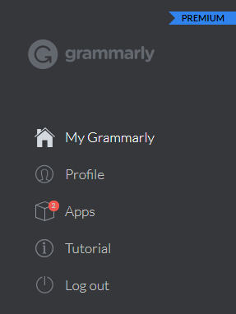

Creating a New File
On the home page, click the New button to create a new file for composing or copy-pasting, or click Upload to work on a file saved on your computer.
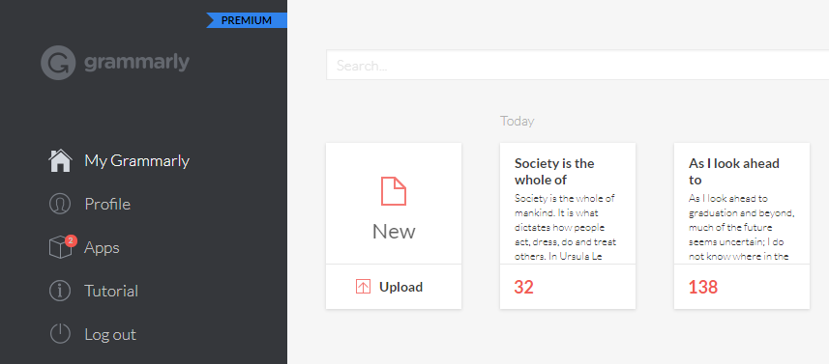

Click the Pen icon to adjust the document type and toggle editing options, such as Style.
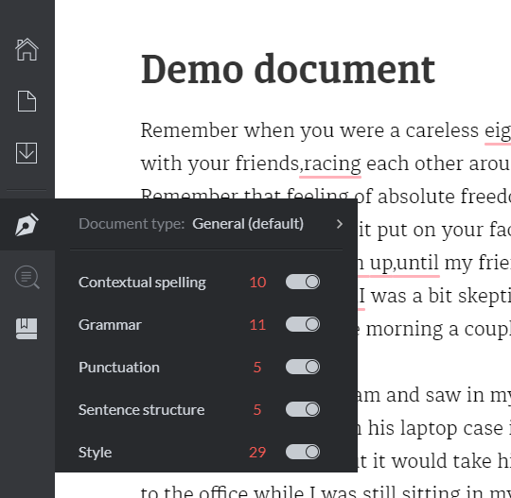

Accepting, Rejecting, and Reviewing Suggestions
Corrections and suggestions will appear to the right of the text. Hovering over the suggestion will highlight the relevant part of the text. For each suggestion, you can choose to accept or reject the correction. Click on the suggestion display in red and/or green to accept the change and update your text. If you do not want to make the correction or feel it is wrong, click the X to reject the correction. You have the opportunity to Undo a rejection immediately after you have done so, and the suggestion will return and can then be clicked on to accept it.
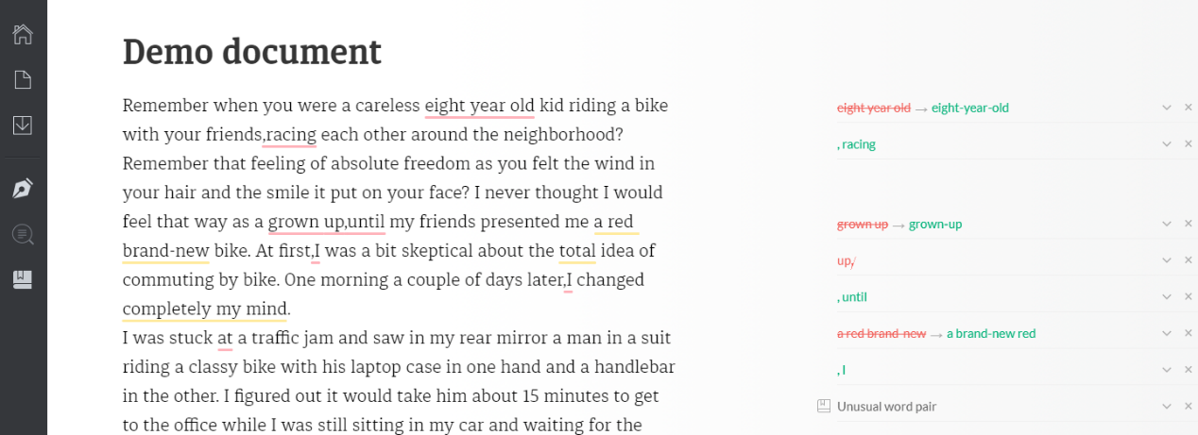

If you would like more information on why the program is suggesting a particular correction, click on the down arrow next to the correction to see a detailed explanation.

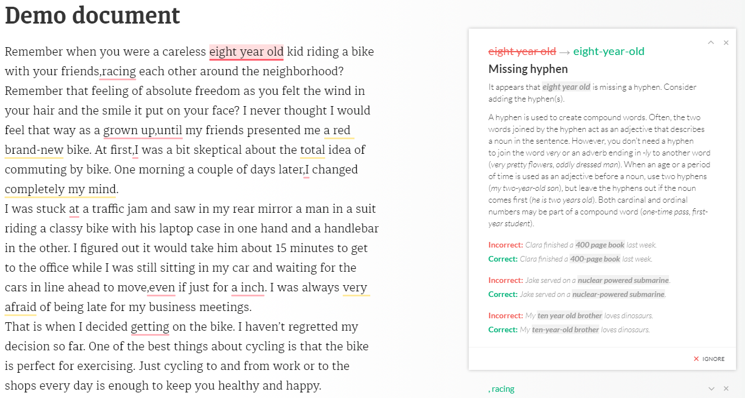

Downloading Additional Apps
Clicking Apps in the main menu bar displays additional apps available for download, including browser and Microsoft Office plug-ins, as well as the stand-alone Grammarly app. Click Install for the desired app and follow on-screen instructions for any additional apps desired.
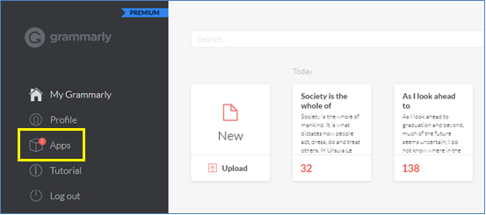
The apps available for download will depend on your operating system and browser.
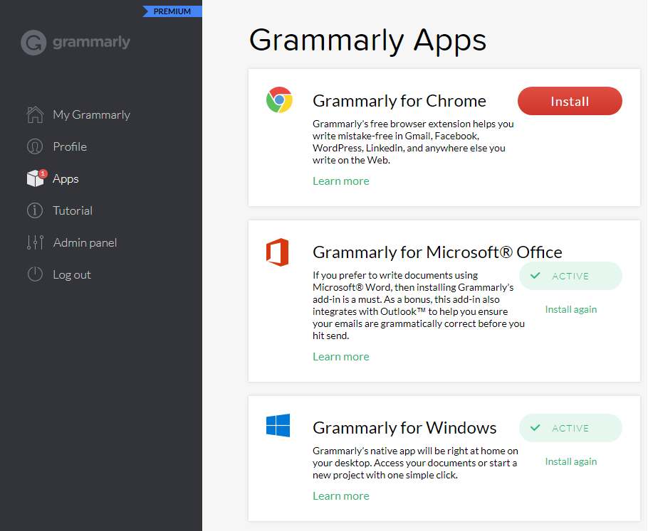

Grammarly Desktop App
The Windows app looks nearly identical to the online version but is launched from the desktop. It uses all of the same functions described above.
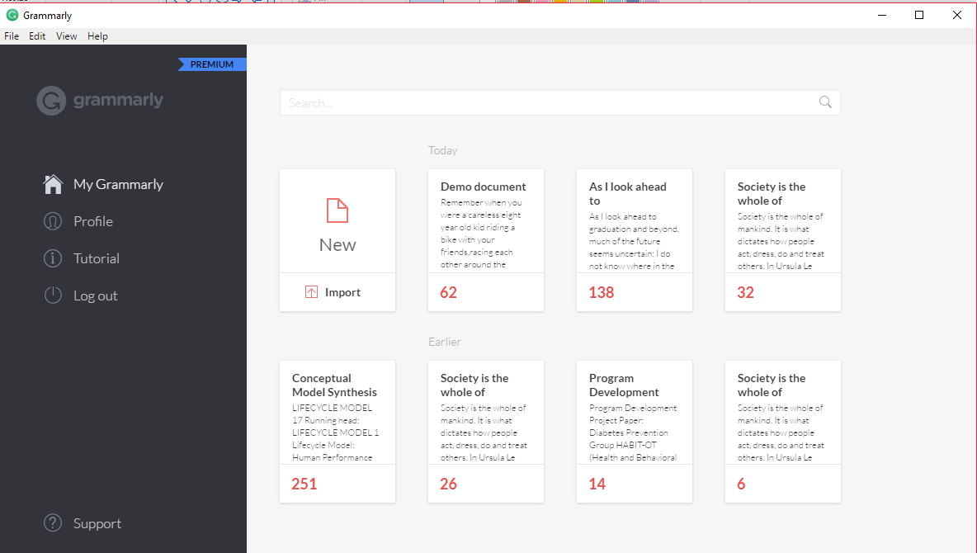

Grammarly Microsoft Office Plug-In
The plug-in for Microsoft Word and Outlook allows you to use Grammarly in line with your text as you are composing Word files and emails.

Microsoft Word Plug-In
After installation, you will see a green Open Grammarly button. Clicking this button will start Grammarly and create Grammarly tab in your action bar, providing the option to toggle on/off various editing options. One open, you can toggle it off by clicking Close Grammarly.
Set the document type in the Type section, then click on any of the buttons in the Checks section to toggle editing options on and off.
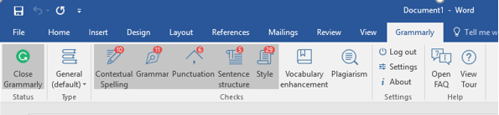
Corrections can be reviewed, accepted, and rejected in the same fashion as the online program by clicking on the corrected text, the down arrow, or the X for each modification.
Users may choose to Grammarly while they are typing and correct as they go, or they may choose to compose their paper without grammar checking, and then enable it later.
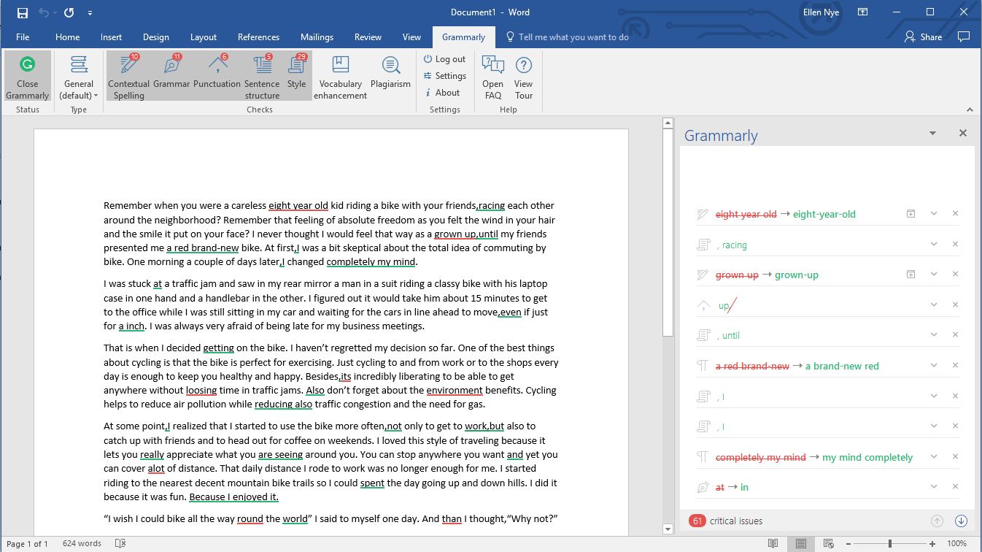
Please note: the “undo” function will not work while Grammarly is activated. To use this function while editing, you can temporarily disable the program by clicking Close Grammarly on the action ribbon.

Microsoft Outlook Plug-In
The plug-in for Outlook integrates directly into the application, and can be toggled on and off. Options. The options are identical to the Microsoft Word plug-in.
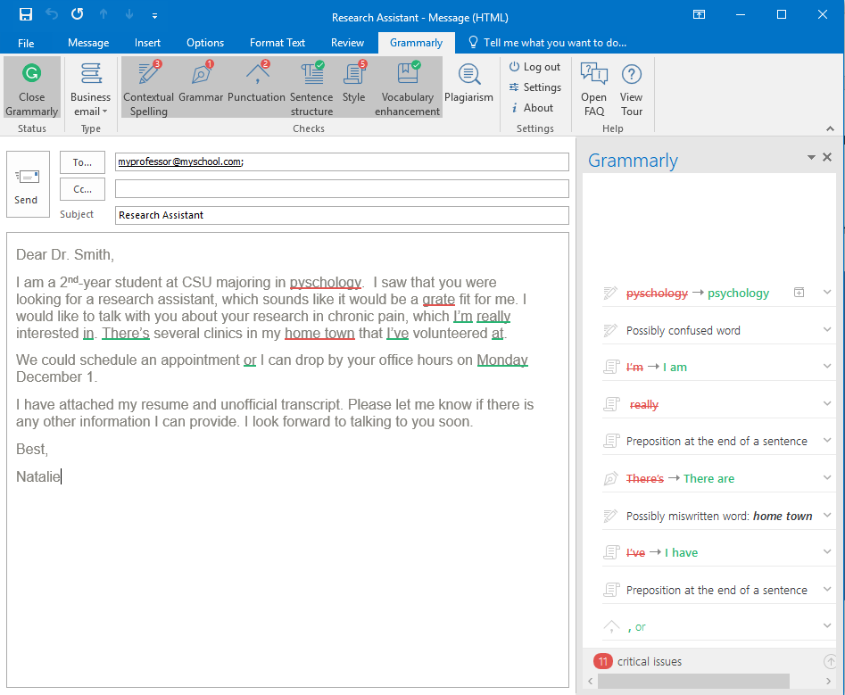
Please note: the “undo” function will not work while Grammarly is activated. To use this function while editing, you can temporarily disable the program by clicking Close Grammarly on the action ribbon.

Grammarly Plug-In for Chrome, Firefox, and Safari Browsers
After downloading, activate Grammarly for a web browser as you would any extension or add-on – see individual browser instructions for how to do so. Once activated, you will see a small green G anywhere Grammarly can provide feedback on a website.
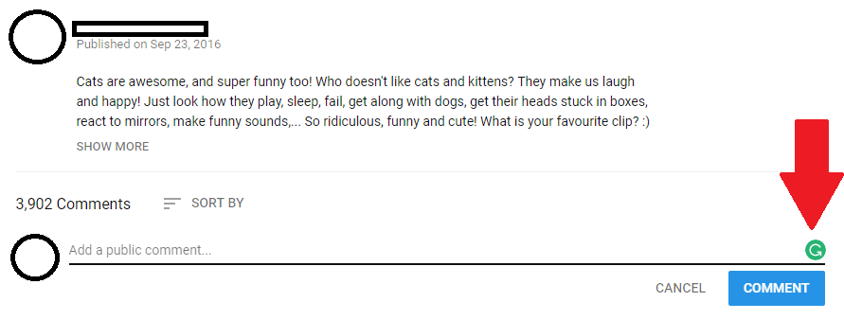
Once you begin typing, Grammarly will provide suggestions on any errors by underlining the text with a red line. Hover your mouse over the word to see a correction, and click on the green word to replace it. If you do not want to make the change, click Ignore, or just move your mouse away from the text.
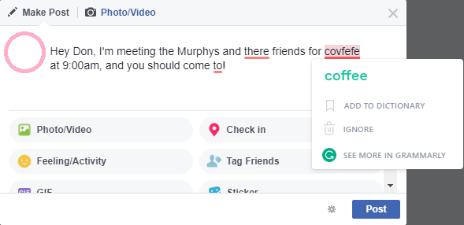

Program Manufacturer Contact Info
Grammarly, Inc.
Individual users have two options:
Basic Grammarly: Includes critical grammar and spelling checks with explanation of grammar rules. Users have access the native desktop app, browser plug-ins.
- Free!
Premium Grammarly: Includes advanced checks for punctuation, grammar, context, and sentence structure, as well as vocabulary enhancement suggestions, genre-specific writing style checks, and plagiarism detector that checks more than 8 billion web pages.
- Monthly Plan: $29.95/month
- Quarterly Plan: $19.98/month (billed as one payment of $59.95 USD)
- Yearly Plan: $11.66/month (billed as one payment of $139.95 USD)
Grammarly also offers plans for schools and businesses with a special discount for multiple licenses.
Download Grammarly at Grammarly software link (https://www.grammarly.com)

