ATRC Logo, Assistive Technology Resource Center, Colorado State University.
phone 970-491-6258,
fax 970-491-6290,
email atrc@colostate.edu,
website http://atrc.colostate.edu/,
accessibility website http://accessibility.colostate.edu

Livescribe Echo Smartpen - Quick Start Guide

# Overview

This pen records audio as you write, and allows you to replay later by tapping your notes. The pen connects to PC and Mac by a USB cord, so files can be transferred on to your computer. The linking of audio and written notes works only with Livescribe dot paper. 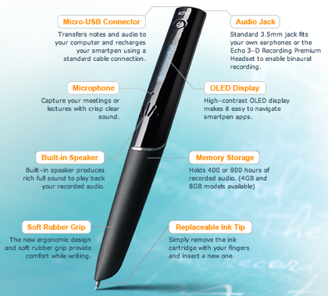

# To Use

To begin, you will need:

1. Echo Smartpen
2. Livescribe dot paper notebook

## Turn On and Off

To activate pen, simply **press** the power button at the top of the pen. The led display will activate. To use the pen, you will need to remove the cover, revealing the ball point stylus. To turn off, press the power button until the display goes black.

## Setting preferences

To set your preferences, open the cover of your Livescribe dot paper. On the inside cover, there is a box titled settings. To change these settings, place the stylus of the pen to the desired setting. When an option is selected, the pen will emit a quiet tone. You can set the date, the time, and the brightness of the display, as well as orient the display depending on right or left handedness. Volume can be adjusted up or down by selecting corresponding up or down arrows in the volume box and you can also select mute. Advanced audio settings can be used to match audio recording with the type of setting, such as large lecture hall or small classroom, and the desired audio quality. These settings can also be changed directly on your pen using the Nav Plus menu (see below).

## Nav Plus and Navigating the Main Menu

Located in the lower left hand corner of each dot paper notebook page is the Nav Plus menu. This menu can be used to customize settings for your notes, your recordings, and your pen’s functions. To start, tap twice on the center of the crossing arrows, and the main menu will appear on the OLED display of the pen.

Picture of NavPlus Menu for use with the Smartpen

To navigate the menus, select the corresponding arrow (up or down) to see the options for menus on the pen. To select a menu, tap the pen’s stylus to the arrow pointing to the right. The settings that can be changed directly on the pen can also be changed on the inside cover of your dot paper notebook.

### Paper Replay

Paper replay allows you to play back an entire session of notes, add a new session of notes, delete a session of notes, delete all notes and password protect your sessions. This feature allows you to replay the audio from entire sessions without having to connect to your computer.

## Taking notes

To take notes, turn the notebook to a blank page. At the bottom of the page, you will see a menu like this:

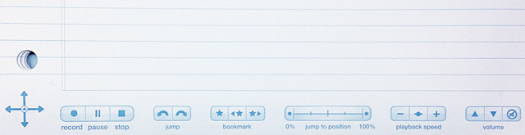

1. Tap pen on ‘record’ icon on the bottom left hand corner of the page. 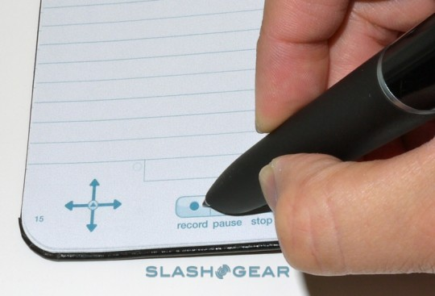
2. Take notes as desired.
3. You can pause recordings during breaks.
4. To add a bookmark during recording, by tapping the star symbol on the bookmark menu at the bottom of your dot paper.
   1. A bookmark will be placed at that point in the audio file. After you have added bookmarks to an audio session, you can scan through the bookmarks using the Previous and Next bookmark buttons.
5. When done, tap pen to stop.

## Playback

You can play back any portion of the audio associated with your notes by tapping words on your notes. The pen will then play the audio that it had recorded while you wrote that note. Using the Livescribe dot paper menus at the bottom of your notebook will assist you in making adjustments during playback, such as:

1. The jump menu allows you to move forward or backward 10 seconds in the recording, by touching the pen stylus to the corresponding arrow.
2. Bookmarks can be created by touching the star icon on the bookmark menu.
3. Navigate using bookmarks by selecting the forward or back bookmark icons with your pen’s stylus.
4. You can jump ahead or back in the playback by using the jump to position menu, which may be helpful for long session recordings.
5. The speed at which the recording is played can be adjusted by touching the pen’s stylus to the playback speed menu.
6. Volume can be adjusted and muted using the volume menu.

## Sync with Computer

Using the USB cord, you can connect your Echo Smartpen to your computer. This allows you to save your written notes and the audio files that are linked with them. To do this:

1. Download Echo Desktop: [Livescribe Desktop Install](http://www.livescribe.com/install)
2. Connect Livescribe Echo Smartpen to computer with USB cord (included with kit)
3. The pen will automatically upload files to Echo Desktop.
4. This allows you to save your notes and recordings to your computer so that you can replay them at your convenience and organize them. 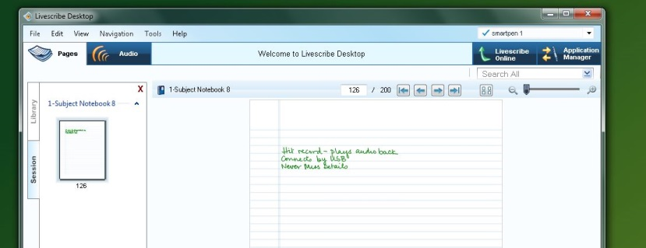

## Advanced Features

The Livescribe Echo Smartpen has many features that you can choose to use to customize and enhance your experience and use of the pen, including use of various different types of writing surfaces, and different apps that the Echo Desktop application can link to. The Livescribe website has a detailed FAQ and support website: [Livescribe Echo Smartpen Support](http://www.livescribe.com/en-us/support/echo/howto/)

### Linking Notes to Previously Recorded Audio

You can write new notes and link them to a previously recorded audio file by writing on dot paper while you play back the audio recording.

1. Begin audio playback by tapping on your partially written notes.
2. Once playback is initiated, begin writing with your Echo Smartpen. Your written notes will be automatically linked to your previously recorded audio or Paper Replay session.
3. Stop playback.
4. Tap on your newly written notes to play back the audio that you linked while writing the new notes.

# Program Manufacturer Contact Info

Livescribe, Inc.

Office Phone: 510-777-0071

Customer Service: CS@livescribe.com 1–877–727–4239 or 510–567–4150

Website:[Livescribe website (http://store.livescribe.com/)](http://store.livescribe.com/)

## Cost of the product

Cost: $120 (for 2GB pen) at the time of this Quick Start publication date.