GhostReader 2.0 - Quick Start Guide

Overview
Ghost Reader Software allows Apple users to listen to text, compose documents, create their own audio files and listen to text within Safari.

Opening a Reader Document

Opening an Existing File
To open an existing file in Ghost Reader, the file must be a TEXT, Word, HTML, PDF or RTF file. Go to FileOpen Reader to load a document.
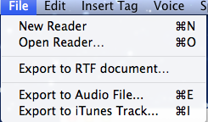

Starting a New Reader Document
To begin a new document within Ghost Reader, go to FileNew Reader. A pop up window will appear. In this document a user can create text and use text-to-speech to listen.

Reader
Ghost Reader enables users to listen to documents and personal written text. Features include:
- Paragraph Start: Begins reading at the beginning of a paragraph.
- Sentence Start: Begins reading at the start of a sentence
- Rewind: Moves to the prior sentence
- Stop: Stops text-to-speech
- Play: Begins text-to-speech where cursor is in document
- Forward: Starts reading the next sentence.
- Skip Sentence: Skips the next sentence
- Skip Paragraph: Skips to the next paragraph
You can access these features through the tool bar at the top of the Reader window and through the Speech menu at the top of the screen.
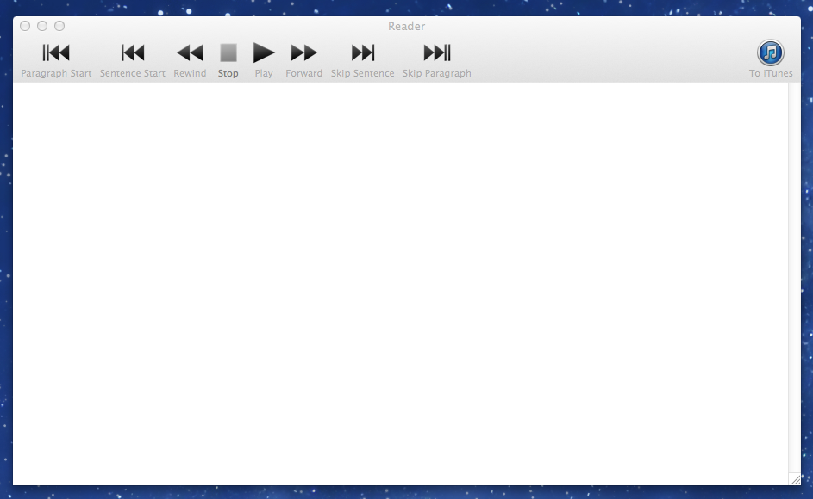
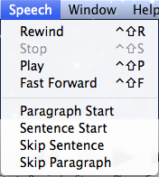
Additionally, Ghost Reader highlights the text as the program reads the text aloud.
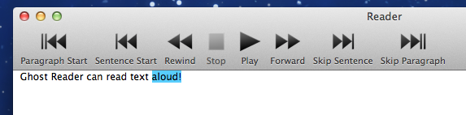

Speech & Reader Preferences

Speech Preferences
Ghost Reader provides a variety of voices with different accents. To access most recent voices used go to Voice Choose preferred voice.
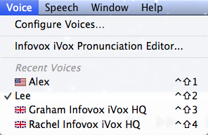
Additionally, users can access Speech Preferences at GhostReaderPreferencesSpeech.
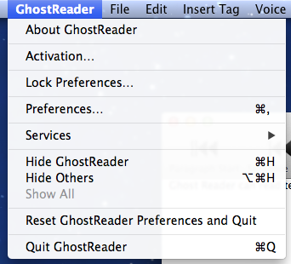
A variety of options for voices, speech and volume are available.
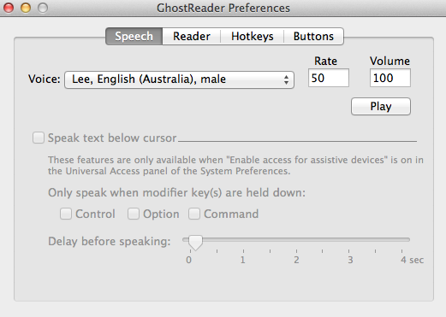

Reader Preferences
Users can customize the Reader window preferences at GhostReaderPreferencesReader. In this pop up window, users can customize the font, size of the font, text color, background food, highlight color and highlighting options when reading.
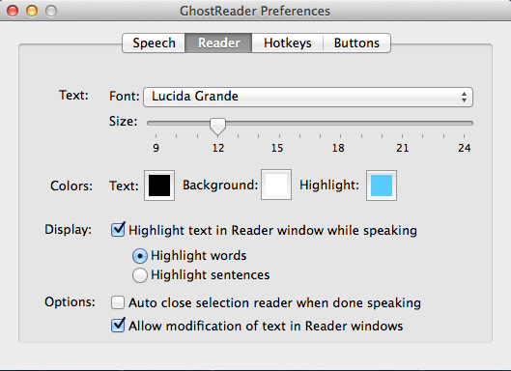

Lock Preferences
Once users have found preferences, a user can choose to lock the preferences selected. To do this go to GhostReader Lock Preferences

Create Audio Files
Using Ghost Reader, users can transfer text files to audio file. Go to FileExport to Audio File. Additionally, Ghost Reader can transfer these audio files to a user’s iTunes account. Go to FileExport to iTunes Track.
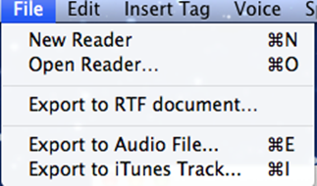

A pop up window will appear for the user to name and save the audio file.
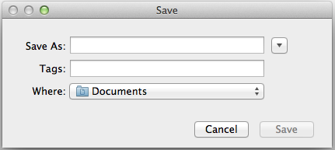

Insert Tags in Reader
The Insert Tags feature allows for the user to place “tags” or commands within text. These commands include Silence (short, medium or long), Volume (low, medium or high), Speech Rate (decrease rate or increase rate), Text Mode (normal or literal) and Number Mode (normal or literal). To insert a tag in the Reader window text go to Insert Tagchoose the preferred tag.
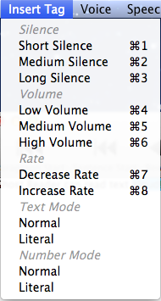
Here is an example of the tags Long Silence and Decreased Speech Rate. Each Tag is separated from the original text through double brackets. When GhostReader is speaking the text aloud, it will follow the commands.
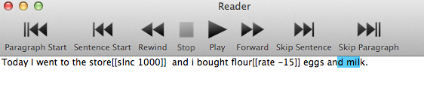

Customize the Toolbar
User can customize the buttons on the Ghost Reader toolbar to the user’s preference. Go to Edit Configure Toolbar.
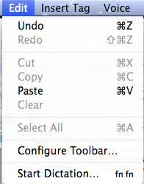
A pop up window will appear. Drag the preferred toolbar button to the bottom of the pop up window. Save all preferences.
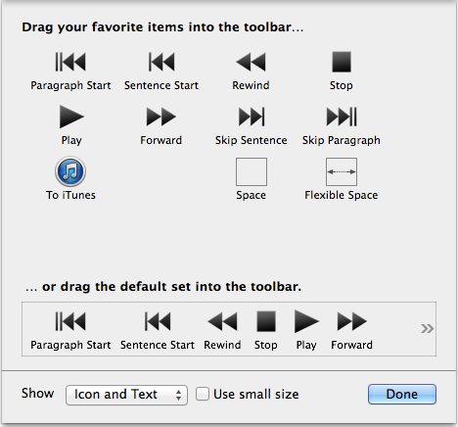

Help for Users
If users need assistance, Ghost Reader has a Help drop down menu. This gives suggestions as well as allows the user to type in a search bar to ask questions.
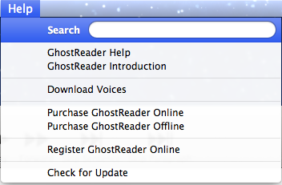

GhostReader Plus Additional Features
In the GhostReader Plus version, additional features include an Edit mode that supports grammar and text editing, additional annotation features, a safari browser add-on to utilize text-to-speech, and colorful tags.
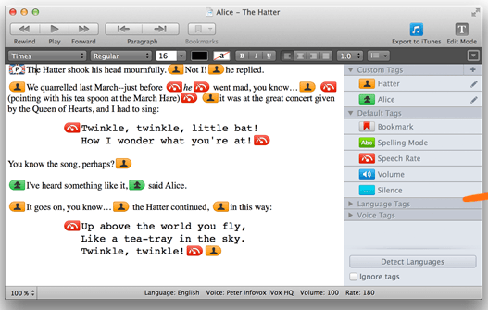

Program Manufacturer Contact Info
Manufacturer: Made by ConvienceWare for Apple products
Where to get GhostReader: Ghost Reader is available in the Apple Store or online at http://ghostreader.en.softonic.com/mac/download
http://www.convenienceware.com/ghostreader
Cost: The product has a free trial version to download.
GhostReader 2.0: $24.99
GhostReader Plus 2.0: $39.99

