Optical Character Recognition (OCR) for PC - Quick Start Guide

Overview
Optical character recognition (OCR) software converts scanned images of text into text that a computer can read, or into a Searchable PDF. The resulting document has text that you can interact with. Benefits include the ability to search, select, highlight, copy & paste, create a table of contents, and listen to text.
The following are examples of inaccessible vs OCR’d PDFs:
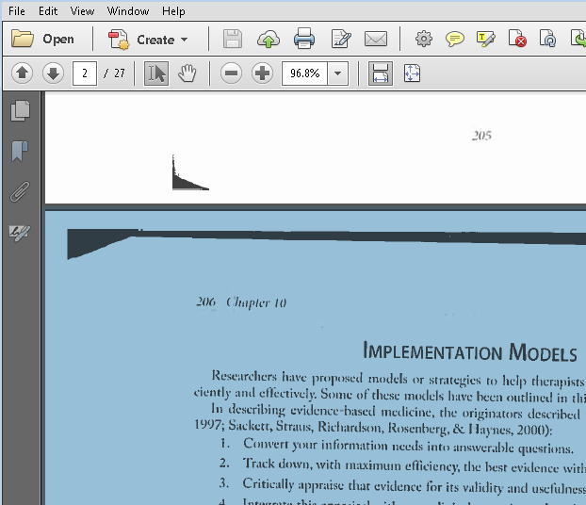
Figure 1: Inaccessible PDF
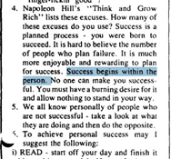
Figure 2: Accessible PDF
This Quick Start Guide will explain the process of creating OCR’d PDF files in the following programs: Read & Write, Kurzweil, WYNN, OpenBook, and Adobe Acrobat Pro.

To Use

Read & Write on PC
- Open Read & Write by double clicking the purple puzzle piece icon .
- Find the Scan icon in the Read & Write toolbar . If it is not showing, you may need to switch the toolbar you are viewing. In default settings, the Scan tool is shown in the “All Features,” “Reading,” and “Research” toolbars. Access toolbar options by clicking on the down arrow next to the Read and Write icon in the top right corner of the screen . Then click “Current Toolbar” and make your selection.
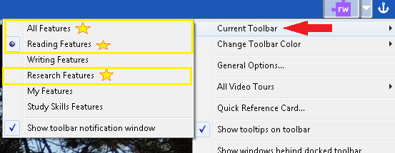
- Click the arrow next to the Scan icon 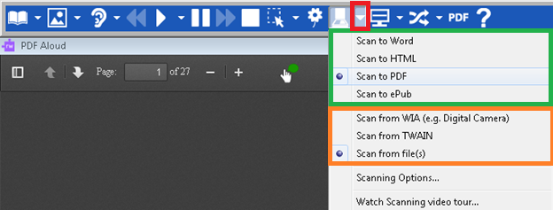
- Select the file type you want to create (Scan to Word, Scan to PDF, etc.). For this example, the program will scan to PDF. 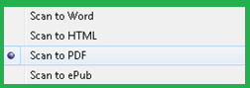
- Select the source of the scan (WAI, TWAIN, or files) 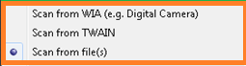
  - Make sure “Scan from file(s)” is also selected if you wish to OCR a file on your computer
  - If you want to scan a paper document, select “Scan from TWAIN.”
  - If you want to scan from a photo, select “Scan from WIA.”
- Select the saved file on your computer you want to OCR and click open.
- Enter the page range you want to scan.
- Read &Write will open a “Save As” window and prompt you to name the scanned file and select where you want to save it.

Kurzweil 3000 (PC)
When a file is opened using Kurzweil, the program will automatically prompt you through the process of creating an OCR’d document.

Opening a document
You can work with virtually any kind of document in Kurzweil 3000 including: image documents that you scan into Kurzweil 3000, documents that you open from another application or open using the KESI Virtual Printer, and text documents.
Click the Read tab in the Main toolbar, then click the Open button . In the Open dialog, navigate to and open the desired file on your computer.
Kurzweil will open a prompt that will ask you to choose a page range to scan. Type the page number you want to start scanning in the left box labelled From Page, then type the last page you want scanned next to To Page.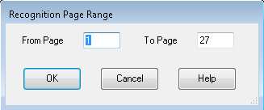
Kurzweil will then process the document page by page. A progress tracker will be displayed close to the start menu at the bottom of the screen. 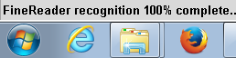

Basic Scanning
Kurzweil also allows you to scan physical documents into an OCR’d format. To scan your own documents into a KEZI file:
- Make sure your scanner or document camera is turned on.
- Place the material to be scanned on the scanner glass (or under the document camera).
- Click the Scan button in to open Scanning toolbar. [Shown in Red box below]
- Change Scanning settings as desired to complete multi-page or color scanning [Shown in Yellow box below.
- Click Scan button [Shown in Orange Box below] to begin scan.
- When the scan is complete the page image appears in the Kurzweil 3000 document area. Each new page you scan is added to the end of the document.
- A document undergoes optical character recognition (OCR) whenever scanned or printed to Kurzweil.
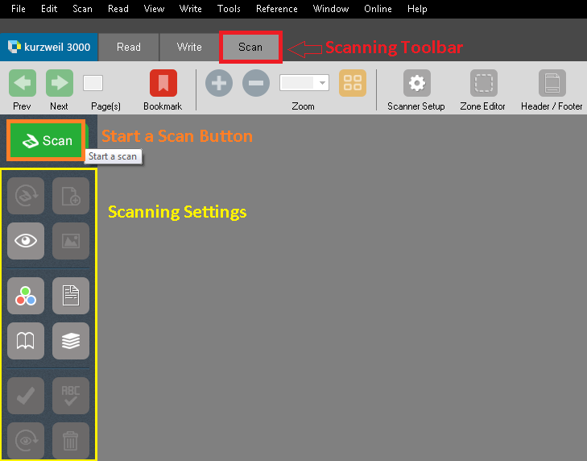

Saving a Document
The default setting for saving a document is as a .kes file. Saving a file as a .kes ensures that all annotations (highlights, notes, brainstorms etc.) are preserved. Documents can be saved as several file types; however this does not ensure annotation preservations. To save:
- Click the save button in the red main toolbar.
- Select location on your computer to save document as a (.kes) file.

OCR with Adobe Acrobat Professional
Software with OCR capability comes with various levels of sophistication and cost. The cheapest and most common software is Adobe Acrobat Professional (about $99 per copy). This is different than the free Adobe Reader program, which can only read PDFs, not change them. Some departments at CSU have site licenses for Acrobat Pro, but if yours does not, Morgan Library also has it on all computers.

Use the Recognize Text Tool
- Open the PDF in Acrobat Pro
- Click on Tools at the top right of the document.
- When the toolbar opens on the right side of the screen, click on Recognize Text to expand the menu.
- Select “In this File” to bring up the OCR menu box.
- Click a range button to choose to OCR either All Pages, the Current Page, or a specific page range, then Click OK. (All pages could take a while on longer documents.)
- Once this finishes running, you should be able to highlight text in the document.

OpenBook
OpenBook is a program that allows users to scan books, magazines, articles, and other printed documents into an electronic, OCR’d format. OpenBook is designed for individuals with low vision, and can be customized to change how the document appears on the screen.
- Start OpenBook by double-clicking the OpenBook Icon 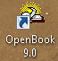, by pressing hotkeys ALT+CTRL+O, or by clicking the Start Menu > Programs > OpenBook.
- To scan a document
  - Select Toolbar > Scan > Scan a Page
  - OR use hot keys NUM PAD - INSERT or F4 to scan a document
- To Scan a document into Word
  - Place the page you want to scan on your scanner.
  - In Microsoft Word, open the File menu and choose Scan Using Open Book.
  - Open Book scans the page. When Open Book is finished scanning, it displays the text of the page in Word.

OCR at the Scanner or Copier
Some scanners and photocopiers have the ability to OCR documents as they scan so that you don’t have to fix it afterwards. Many Xerox photocopiers can scan to PDF via email or a network, and you can select the option to make that PDF searchable. Look for keywords OCR or Searchable PDF in the save options while scanning.

Program Manufacturer Contact Info

Read & Write
Texthelp Inc.
Cost: $145 (CSU students may be able to use Read & Write on personal computers through our site license while they are students, and Read & Write is available to all CSU students in Morgan Library)
600 Unicorn Park Drive Woburn, MA 01801 TextHelp Website (www.texthelp.com)
Phone: 888-248-0652
Fax: 866-248-0652
General Inquiries: u.s.info@texthelp.com
Technical Support Phone: 888-248-4947
Support Inquiries: Customer Support Contact (us-support@texthelp.com)

Kurzweil 3000
Cambium Learning Technologies
Kurzweil Educational Systems
Phone Number: 800-894-5374; Outside of US and Canada: +1-781-276-0600
Website: Kurzweil 3000 Website (http://www.kurzweiledu.com/products/k3000-win.html)
Cost: $1395 at the time of this quick start publication date.
(Students registered with the ATRC may be able to use Kurzweil or Read & Write on their home computers through our site license while they are students at CSU.)

Adobe Acrobat Professional
Adobe Systems Incorporated
Adobe Systems Website (https://acrobat.adobe.com/us/en/acrobat/pricing.html)
Cost: Varies by Version
Acrobat Pro DC: $14.99/month
(Available for free CSU student use in Morgan Library Computer Lab)

OpenBook
Freedom Scientific
11800 31st Court North
St. Petersburg, Florida 33716
Freedom Scientific Website (www.FreedomScientific.com)
1-800-444-4443
Cost: $1,000

