Technology Strategies for Scotopic Sensitivity

Advanced Software:

WYNN – Windows only, free trial version
Student is able to:
- Adjust the background color in text view
- Adjust the text size and font using WYNN settings
- Adjust the spacing between words and between lines
- Adjust highlighting colors as the text is read aloud
- Masking: Similar to placing an overlay over the computer screen.
  - Masking is available when reading the web:
    - Able to mask by line, sentence, paragraph or full screen
  - Masking by line, sentence or paragraph is available when reading in text view.
    - You must select Read only from the Edit menu to use masking in text view.
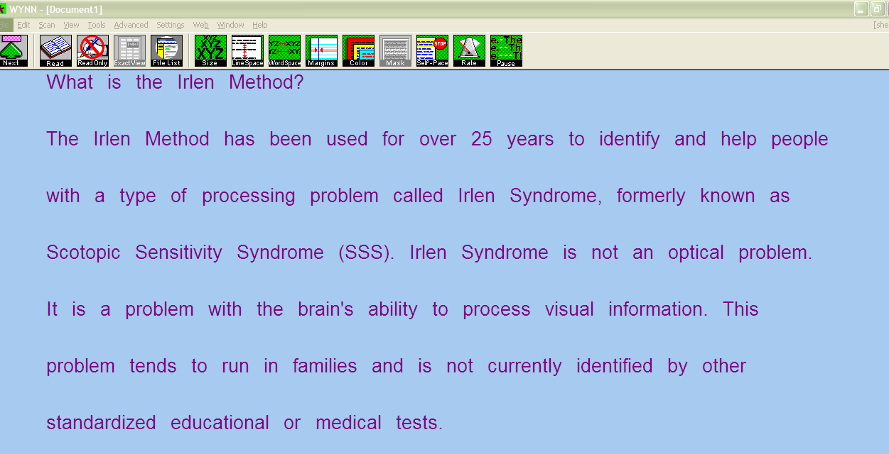
Figure 1 : Example of increased spacing between words and lines and color changes to text
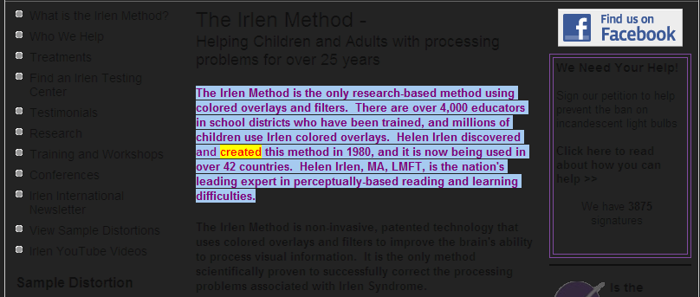
Figure 2: Example of web masking in WYNN

Read and Write Gold – Available for Windows and Mac, free trial version
Student is able to:
- Adjust highlighting colors as the text is read aloud
- Mask the screen in a variety of ways:
  - Full Screen Tinting tints the entire screen similar to using an overlay. Choose from a variety of colors and adjust the gradient
  - Mouse underlining: The line that is being read is underlined with the student’s chosen color for increased focus to that line.
  - Mouse spotlight options: Chose to read by line or by paragraph. Everything not being read at that time will be masked by the chosen color.

Figure 3: Example of mouse spotlight in Read & Write for Windows

Kurzweil 3000 – Available for Windows and Mac, free trial versions
Student is able to:
- Adjust the background color (limited options with Mac version)
- Adjust the text size, text color, font, and word spacing
- Adjust highlighting colors as the text is read aloud
Figure 4: Example of a rose background color and highlighted colors as text is read aloud in Kurzweil 3000 for Windows

ClaroSoftware – available for Windows and Mac, free trial versions

ClaroView – Mac only
Student is able to:
- Use an overlay to change the color and tint of the screen.

ScreenRuler – Windows and Mac
Student is able to:
- Use an overlay to change the color and tint of the screen.
- Use a reading ruler across the screen
- Use a colored underline that follows the cursor
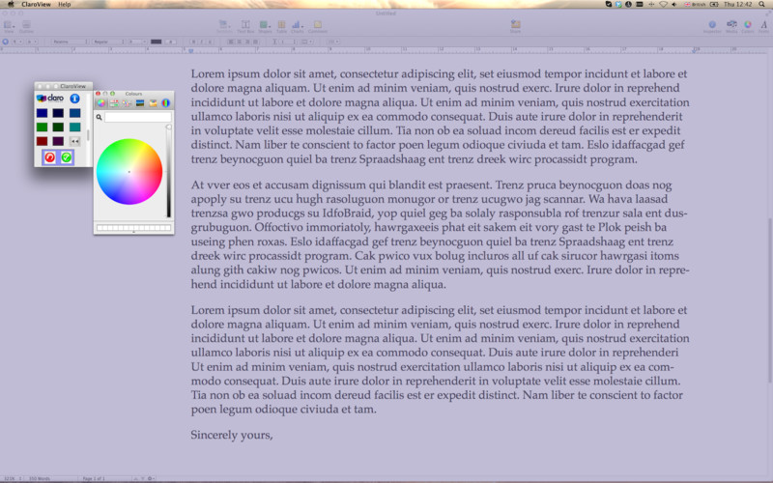
Figure 5: Example of ClaroView overlay and control options

Rapid Reader - Windows only
Student is able to:
- Read one word at a time with high color contrast setting
- Font and location of word can be customized to meet user’s preference
- Speed of word displayed can be changed
Figure 6: Example of reading with Rapid Reader

Free Software for Windows:

SS Overlay
Student is able to:
- Use this program in place of a physical colored overlay on any computer.
  - Download SS Overlay: http://www.fx-software.co.uk/assistive.htm
  - Activate program by right clicking on the Yellow Up Arrow located on the toolbar on the bottom right-hand corner of the screen, and select Settings
  - Set your preferred color settings, select OK. This will activate the overlay.
  - To turn SS Overlay off, right click on Yellow Up Arrow located on the bottom toolbar. Select Exit.
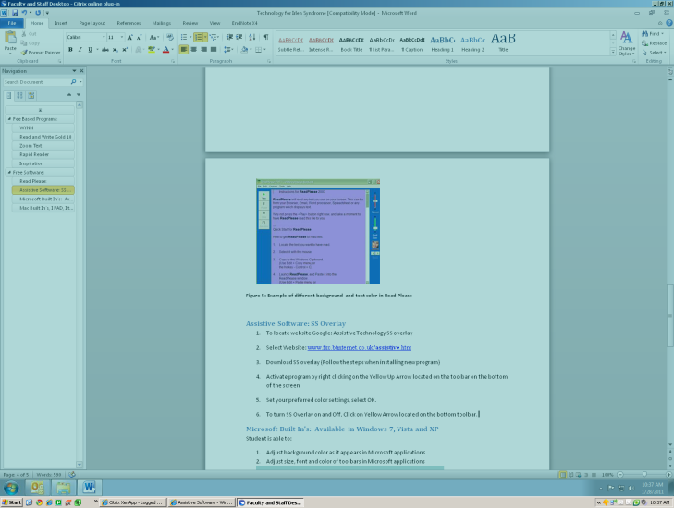
Figure 7: Example of teal screen masking using SS overaly

T-Bar
Student is able to:
- Use a colored bar to drag around the screen or lock to the mouse.
  - Download T-Bar: http://www.fx-software.co.uk/assistive.htm
  - To change the bar color and size, right click on the bar and select Controls.
  - To lock the bar to the mouse cursor, right click on the bar and select Lock.
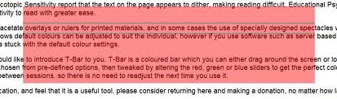
Figure 8: Example of T-Bar

Windows Built-Ins: Available in Windows 7, Vista and XP
Student is able to:
- Adjust the background color of the screen as it appears in Windows applications
- Adjust size, font and colors of toolbars in Windows applications within Display options
- These settings will carry over in Microsoft Word and Outlook

Windows XP
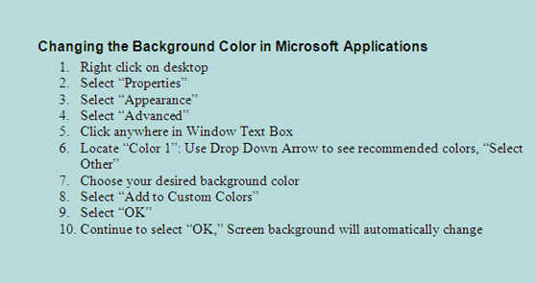
Figure 9: Example of background color change in Windows XP with directions

Windows 7
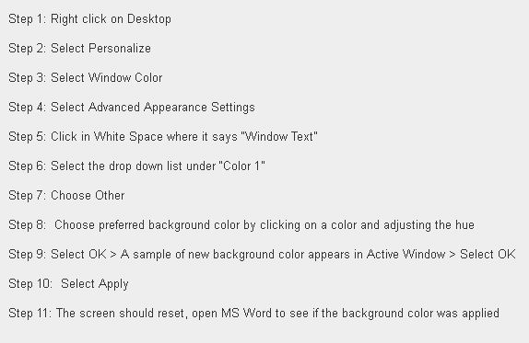
Figure 10: Example of background color change in Windows 7 with directions

Free Software for Mac:

Screen Shades
Student is able to:
- Tint the entire screen with preferred color.
  - Download Screen Shades: http://download.cnet.com/Screen-Shades/3000-2094_4-209362.html
  - Launch Screen Shades – a Control Panel will appear.
  - Select desired tint, or click on My Tint to customize the color.
  - To adjust the tint darkness, move the scrollbar to the right or left.

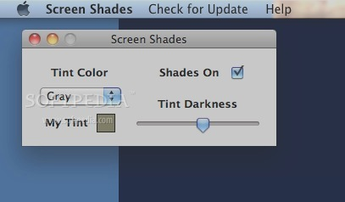

Figure 11: Screen Shades Control Panel and tinting

iOS Built-Ins: Mac and iOS Mobile Devices

Available in Setting Preferences > Accessibility on a Mac
Available in Settings > General >Accessibility on iPad, iPhone, or iTouch

Student is able to:
- Adjust contrast, invert colors, or use a gray scale
- Adjust size of font, and zoom options.
- In newer versions of MS Word for Mac, change the background color by clicking on Layout then Color under Page Background. Select preferred color.

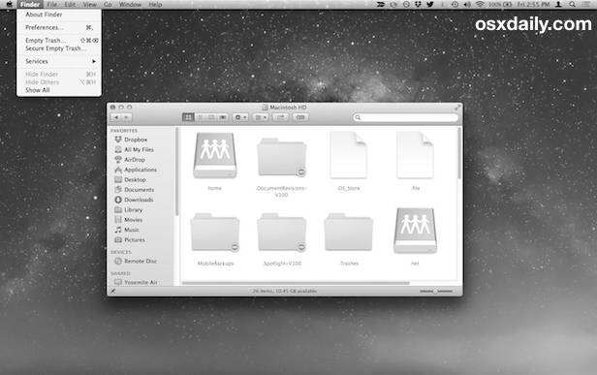
Figure 12: Mac OS running in Grayscale mode

Adobe Reader and Adobe Acrobat Pro
Student is able to:
- Adjust background color in PDFs for Windows and Mac
  - Go to Preferences > Accessibility > click on Page Background
  - Use color pane to select preferred color
  - Note – the PDF must be in an accessible format for this to work
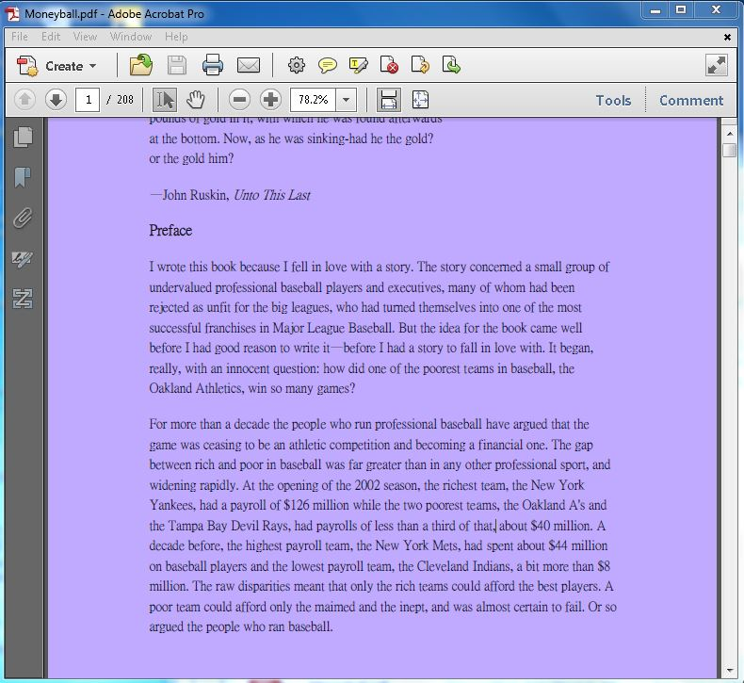
Figure 13: Purple background color change in PDF

Apps

Voice Dream Reader – iOS only
Student is able to:
- Download Voice Dream Reader: https://itunes.apple.com/us/app/voice-dream-reader/id496177674?mt=8
- Adjust the background color, text size, and font
- Adjust the margins, line spacing, and character spacing
- Adjust highlighting colors as the text is read aloud
- Mask everything except for 1 line, 3 lines, or 5 lines

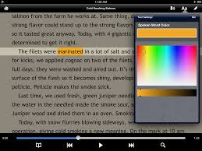
Figure 14: Example of color adjustments in Voice Dream Reader app

Screen Adjuster – Android only
Student is able to:
- Download Screen Adjuster: https://play.google.com/store/apps/details?id=com.netmanslab.sa
- Tint the entire screen using an overlay
- Adjust the color, contrast, and brightness of the overlay
- Adjust system brightness
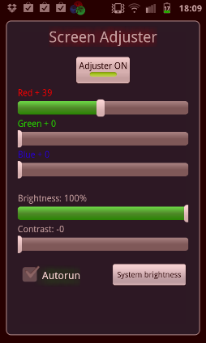
Figure 15: Screen overlay adjustments in Screen Adjuster app

