Quick Start Guide – Sonocent Audio Notetaker

Overview
Audio Notetaker is a notetaking and audio recording support program designed to support the note taking process and provide tools to enhance the studying process. Individuals who may benefit from Audio Notetaker include those who find it difficult to take notes while listening to what is being said, those who have challenges taking notes quickly enough to write all the necessary information, and those with auditory processing challenges, difficulty maintaining attention, or musculoskeletal impairments that make it hard to write or type notes.
For a full guide of all available features of Audio Notetaker visit the sonocent audio notetaker website (https://www.sonocent.com/en-us/audio-notetaker)

To Use

Opening Audio Notetaker
To open Audio Notetaker, double click the blue icon with a microphone on it . Once open, Audio Notetaker gives you the following options to start a new project: Blank project, Recording from microphone + speakers, Recording from speakers only, Import audio, or Import slides.
Starting a blank project allows the user to record audio from the built-in microphone on their computer or the microphone they have selected on their device. Recording from the microphone and speakers allows users to record audio through the microphone as well as from audio being played through the system’s speakers. This can be helpful if the user is watching a video online and would like to take notes and record the audio at the same time. Recording from speakers only is similar to the previous option but does not allow the user to record any audio through the microphone. Importing audio allows users to record a lecture on a recording device and then import that audio into Audio Notetaker to annotate and categorize their notes. Users can also import PowerPoint slides prior to or after recording audio notes.

Basic Features

Recording Audio
Once a project is opened, the following screen will be displayed which allows users to begin recording audio. To begin recording, click the Record button. To create a new topic section, such as when the professor moves to the next slide in their presentation, select the Enter key on the keyboard. Audio Notetaker will create a new note section below the previous section. In order for this feature to work, make sure the audio pane is selected by clicking anywhere in it with the mouse.
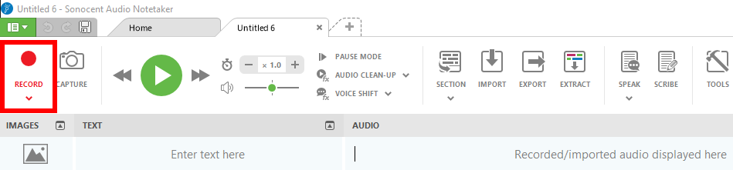

Organizing and Labeling Audio
Audio Notetaker allows users to color categorize their audio notes into Chunks during or after recording. This feature allows the recording to be categorized into established and customizable categories such as information that is important or needs to be reviewed, tasks that need to be completed, and other categories that the user needs to support their notetaking and studying. This will result in specific audio clips being labeled depending on the user’s preferences. After clicking the Record button, users can categorize notes in the following ways:
- Using the mouse to select the category that the audio notes fall in. Categories can be found on the right side of the screen. For example, to label notes as important, click on Important or the purple circle to it.
- Users can also select Chunks using the number pad on their computer. For example, elect the number 3 on your number pad to chunk the audio into the Task category.
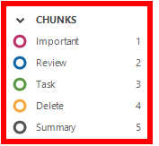
Audio Notetaker also allows users to categorize their audio notes into Sections. This is done in the same way as chunking but instead, organizes larger sections of information into categories. This can be done using the same two methods listed above for organizing chunks of information, by either clicking the Section theme with the mouse pointer or selecting the corresponding number on the computer number pad. The Section options are also located on the right side of the screen, below the Chunks options.
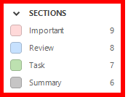

Importing Files
Audio Notetaker allows users to import the following file types into the note: Audio, Images, PowerPoint Slides, and Transcription. Select the Import button, select the file type you wish to import from the dropdown menu, then find the file from the saved files on your computer.

Audio Files
Users can import audio in two ways. The first is from the home screen by selecting Import Audio which will then prompt the user to find the location of the file on their computer. Users can also select the Import button and then select Import Audio from the dropdown menu.
Audio files will be imported into the audio section of the page. Users can then categorize the audio using the same steps listed above to sort and color code them into Chunks and Sections.

Images & Slides
Imported Images and Slides will appear in the Images section on the left side of the page. Each slide imported will have its own note section. Images and slides can be imported before or after recording audio. In order for the audio to line up with the images or slides that they relate to if added after recording audio, users should create new audio recording sections by pressing the Enter button during the recording process.

Transcription
For those who use transcribing software such as Speechmatics, Audio Notetaker allows users to import those transcriptions directly into the text pane.
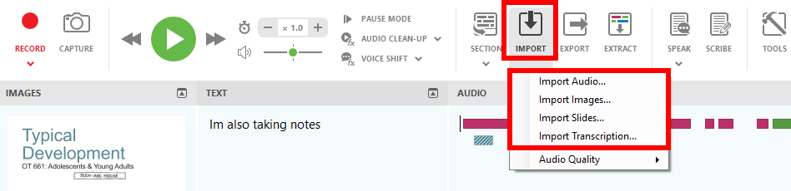

Taking Notes
While recording, users can take notes in the Text section of the screen. Uses are encouraged to only take notes on important information rather than taking notes on all content. By doing this users can pay better attention to the information being presented and worry less about capturing all of the information in the text section.
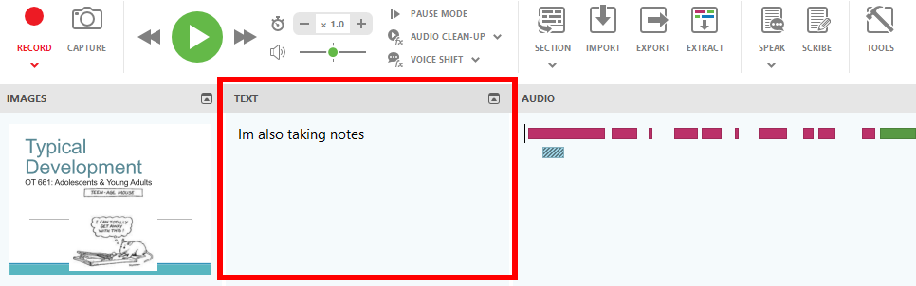

Extracting Audio
When finished recording audio, the program allows users to extract specific audio chunks or sections that they wish to review. To access this feature, select Extract, and then choose Extract Audio to extract specific chunks of audio or Extract Sections to extract whole sections of audio. Next, select which chunks or sections you wish to extract and select Okay. Audio Notetaker will then open a new project tab at the top of the page with the selected audio included in it.
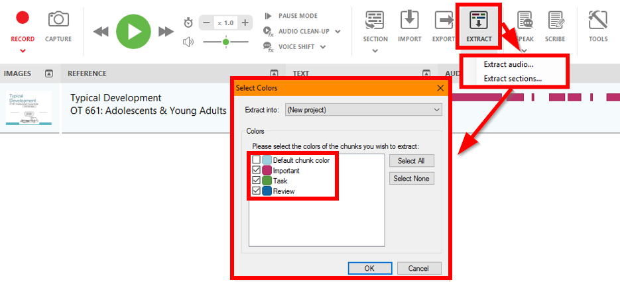

Using the Reference Section for Studying
Notetaker has a Reference section that users can use to study. This feature serves as a type of flash card or quiz tool that allows users to hide and reveal information while studying. For example, if a user wants to quiz themselves on capitals of each state, they can enter the state capitals into the reference section and only reveal it when they have guessed and want to check if they were right. To access the reference section, click the Reference button at the bottom of the page . This will reveal the reference section to the left of the text section.

Speak Text Out Loud
Audio Notetaker provides a feature called Speak that allows users to hear their typed notes spoken out loud to them. To access this feature, select Speak and then select from the following options: Speak all text which will speak out loud the text in the notes section; Send speech to audio pane which will convert notes highlighted in the text pane into audio in the audio pane; and Send all speech to audio pane which will convert all text into audio.
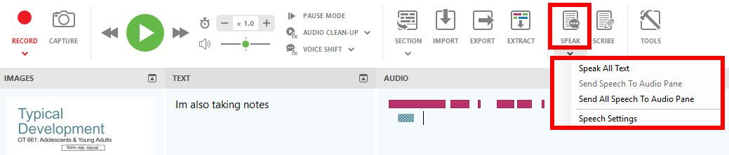

Common Settings

Reviewing Audio
When reviewing audio, users can select the green Play button to begin playing the audio. When playing, users have the opportunity to skip ahead or go back to the prior chunk of audio. Users can also increase or Decrease the playback speed, and change the Volume of the playback.
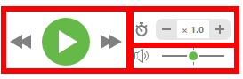
Pause Mode is a setting that plays back audio one sound chunk at a time before pausing until the user clicks the Play button to hear the next audio chunk. Select the Pause Mode button on the main toolbar to activate.
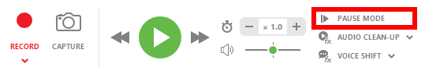
Voice Shift is a setting that allows users to change the way the voice sounds when audio notes are being played back to users by changing the pitch. Select Voice Shift and choose from the following settings on the dropdown menu: deepest, deeper, normal, higher, and highest
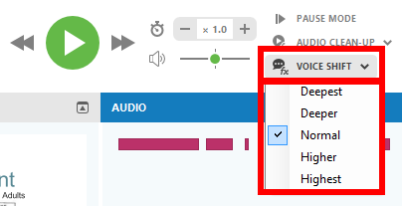

Page Display
In the bottom left corner of the screen, users can dictate which panes are visible. Users can choose to hide or show the Image, Reference, Text, and Audio pane by simply clicking on the green icons in the bottom left of the screen. There is also a Full Screen option.

Editing Audio Recording
Audio Notetaker allows users to copy, paste, delete and click and drag audio to other sections. This can be done by selecting the audio and right clicking on it or by using the standard ctrl + commands that you use with Word documents.

Advanced Features

Customizing the Audio Color Coding Key
Customize the color key for categorizing audio clips by selecting the Edit Color Key button on the right side of the page under the audio tab. In the dialogue box, users can either edit existing color coding templates or create their own color coding template. Next, select or edit which chunks or sections you wish to include, appoint names and customized colors, then select Save to add your changes. To switch between templates, select the dropdown menu below the Edit Color Key button and select the desired template.
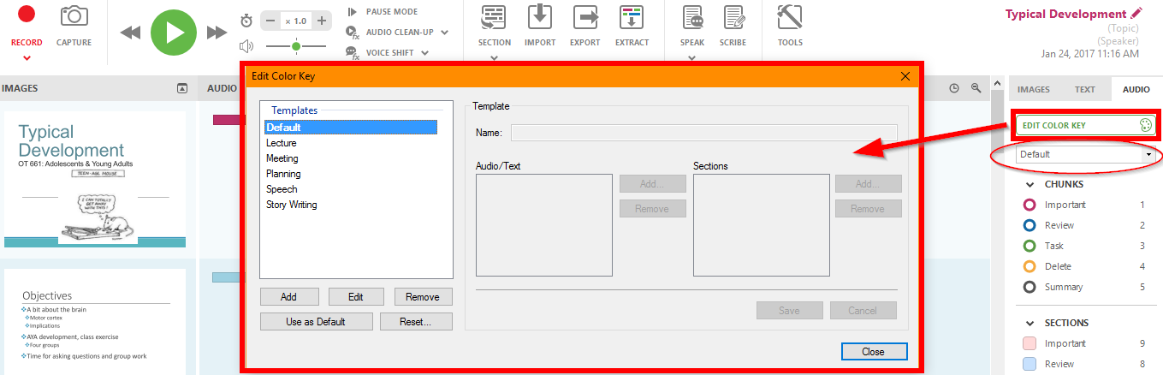

Exporting Audio, Texts, & Images
Audio Notetaker allows users to export the audio, text, and images from their Notetaker file. Select the Export button and choose from the following export options in the dropdown menu: Audio as Album, Album to iTunes, Selected Audio, Audio and Image as Video, and Text and Images. Follow the prompts to save the file on your computer.
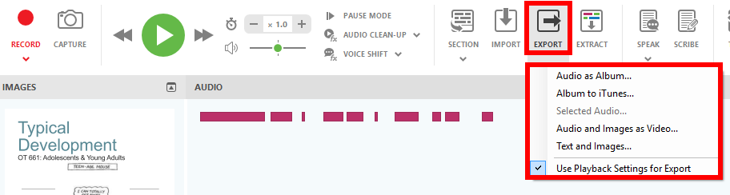

Program Manufacturer Contact Info
Manufacturer: Sonocent LLC, 4500 140th Ave North, Suite 101. Clearwater, Florida, 33762, USA

Contact info:
Phone: 202 657 4332
Sonocent Audio Notetaker Sales Email (sales@sonocent-usa.com)
Sonocent Audio Notetaker Support Email (support@sonocent-usa.com)
Website to locate the product:
Sonocent Audio Notetaker Website (https://www.sonocent.com/en-us/audio-notetaker)

Cost of the product
Cost and product information can be found at the Product Information Website (https://www.sonocent.com/en-us/purchase)

