SSOverlay - Quick Start Guide

Overview
SSOverlay is a simple program which places a colored overlay onto the computer screen. Useful for individuals with Scotopic Sensitivity Syndrome, the overlay colors and transparency are easily adjustable.

To Use
Double click on the shortcut SSOverlay icon on the desktop or go to the Start Menu and select SSOverlay.
When SSOverlay opens, an overlay will cover computer screen. The color and transparency settings will remain the same from the previous time you used SSOverlay.

Some Common Settings
To customize the color and transparency, right click on the SSOverlay icon in the Windows Taskbar at the bottom right of the computer screen.
By right-clicking on the icon, the following options will appear.
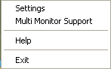
Click on Settings to view a list of colors to choose from and an adjustable tab for the transparency.
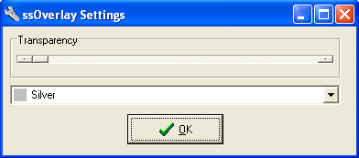
To change the transparency, slide the tab under transparency until your desired transparency level appears. To change the color, click on the drop-down arrow and select a color. Click on OK to apply the color and transparency settings. If one of the default color choices does not suit your needs, you can open multiple overlays at once and combine colors. For example, you can open one overlay in silver and then click on the SSOverlay icon again to open a second overlay. If you set this second overlay color to blue, the resulting mix of the two overlays would be a greyish-blue.
SSOverlay can be used on two connected computer screens by right clicking on the icon in the Windows Taskbar and selecting Multi Monitor Support. This will apply the color to both computer screens. Selecting Multi Monitor Support again will remove the overlay from the second screen.
To remove the overlay from the screen and exit out of the SSOverlay program, right click on the icon in the Windows Taskbar and select Exit.

Program Manufacturer Contact Info
Software Developer: Fx Software
Website: http://www.fx-software.co.uk/assistive.htm
Note: you must scroll down on webpage to find SS Overlay download
Contact: fxc@btinternet.com
Cost: Free

