Vu-Bar 4.5 - Quick Start Guide

Overview
Vu-Bar is a simple piece of software that provides an on-screen, slotted-ruler. Vu-Bar assists with tracking and helps users keep their place while reading.

To Use

How to open
Open Vu-Bar by double clicking on the icon.
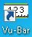
Vu-Bar will automatically appear.

How to use
Simply drag the bar over the text you need to read to help keep your place. Vu-Bar can also be locked to the mouse pointer for ease of use and can be controlled by moving the mouse or by the arrow keys on your keyboard. To lock the bar, right click on Vu-Bar and select Lock.

Common Settings
You can customize the bar by changing the width, height, viewing slot size, and color. To adjust settings, right click on the bar. A drop down menu will appear.
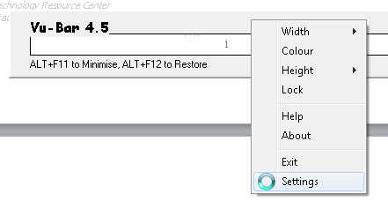
You can change the width of Vu-Bar by either selecting Width or Settings from the drop down menu. To change the height of the bar, select Settings, then Bar Height. Important note: the Height option from the drop down menu adjusts the height of the viewing window, not the height of the bar.
To change the color, select Colour from the drop down menu. A color palette will appear. You can select a basic color on the palette, or customize your own color.
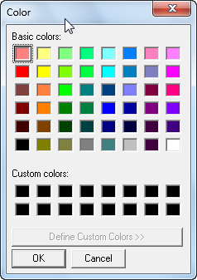

To change the height of the Vu-Bar viewing window, select Height from the drop down menu. This allows you to choose the correct size based on font size of your reading. Important note: the Slot Height in Vu-Bar settings does not adjust the viewing window height.
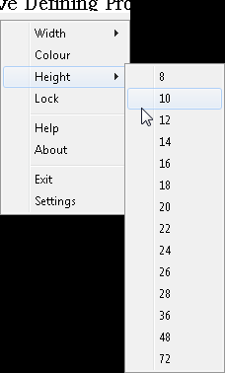

Program Manufacturer Contact Info
Software Developer: Fx Software
Website: http://www.fx-software.co.uk/assistive.htm
Contact: fxc@btinternet.com
Cost: Free (donations are accepted)

