Android - Quick Start Guide

Overview
This guide explains android Oreo accessibility features and how to use them. This operating system is found on all Samsung products and other smartphones and tablets from other manufacturers as well.

Accessibility Tab
The settings featured below are found under Settings -> Accessibility

Vision

Voice Assistant
Receive voice feedback. For example, hear what you can interact with on each screen. Tap items to select them and hear what they are. Similar to a screen reader for your phone. Double tap to perform the related action.

Screen Zoom and Font
Adjust how far the screen is zoomed in, and the font size and style in Samsung apps and on home screen.
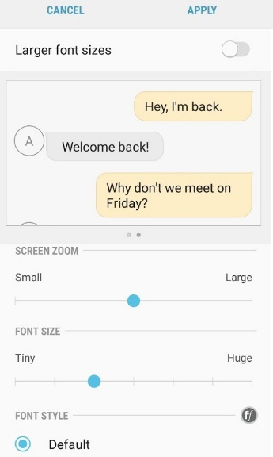

High Contrast Fonts
Adjusts color and outlines fonts to make them stand out more. Works on all Samsung-owned apps.

High Contrast Keyboard
Change size and colors of Samsung keyboard to improve visibility. Does not work on third-party keyboards.

Screen Magnifier
Creates an on-screen magnifier that can be moved around to make on-screen content underneath the magnifier larger and thus easier to read. Move the magnifier by holding the bar on the bottom of the magnifier and sliding it around the screen.
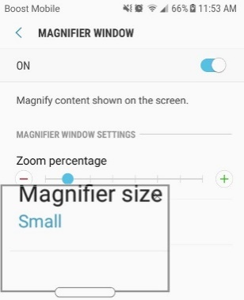

Color Inversion
Inverts all colors on screen. Works on everything the device displays, including third-party apps.
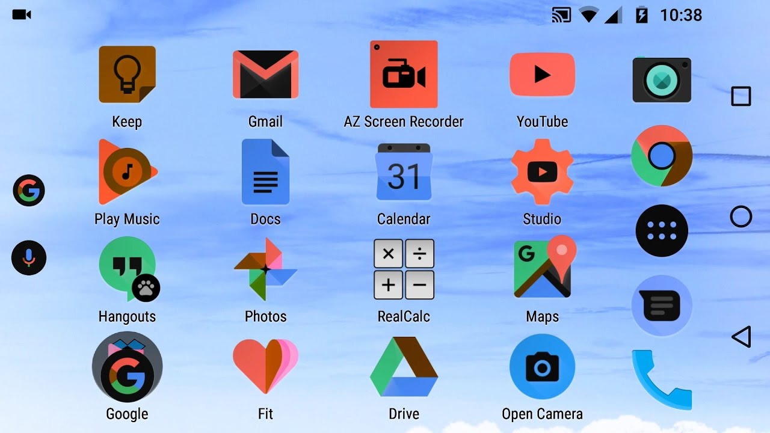

Color Correction
Adjusts screen colors to accommodate for various types of color blindness. Works on everything the device displays regardless of what application it is running.

Hearing
Flash Notification
Flash the camera light when notifications are received or when the alarm sounds.

Hearing Aids
Changes the sound quality to better work with hearing aids.

Subtitles
Toggle subtitles and choose between the Samsung and Google versions.

Sound Balance and Mono Audio
Adjust sound balance in headphones.

Dexterity and Interaction
Assistant Menu
Adds an on-screen menu from which several functions can be accessed. These functions include -
    - Control Volume
    - Lock Screen
    - Take Screenshot
    - Pinch to Zoom
    - Phone Options
    - Menu Settings
    - Access Recent Apps
    - Go to Home Screen
    - Go Back
    - Open Notification Panel
    - Activate Cursor
    - Open Alternate Screen Control
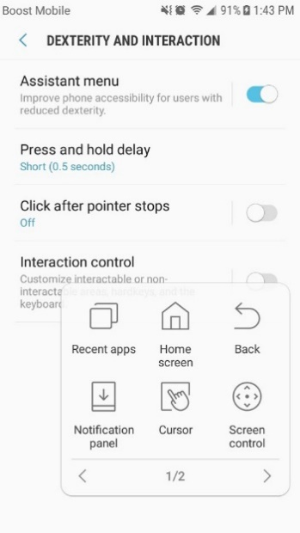

Press and Hold Delay
Change setting determining how long to hold for functions requiring the user to hold one place on the screen.

Click after Pointer Stops
Move cursor to where you want to click, stop moving the cursor, and after a delay (which is adjustable) the cursor will click. Recommended for use with a mouse.

Interaction Control
Block touch recognition for certain areas of the screen. Customize hardkeys (Physical buttons not on the touchscreen) and the keyboard.

More Accessibility Settings

One-Handed Mode
This feature found in Settings > Advanced Features allows the user to decrease screen size and move the useable screen to either of the bottom corners to make it easier to use the device one-handed.
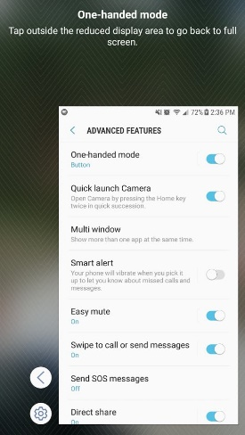

Text-to-Speech
Found in Settings > Accessibility. Turn on the built in text to speech feature and adjust related settings.

Google Assistant
Found in Settings -> Google -> Search. Say “OK Google” to ask questions or have the assistant do things based around your google accounts such as Google Calendar or Gmail. Similar to Siri on iPhone.

Program Manufacturer Contact Info
Android
Phone: 650-475-8900
Address: 156 University Avenue
Palo Alto, CA 94301
United States

Android Website (https://www.android.com/)
Android Support (https://support.google.com/android/?hl=en#topic=7313011)
Android Operating System (https://www.android.com/versions/oreo-8-0/
Free with device

