Central Access Reader (CAR) - Quick Start Guide

Overview
Central Access Reader (CAR) is a free, open source, text-to- speech application designed specifically for students with print-related disabilities. CAR reads Word Documents and pasted text using the built-in voices installed on your computer.
CAR can also read math symbols if the Word document is created with MathType software, and can export documents to mp3 files.

Loading a Word Document into CAR
Open a Word document by pressing the Plus button. A window will appear allowing you to choose a document to upload into CAR. This will begin a new CAR tab at the top of the CAR window. Additional ways to upload document:
- In the new window, drag the Word document into the window.
- Copy and past text from Clipboard
- Using the drop down menu in the right hand corner go to Fileopen Word document

Accessing the Document
Within each word document, CAR presents the Headings and Pages allowing for easy access to the document’s content.
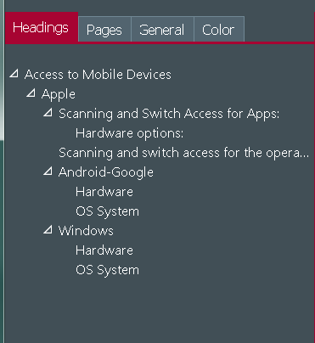

Text-to-Speech
Begin text-to-speech by clicking the Play button in the CAR toolbar. CAR will begin reading aloud where the mouse cursor is situated within the document.
Text-to-Speech options are located within the General Settings button o f the CAR toolbar.
You can select a preferred voice, rate of speech, volume, and pause length.
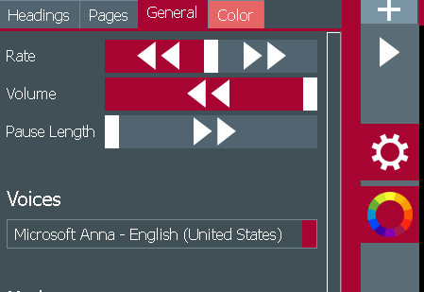
These options can also be accessed through the dropdown menu in the top right corner. Go to Function Read or Stop

Short Keys:
- Start Reading: CTRL + R
- Stop Reading: CTRL + S

Visual Display
While reading aloud, CAR can highlight the word and/or sentence in various colors. You can select a preferred color for:
- Background color
- Text color
- Highlight background color
- Highlight text color
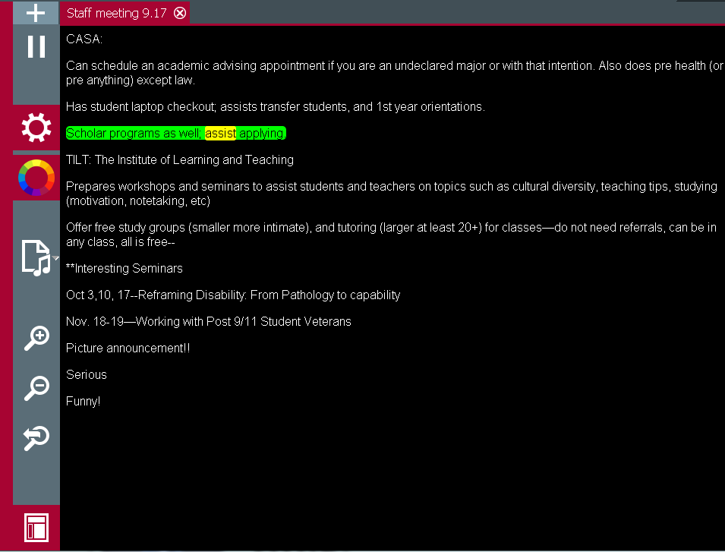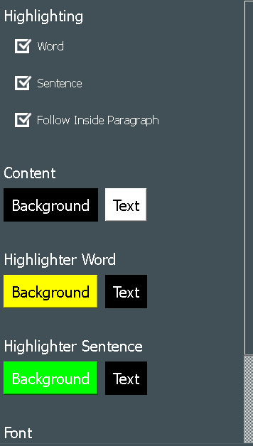
You can choose a preferred Word font to apply to the document and a preferred theme for the CAR window. If you do not like the new changes, you can reset using the Restore to Default Settings button.
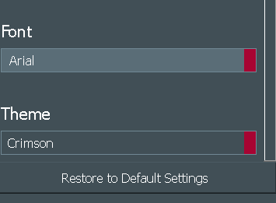

Zoom Settings
CAR enables you to enhance the magnification within a document. To increase the zoom,
- Go to the CAR toolbar
- Press the plus magnifying glass to incrase the zoom, or to decrease the zoom press the minus magnifying glass.
- To reset the magnification settings press the magnifying glass with the arrow.

Zoom Short Keys
- Zoom in: CTRL + =
- Zoom out: CTRL + -
- Zoom Reset: CTRL + Backspace

Exporting File Options

Convert to MP3
You can convert Word or text documents into MP3 audio files. To convert the loaded document:
- Press the convert button.
- In the dropdown menu, choose to save all or just save selected text.
- A pop-up menu will appear to save the new mp3 file in the preferred destination.
You can also access these options in the drop down menu in the top right corner for the CAR window. Go to MP3choose option.

Short Keys:
- Save All: CTRL +M
- Save selected text: CTRL +SHIFT+M

Export to HTML
You can also convert documents into HTML files.
- Press the convert button
- In the drop down menu, choose HTML.
- Choose where to save the file.

Math
CAR reads math symbols and problems that are created in Word using MathType. It can adjust the terms it uses to read different types of math, so you need to select the type of math in your document:
- Load the document
- Go to Settings button click on Math.
- In the drop down menu, choose from Calculus, General, Geometry, Linear Algebra, Logic or Statistics.
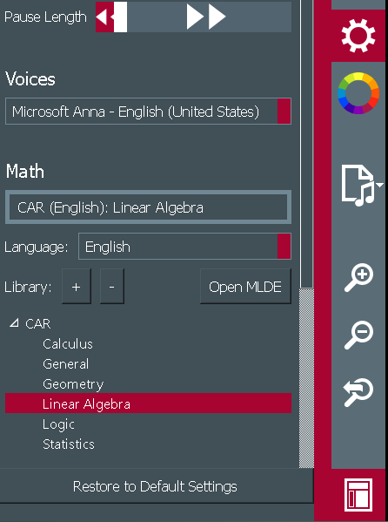

Advanced Feature: Creating Math with CAR
Open the Math Library Development Environment (MLDE) tool by clicking on the button in the general toolbar.
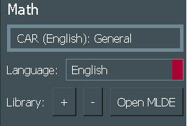
You can run math problems and equations with the Math Library Development Environment. To upload a document go to File Open from Library choose a document.
You can also copy math problems into the “Run” box or type them out using the Pattern menu on the left hand side of the MLDE window. This pattern menu has guides on how to type certain types of math with CAR.
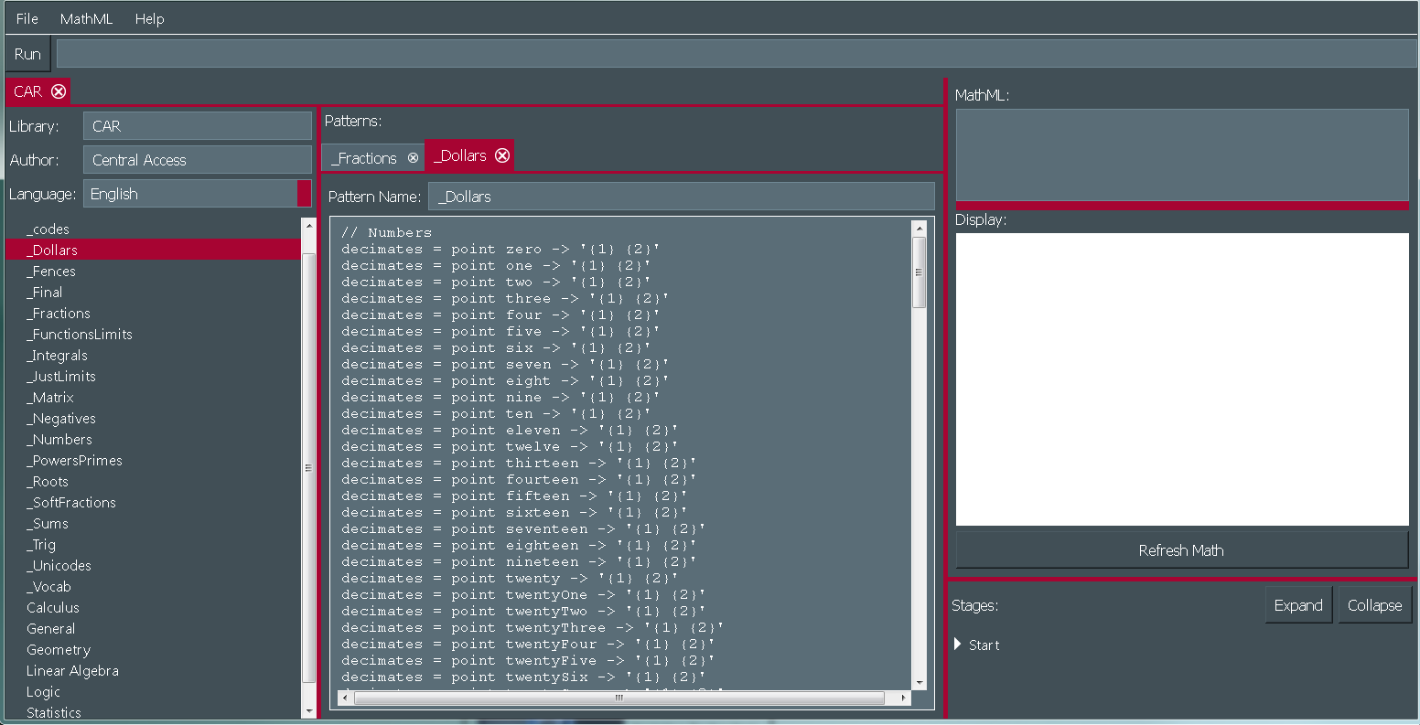

Help
For assistance you can access a Help menu.The Help menu is located in the drop down menu in the top right corner of the CAR window. Within this menu is Tutorials, Announcement, Quickstart, About, Report a Bug and Give Us Feedback options. Go to Helpchoose preferred option.

Program Manufacturer Contact Info
Central Washington University
CAR website (http://www.cwu.edu/central-access/reader)
Central Access Reader (CAR) is a free download for Mac (Mavericks, Mountain Lion or Yosemite OS) and Windows (64-bit only).

