OFFICE ERGONOMICS

Factors contributing to Cumulative Trauma Disorder (CTDs)
- Repetitive tasks
- Forceful exertions
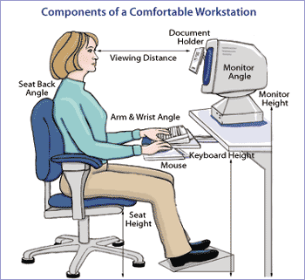
- Compression against a hard surface
- Awkward joint positions
- Lack of recovery time

Prevention Checklist:

Sitting
- Feet are flat on the floor or supported by a footrest
- Low Back is supported by lumbar support in chair
- Knee angle at approximately 90 degrees while sitting in your chair - Thighs are parallel to the floor
- Hip angle at approximately 90 to 110 degrees
- 1-2 inches of clearance between the front of the seat and back of your knees
- Keep shoulders, arms, and elbows relaxed close to body
- Head centered over body

Monitor
- Directly in front of person & approximately an arm’s length away
- Top of viewing screen at or slightly below eye level
- Adjust brightness and color settings to avoid glare or eye strain

Keyboard/Mouse
- Keyboard and mouse are positioned directly in front of person approx 2” from edge of desk
- Keyboard and mouse are next to each other to avoid excessive shoulder movement
- Elbow angle at approximately 90-120 degrees for comfort – forearms parallel to the floor
- Wrists are neutral when typing, mousing and resting

Accessories
- A document holder in line with the screen helps to avoid looking up and down at the monitor
- Task lighting eliminates glare, headaches and eye strain
- Keyboard and mouse rest provide a comfortable place to rest your wrists when not typing
- Position printer away from desk to encourage short breaks for walking and stretching

