Evernote - Quick Start Guide

Overview
Evernote is a program that allows you to make notes and sync them to the web so you have access to your notes, documents, images, web clips and audio notes wherever you go. You can access Evernote on a PC, Mac, tablet, iPad or a smartphone. Evernote will automatically sync your most recently saved files to all your devices so you can access your most up-to-date notes whenever you need. This program is great for keeping school and professional work organized and easily accessible. Menus may vary slightly depending on your version because Evernote is frequently updated.

To Use

Getting Started
- You can create your Evernote account by visiting the Evernote website (www.evernote.com) and clicking on Sign Up. Choose if you would like the free, plus or premium version. You may set up your personal account either after installing the program onto your electronic device.
- You can access your Evernote account by logging in online or you can open up the program from your computer desktop.

Notes
Notes are files that provide an array of useful tools. Evernote has a rich text editor, which allows you to change the font, size and color of the text.
You can easily access your notes either by clicking on the notebook in which they belong to or by Tagging your notes. A tag is simply a key word in the name of the note that helps you locate that note and others like it when searching by tags. Notes can have more than one tag. Using tags is another option in staying organized that is similar to using notebooks.
There are many items you can add to a note, including photos, voice memos, documents, PDFs, screen shots, reminders, check boxes for to-do lists, a chart maker and more. These items are found on the note menu bar.
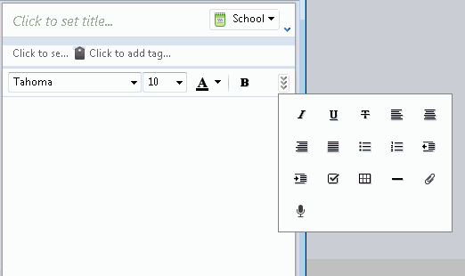

Creating and Organizing Notes
To create a note click on New Note. By making a new note, it will automatically be saved to your default notebook unless you otherwise specify. In the New Note drop box you’ll have choices of different types of notes.
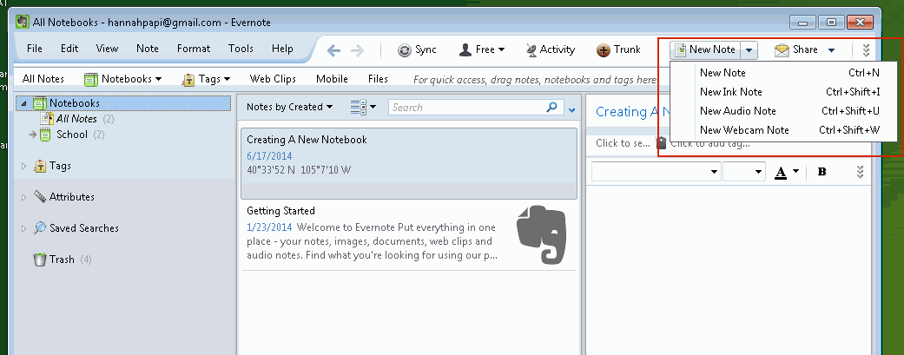
If the default notebook ends up not being the right notebook for that note, you can change the notebook that it is saved to by right clicking on the note and selecting Move to Notebook… from the menu. Select the notebook you would like your note to be moved to and click Move. You can also drag your note into the notebook you would like it in.
Because Evernote syncs very frequently, you don’t have to worry about saving your notes before closing Evernote.

Creating and Organizing Notebooks
Notebooks are folders that contain your notes. Notebooks help you keep your notes organized and easily accessible.
- To create a new notebook click File, then New Notebook.
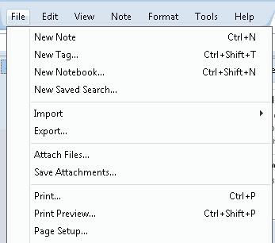
- You will be asked to create a Notebook name. Simply name it and click OK
- If you right click your notebook name, you can rename, delete, share and make it your default notebook.
  - A default notebook is where your new notes will automatically save if you do not otherwise specify the notebook you would like them to be saved to. You can simply move your notes to other notebooks if you wish to do so by dragging the note into the desired notebook or by right clicking the note and selecting Move To Notebook… from the menu and selecting the desired notebook.
- Although your Evernote will automatically sync every few minutes, you can still manually sync them simply by clicking on Sync. If you are without internet and edit a note, the note will sync as soon as you have service
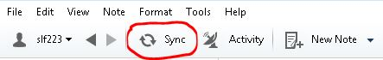

Sharing Notes
You can make your notes public by sharing them with social media networks such as Facebook or Twitter or email. Sharing your notes makes it easy to coordinate group work with other members.
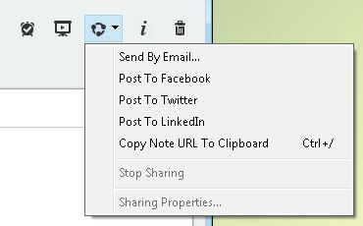

Attaching Files
You can attach files to your notes by selecting the paperclip in the toolbar above your note.
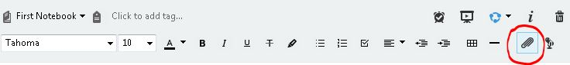
A window will open allowing you to select the file from your computer that you wish to attach to your note. Once you select the file click Open and the item will be placed into the note.

Web Clipper
Web clipper is an extension for your web browser that allows you to save articles, selected text, images and webpages in Evernote. Once saved, you can access these items offline. You are also able to annotate the saved items with highlighting and visual callouts such as arrows.
To clip to Evernote, select the Evernote symbol to the right of the address bar in your web browser.
You can select what type of clipping you would like (article, simplified article, full page, book mark, or screen shot) and then select Save.
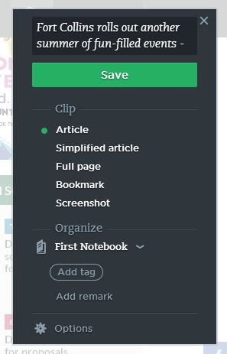

Once the clipping is saved you can share it through email, Facebook, Twitter, etc. by selecting Share.
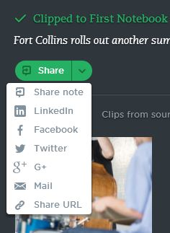
If you take a Screenshot of the page you can annotate the selection with highlighting, text, and visual callouts.
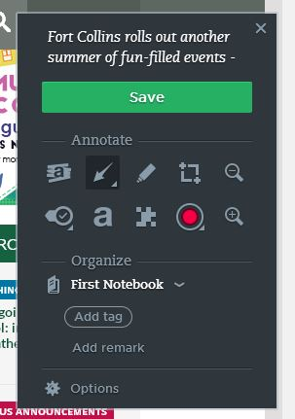
The web selection can also be edited and annotated within your saved note in Evernote.

Other Features
The atlas is a feature on Evernote that allows you to see where a note was made and modified. This can be helpful when your notes are being shared with a group to see when and where someone last updated it.
You can add users to your account. This will allow other users to access your notes and make changes to them as well as create their own. This is a great feature for class or work projects with others.

Product Information

Evernote can be downloaded from the Evernote website (www.evernote.com)
Evernote Basic is free
Evernote Plus is available for $24.99 per year
Evernote Premium is available for $49.99 per year

