Screen Shades for Mac – Quick Start Guide

Overview
Screen Shades is a free screen overlay program for Mac. You can adjust the color and brightness of your display to make reading on the screen less tiring.

To Download
Go to Mac Update Website (http://www.macupdate.com/app/mac/29478/screen-shades) and click on the Download bar towards the top of the screen.
After the .zip file has been downloaded, open it and accept the prompts to extract the contents. Then drag the Screen Shades icon into your Applications folder to install it.

To Use

Opening and Closing Screen Shades
To open the application, double-click on the Screen Shades icon in the Applications folder.
To close the application, click Screen Shades on the menu bar, and choose
Quit Screen Shades. You can also press Command + Q while the application is active, or click on the ‘x’ to close the window.

Adjusting the Color
Screen Shades is controlled by the Screen Shades window. In the upper left portion of the window is a drop-down menu for selecting which color tint you would like: Gray, Blue, Yellow, Pink, or My Tint.
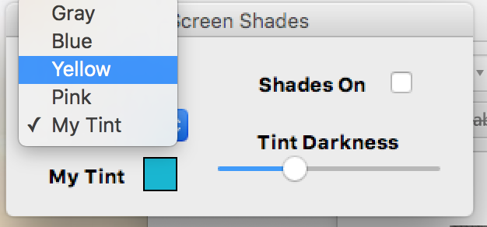
Selecting My Tint allows you to personalize this color. Click on the colored box next to My Tint to open the color selection window. Choose a color and click OK. This color will only be active if you also select My Tint in the dropdown menu.
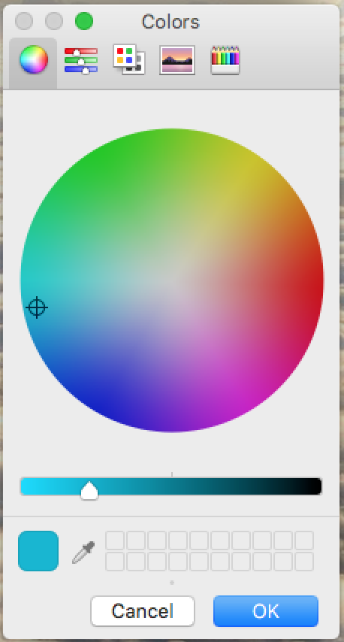
The darkness of the tint can be adjusted by moving the dot along the Tint Darkness scale.
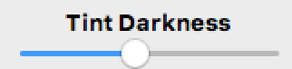
To turn the screen shading on and off without closing the application, you can check and uncheck the box next to Shades On.

Program Manufacturer Contact Info
Website: Mac Update Website (http://www.macupdate.com/app/mac/29478/screen-shades)

Cost of the product
Cost: Free

