RapidSet - Quick Start Guide

Overview
Allows quick and easy changing of the background and font colours, without having to go through the Screen Properties dialogs.

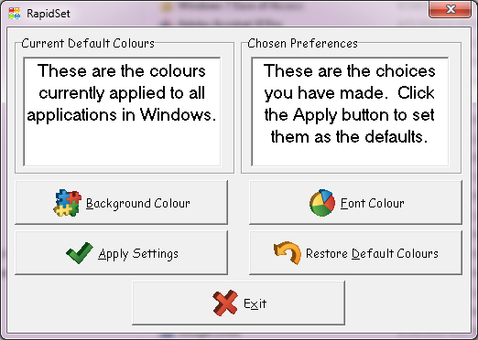

To Use

Background Colour
- Click Background Colour to change the default background color.
- Choose a color, or click Define Custom Colours
- Click OK
Now you should see your new background color in the Chosen Preferences window, so you can preview your changes before you make them.

Font Colour
- Click Font Colour to change the default font color.
- Choose a color, or click Define Custom Colours
- Click OK
Once you are happy with the way that the Chosen Preferences window looks, you can click Apply Settings. Now the Chosen Preferences window and the Current Default Colours window should match. You can now click Exit and use the settings you chose throughout Windows.

Restore Default Colours
Click Restore Default Colours if you want to undo any changed you might have made. This should change both of the preview windows to the original default colors of black and white font and background colors.

Program Manufacturer Contact Info
FX Software
Customer Support Email for RapidSet (chris@fx-software.co.uk)
Link to download RapidSet (http://www.fx-software.co.uk/assistive.htm)
This is a free software

