t

Built-in Screen Modifications for Windows 10:

Quick Start Guide

Overview
The following will help you change the appearance of your screen using built-in features already included on your PC (personal computer) which employs Windows as its operating system.

To Use

Color Inversion
Essentially color inversion flips to colors on the screen to the opposite color they appear normally.
- Fun fact: On PC’s, the magnifier must be on for Color Inversion to work.
- In the lower left corner of the screen, click on the Windows logo and begin typing: Magnifier
  - Magnifier should appear in the option menu, click on it and Magnifier will open
  - Once magnifier appears, you can use the following short cut to invert the colors on the screen: Ctrl-Alt-I (that is an uppercase i)
  - You screen should now be inverted! To stop inverting the colors, simply press Ctrl-Alt-I once again.
  - To close “Magnifier” click on the “x” in the corner of the application tab
    - 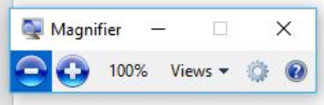
  - If magnifier does not open automatically, you can go into Settings (by searching for it using same search method above) and clicking on “Ease of Access,” and finally clicking on “Magnifier,” then toggle the switch to “on” (See next page)
    - You can directly search for Ease of Access, but for some reason, the appearance drastically changes than when you search for it through Settings…the method described here is much more user friendly in appearance.
    - 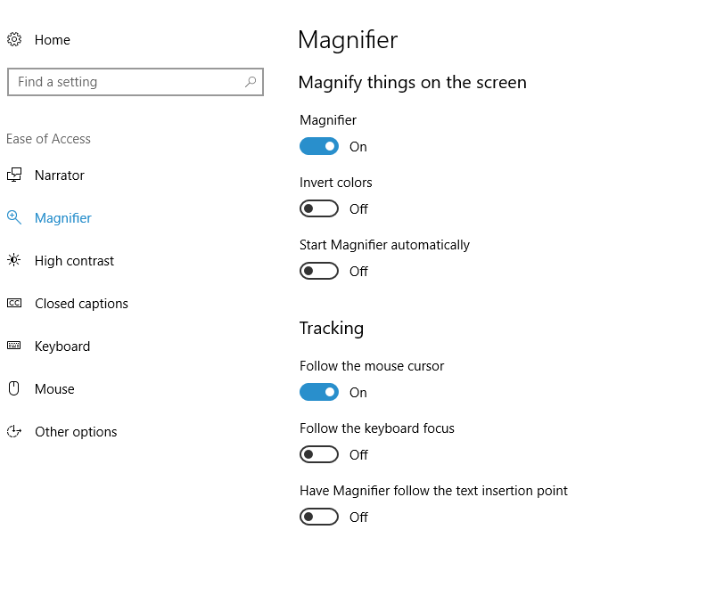
- From that same menu, you can toggle the switch for Invert Colors to on as well.

Color Filters
On laptop versions of PCs, the color filters option exists. On desktop monitors, buttons on the monitor manually control this feature (though not quite as well).
- Search for Settings using the Windows menu key in the lower left corner of the screen
- Click on “Ease of Access”
- Click on “Color Filters”
  - Here you can toggle the “Color Filters” switch to on, and can choose from an array of filters
    - Inverted
    - Grayscale
    - Grayscale inverted
    - Other filters to support colorblindness
  - Select the option that is right for you

Brightness
Like color filters, this option is controlled on the monitor of desktop PCs through buttons on the front; the following directions are for use on laptop PCs.
- Search for Settings using the Windows menu key in the lower left corner of the screen
- Click on “Ease of Access”
- Click on “Display”
- Use the slider to adjust the display to a brightness that works for you!
  - 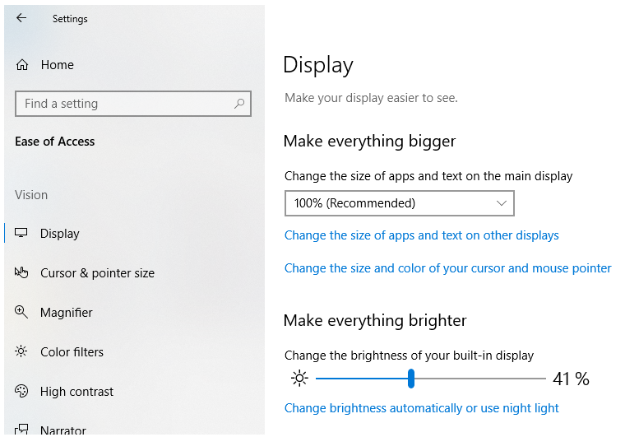
- Alternatively, you can access the display by right-clicking on the desktop screen of your device and selecting “Display” from the dropdown menu that appears.

High Contrast
- Search for Settings using the Windows menu key in the lower left corner of the screen
- Click on “Ease of Access”
- Click on “High Contrast”
- Select “High Contrast #1” from the Choose a Theme drop down menu (see next page)
- From here, you can click on each individual box and set a color that works for your eyes.
  - These options will save until they are changed and the next time you open “High Contrast #1” you will open your previously selected colors.
  - 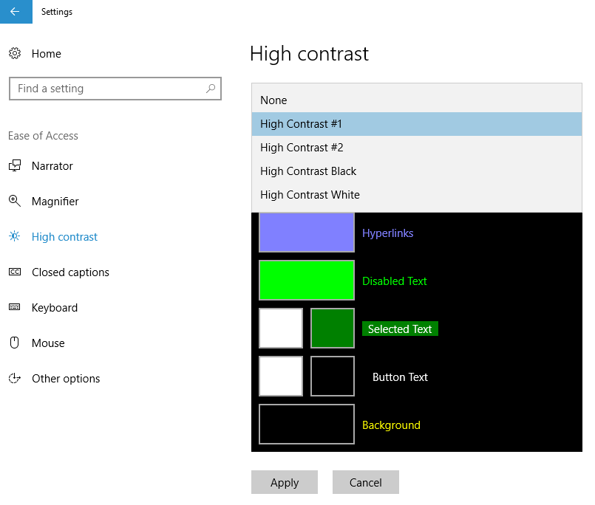

Night Light

- Search for Settings using the Windows menu key in the lower left corner of the screen
- Click on “Ease of Access”
- Click on “Display”
  - Alternatively, you can access the display by right-clicking on the desktop screen of your device and selecting “Display” from the dropdown menu that appears.
- Look for the “Night Light” option (it’s below Brightness) and slide the toggle to “on”
  - 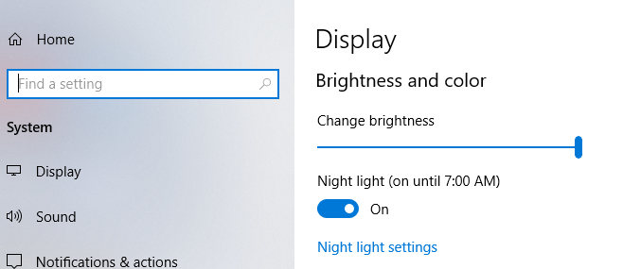
  - Click on “Night light settings” to change the color shade
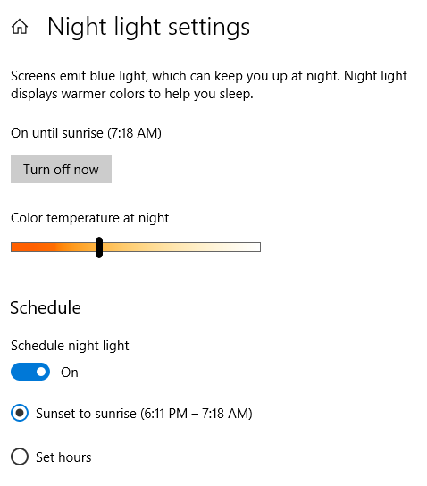
  - Click on “Set Hours” for a custom experience
