Quick Start Guide: Read&Write 12

Overview
Read&Write is a software that provides a variety of reading and writing supports that are helpful for computer users, including people with disabilities. This QuickStart Guide is for Read&Write 12 for Windows, and is designed to assist computer users as they navigate Read&Write’s basic functions. This guide has been written for those using Read&Write on a PC computer. More information and detailed instructions are available from the TextHelp website, which provides a more comprehensive training guide for PCs (https://www.texthelp.com/Uploads/MediaLibrary/texthelp/US-Training-Documents/Read-Write-for-Windows-Training-Guide-USA-Jan-2019.pdf).
For Mac users: The latest Read&Write update for Macs (Read&Write 7) is very similar to the PC version. It has a slightly different design, but the icon pictures look similar and this guide should give you an idea of how to navigate the program. For more specific information and detailed instruction to use this program on Mac computers, please find the comprehensive training guide for Macs (https://www.texthelp.com/Uploads/MediaLibrary/texthelp/US-Training-Documents/Read-Write-7-For-Mac-USA-Training-Guide-Jan-2019v2.pdf).

To Use
First, open the Read&Write application and log in.
- Double-click on the Read&Write icon.
- To log in, click the icon in the top right-hand corner of the screen. The following pop-up will appear:
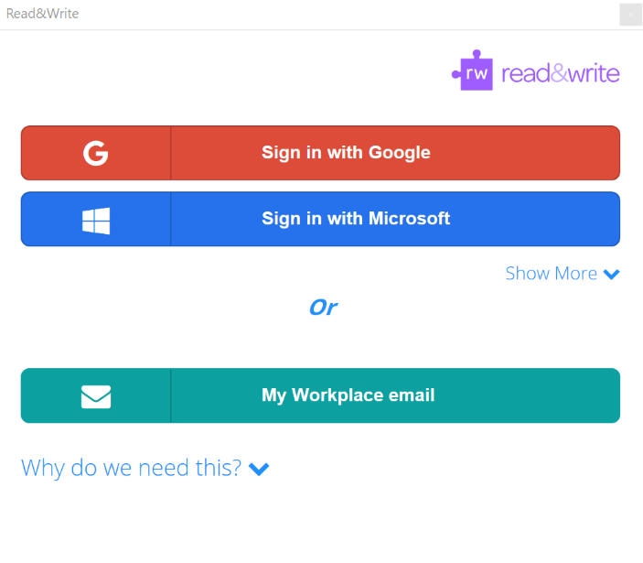
CSU students with an @rams.colostate email account will sign in using Google (note: if this does not work, try signing in with Microsoft but leave ‘rams.’out of your email. For an Exchange/Outlook @colostate account, sign in with Microsoft. Your username will be your CSU email (eid@colostate.edu) and password will be the same that you use to log into other CSU websites and applications.

Toolbar and Commonly Used Tools
When you open the application, the Read&Write toolbar will appear at the top of your screen. While this is the default setting, it can also be docked at the side or bottom of your screen by clicking and dragging the toolbar to the desired side of the computer screen, where it will automatically rearrange itself.

Check It
The Check It tool is used to identify potential grammar and spelling errors in your writing. When you would like to check a document for errors, click the Check It icon and a small box will appear on your screen:
Clicking the red expansion button will open the full Check It window, which goes through errors one by one. Here you can decide whether to add custom word spellings to your personal dictionary or correct mistakes as identified by Check It.
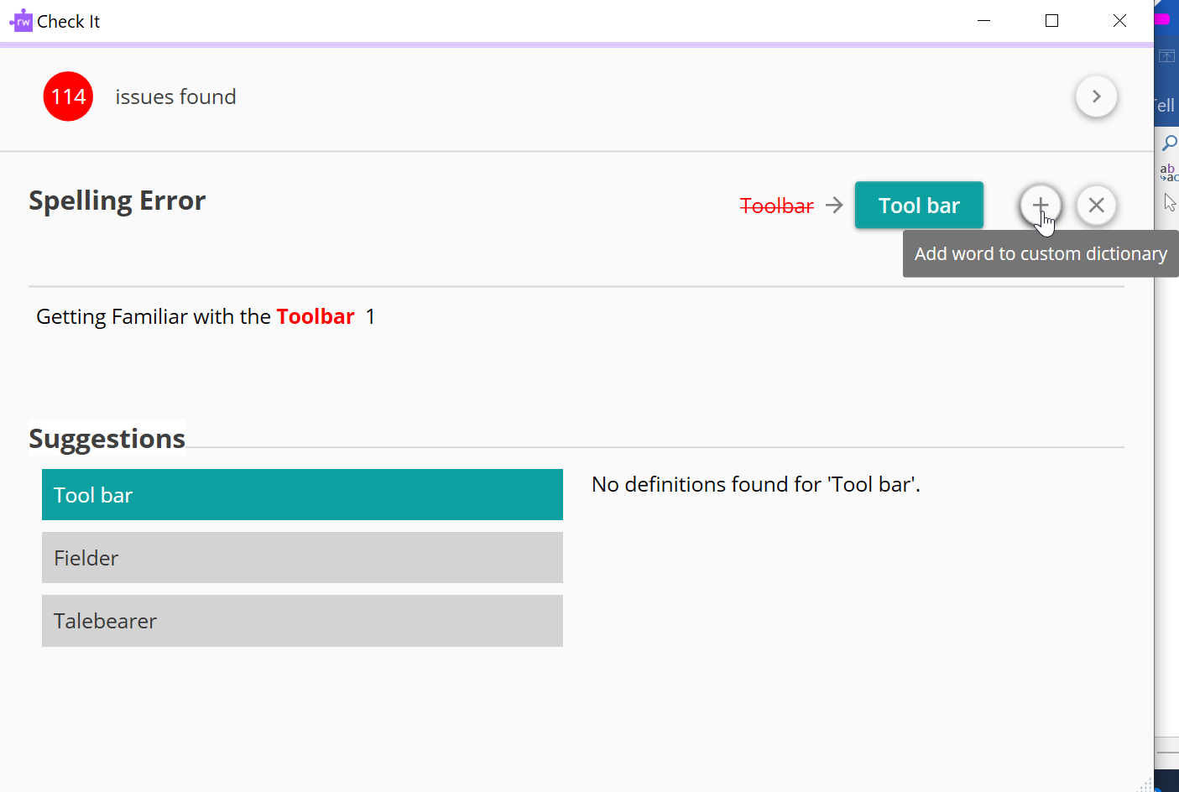

Prediction
The Prediction tool will open a small menu that offers keyboard shortcuts to expand words as you type and predict what you will type next in order to reduce the number of keystrokes you must use as you type.
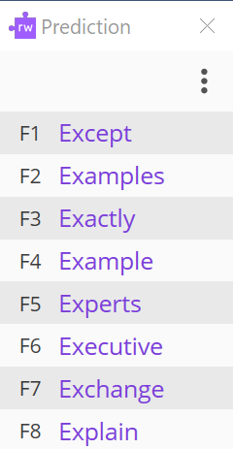

Dictionaries
If you need the definition for a word, you can use the Dictionary tool to view definitions immediately. Simply highlight the word you have a question about and click the Dictionary icon to view definitions of that word.
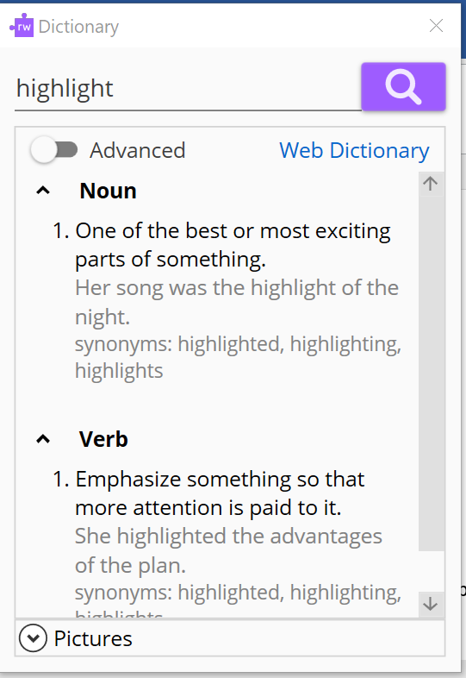
By default, the dictionary menu shows simple definitions that are limited to only a few options. Clicking on the “Advanced” button will open additional definitions. Additionally, you can click on “Web Dictionary” to automatically open a Google search for the highlighted term, or expand the “Pictures” menu to search for an image of the term you have selected.
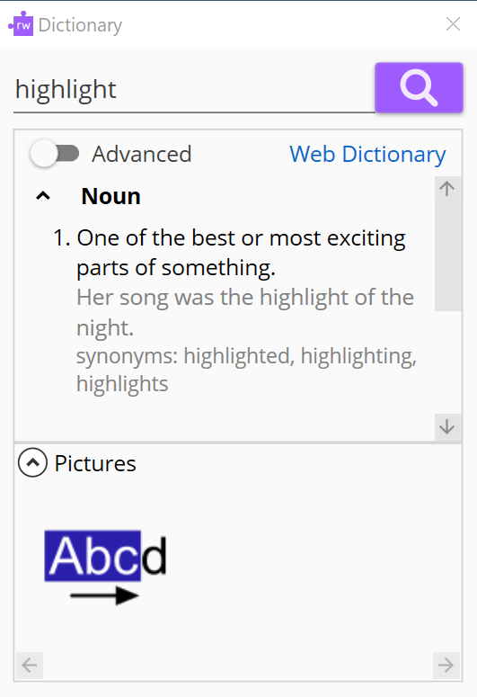
The Picture Dictionary allows you to search for a term you’re unfamiliar with to find an image of it. You can use it in the same way as the normal dictionary tool, by highlighting a word and then clicking on the Picture Dictionary icon. You can also open the Picture Dictionary and directly type the word in there.

Text-to-Speech
The next set of menu items are the playback buttons, which work with Read&Write’s text-to-speech feature to read documents displayed on your computer screen.
If you are in a Word document and click the Play button, Read&Write begins reading the sentence where your cursor is located, highlighting a sentence at a time (or a paragraph at a time, depending on what your ‘Reading Unit’ is set to). As it reads, each word is also individually highlighted as shown in the below example:
You may use the Rewind/Forward keys to go backward or forward one sentence at a time, Pause to temporarily stop playback, or Stop to discontinue playback until you click Play again. The text-to-speech feature can also be used for PDF documents (see below under “Reading PDF Documents”).

Screenshot Reader
The Screenshot Reader is useful in cases where some text appears in an image, which Read&Write may not recognize as readable. To use, click the ScreenShot Reader . Your cursor will turn into a plus sign, which you can then click and drag to create a screenshot of the desired text. Read&Write will read the text aloud after a moment, after which you can re-read by selecting the play button within the window or exit by clicking the X.
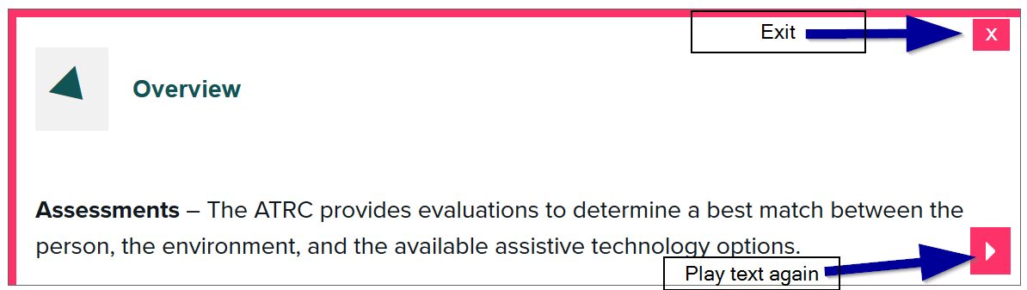

Scanner
The Scanner can be used to ensure that any documents you scan and save on your computer are recognized by Optical Character Recognition (OCR), which ensures that they can be read by Read&Write or other assistive technology. To use, click the icon and designate the proper scanner and desired file output (Word or PDF).
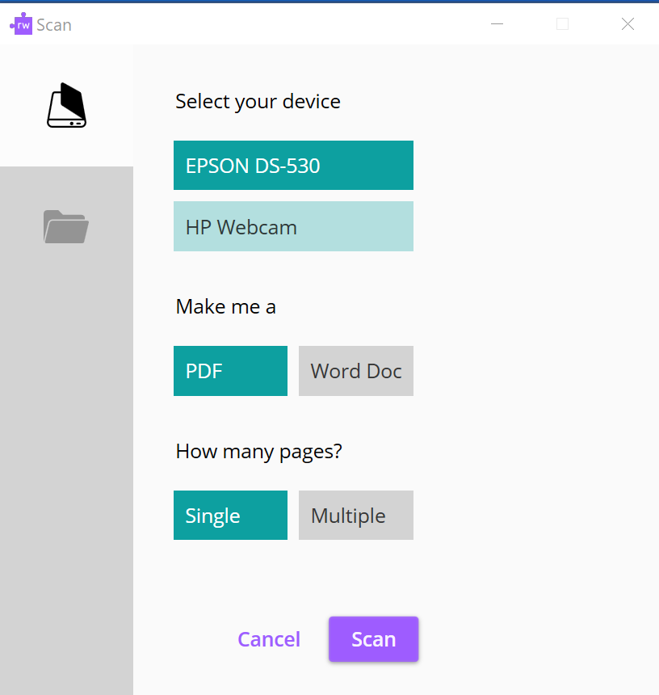
The Scanner can also be used to make PDF documents accessible as outlined in the below section titled “Reading PDF Documents.”

Audio Maker
The Audio Maker tool allows users to create an MP3 audio file from selected text, so that it can be listened to on mobile devices as well as the computer. To use Audio Maker, first highlight the desired text and then click the Audio Maker icon . The text you highlighted will appear in the Audio Maker panel that pops up. You can then preview the audio to see what the MP3 will sound like, choose the folder where you would like the MP3 file to be saved, and create the file. Then simply double-click on the file to open and listen to it.
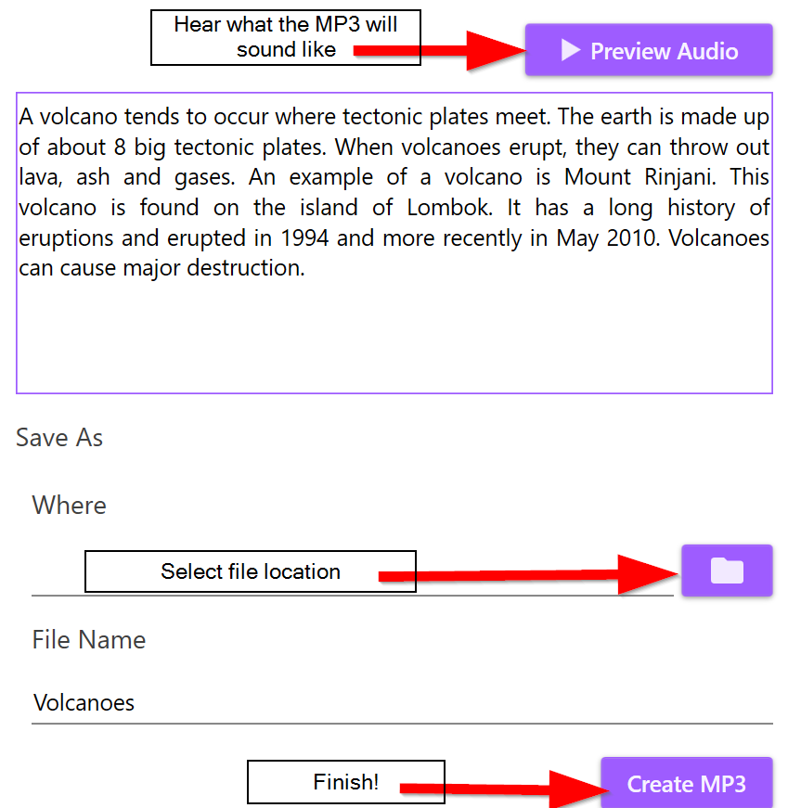

Screen Masking
Another benefit of Read&Write is that it allows the user to change the tint of their computer screen. To test this, click the Screen Masking tool . The screen now has a light blue tint and a small menu appears. From here, you can click and drag the screen masking menu around on your screen, open the settings menu, or turn off screen masking. Note: to change screen masking settings in Read & Write for Mac, go to settings>screen masking.
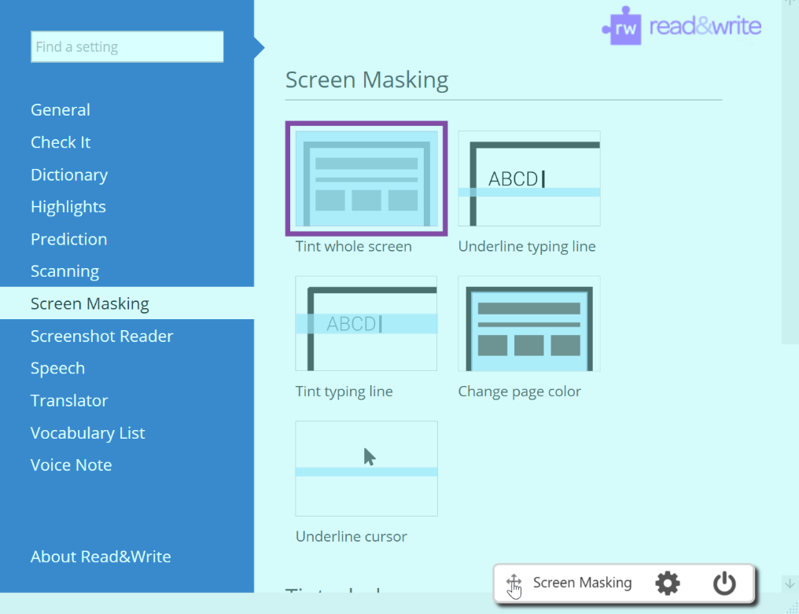
Within the settings menu, you can personalize the screen mask by changing the color and opacity of the tint. There are also options to create just one bar across the screen that will follow your typing line, underline your cursor on the screen, or tint the whole screen and turn on a reading ruler. By changing the color and opacity settings, this can be used as a digital reading ruler as seen in the example below.
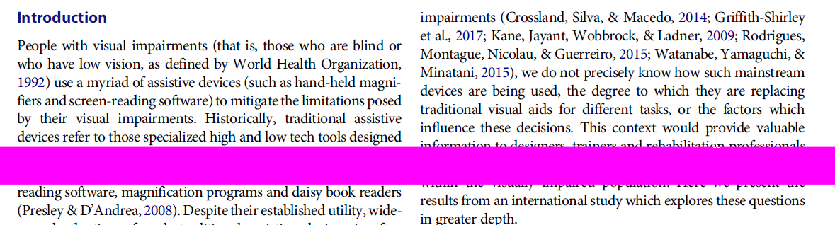
Experiment with these settings to find the best solution for your own computer use.

Talk&Type
The Talk&Type tool is a dictation tool that allows users to navigate the computer using their voice rather than by typing. When you first click on this tool, a Speech Recognition Voice Training Wizard is displayed:
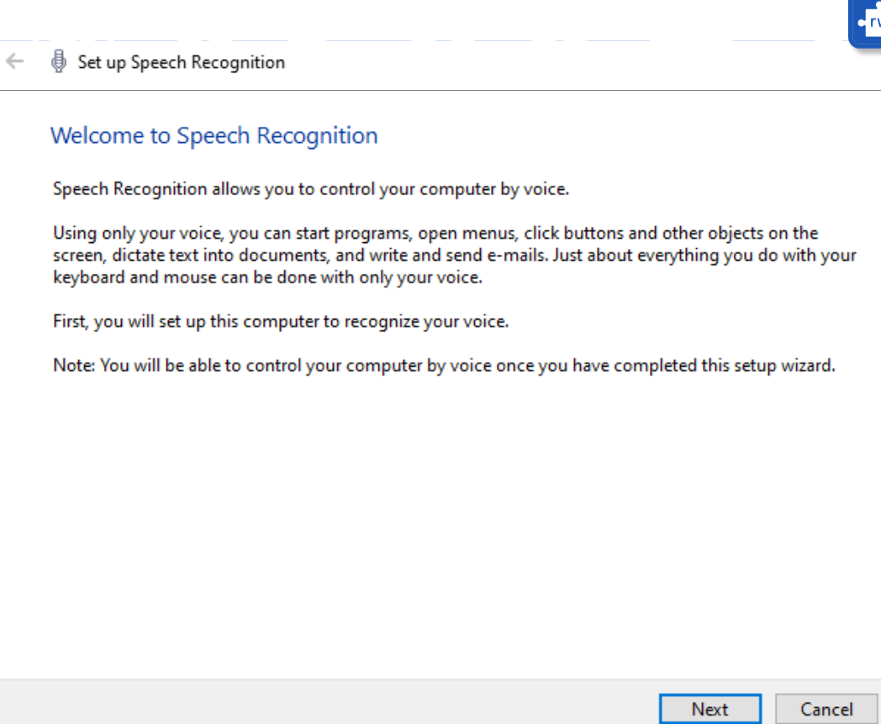
This is a first-time set-up that guides you through setting up your microphone and training Talk&Type to recognize your voice. You will be able to select the type of microphone you are using, whether you prefer manual or voice activation to begin using Talk&Type, and whether you’d like speech recognition to start up every time your computer turns on.
When Talk&Type is finished setting up, it will open a small drop-down box that will show when the microphone is listening for commands. This is how Talk&Type will look every time you open it after completing the set-up wizard.
From here, you can either click on the microphone on the left-hand side to activate or deactivate Speech Recognition or (if you set it up to be voice activated) you can say “Start Listening” and “Stop Listening.” When Speech Recognition is on, you can use it to write, open and close applications, and a wide variety of other commands. You can learn more about these by visiting Windows Speech Recognition Commands (https://support.microsoft.com/en-us/help/12427/windows-speech-recognition-commands).

Translator
The Translator tool assists users in translating text. First, you will want to click on the Settings menu and navigate to Translator to select the languages you are working with.
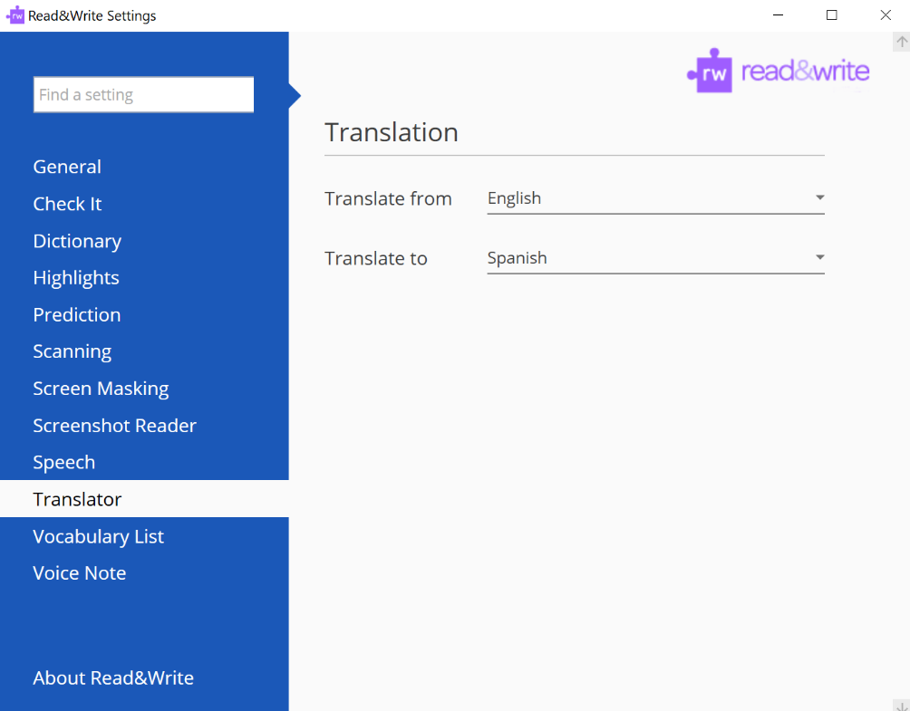
Then simply highlight a section of text and click on the Translator icon. It will open a new browser window that shows the translation to the desired language.
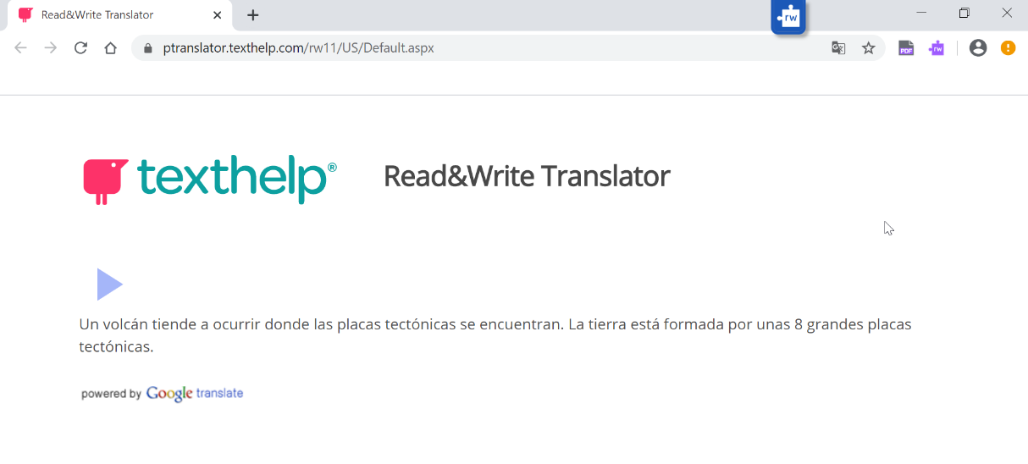

Reading PDF Documents
In addition to Word documents, Read&Write can read PDFs. First, click on the PDF Reader and open the desired PDF file. Then click on some of the text to test whether the text-to-speech function is operating fully.
If the text has not been OCR’ed, Read&Write may only read a line at a time rather than recognizing full sentences, forcing you to manually click through the document one line at a time as seen below, or Read&Write may not be able to read the text at all.
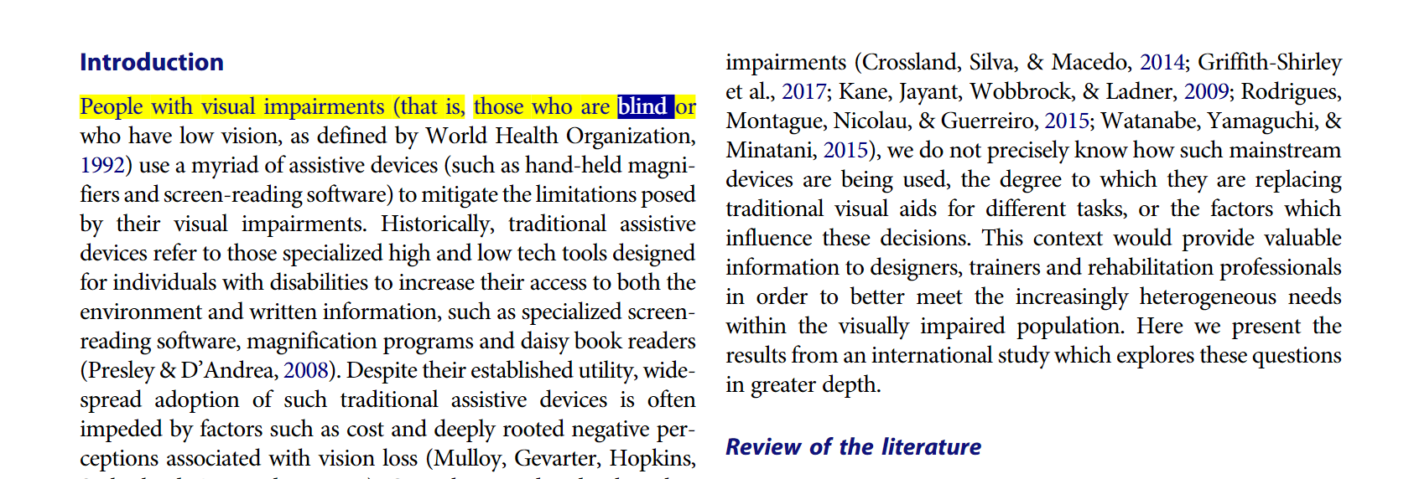
In order to make sure the full document will be read correctly, use the Scanner to scan your document before reading it.
- Click the Scan icon.
- Within the Scan menu, click the file folder to upload a PDF file.
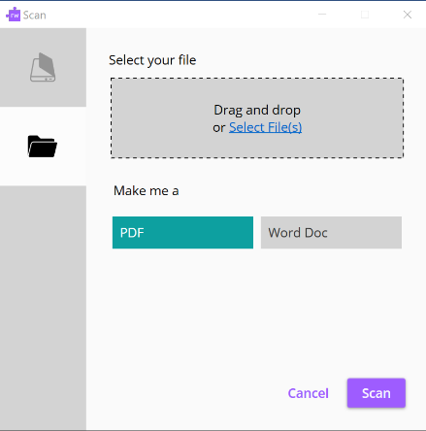
- Decide whether you want your document to end up in PDF or Word format and click “Scan.” Save the file to the location of your choosing. When the scan is complete, your document will open and is ready for playback.
Note: As a general rule, Read&Write tends to work better with Word documents than PDFs.

Highlighting
The final set of tools on the toolbar are the highlighters . Use these to highlight portions of text while you are studying. Erase highlights by clicking the highlight eraser icon.
When you are done highlighting, you can click the color wheel icon , which collects everything you have highlighted up to this point and exports it into a new Word document, organizing the highlights by color. It also inserts a bibliography at the bottom of the page. This can be a useful study tool, allowing the user to collect notes and study points by topic.

Voice Note
When you are working on a document in Word, you can use the Voice Note tool to insert audio comments. To try, click the Voice Note icon and a panel will appear:
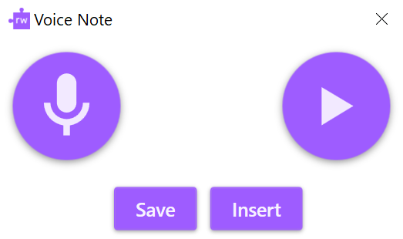
You can then click on the microphone button to begin the audio recording and speak into your microphone. When you’ve finished, click Stop. You can replay the Voice Note by clicking on Play or click on Insert to add it to your document as a comment. It will appear in your Word sidebar:
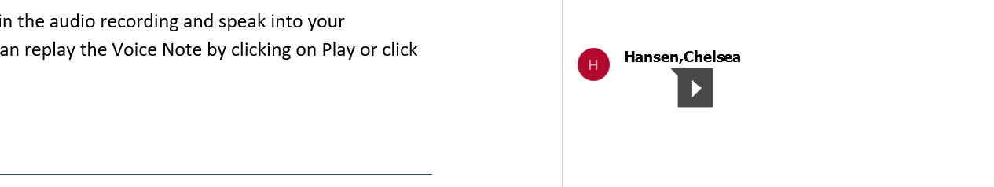

Some Common Settings

Changing Your Settings
Navigate to the advanced settings menu by clicking the Settings icon and then on the words “Show more settings.” This will open a menu with several options to adjust settings for each of the tools that Read&Write provides.
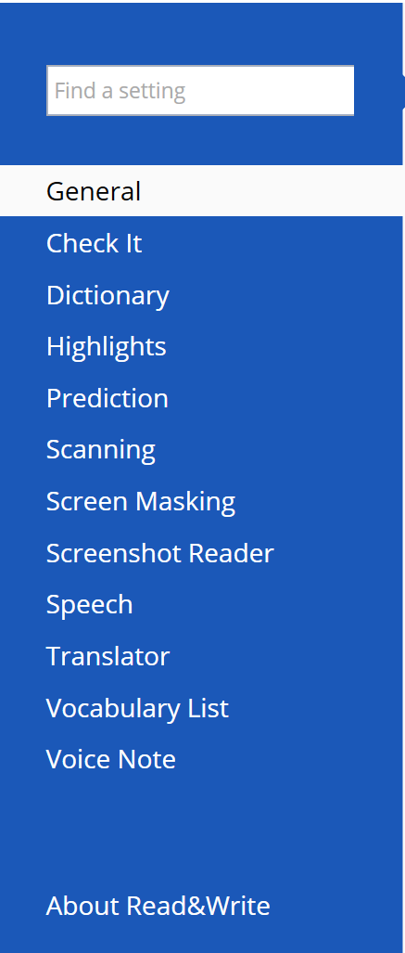

Customizing the Toolbar
To change the look of your Read&Write toolbar, click on General within the advanced settings menu. Here you can choose how large or small the icons in your toolbar appear, change the color of the toolbar, choose whether Read&Write should launch every time you log into your computer, and change the reference style for your bibliography.
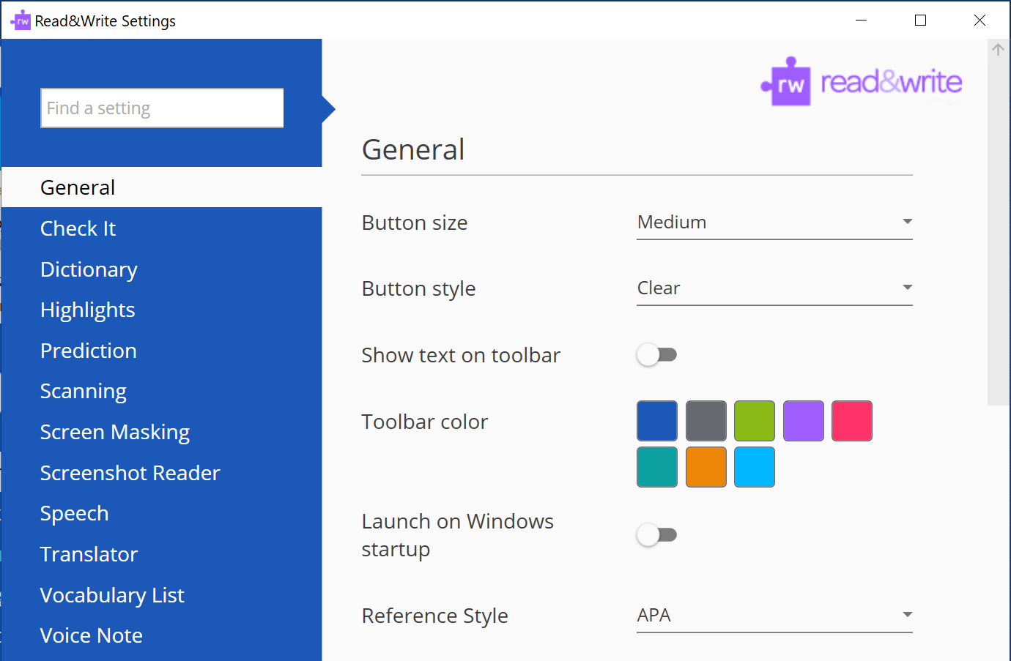
You can also choose which icons appear in your toolbar. If there are tools you know you are less likely to use, you can remove them by scrolling to “Features” and de-selecting the icons you don’t want in your toolbar. These can be added back at any time.
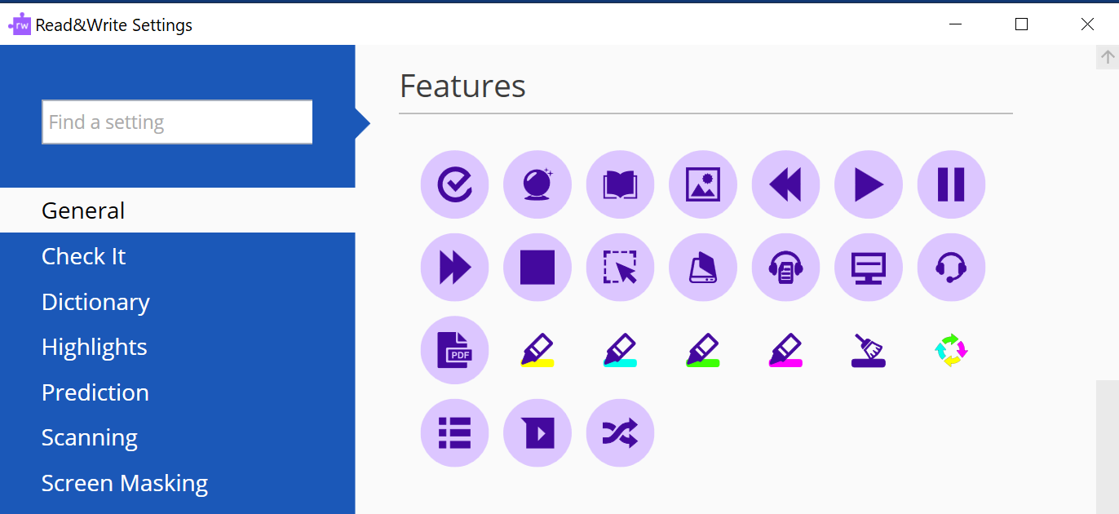

Changing Text-To-Speech Settings
To change the voice settings for text-to-speech, click on Speech within the advanced menu. Within this menu, you can change several settings for the playback voice, including accent, speed, voice pitch, length of pauses between words, and more.
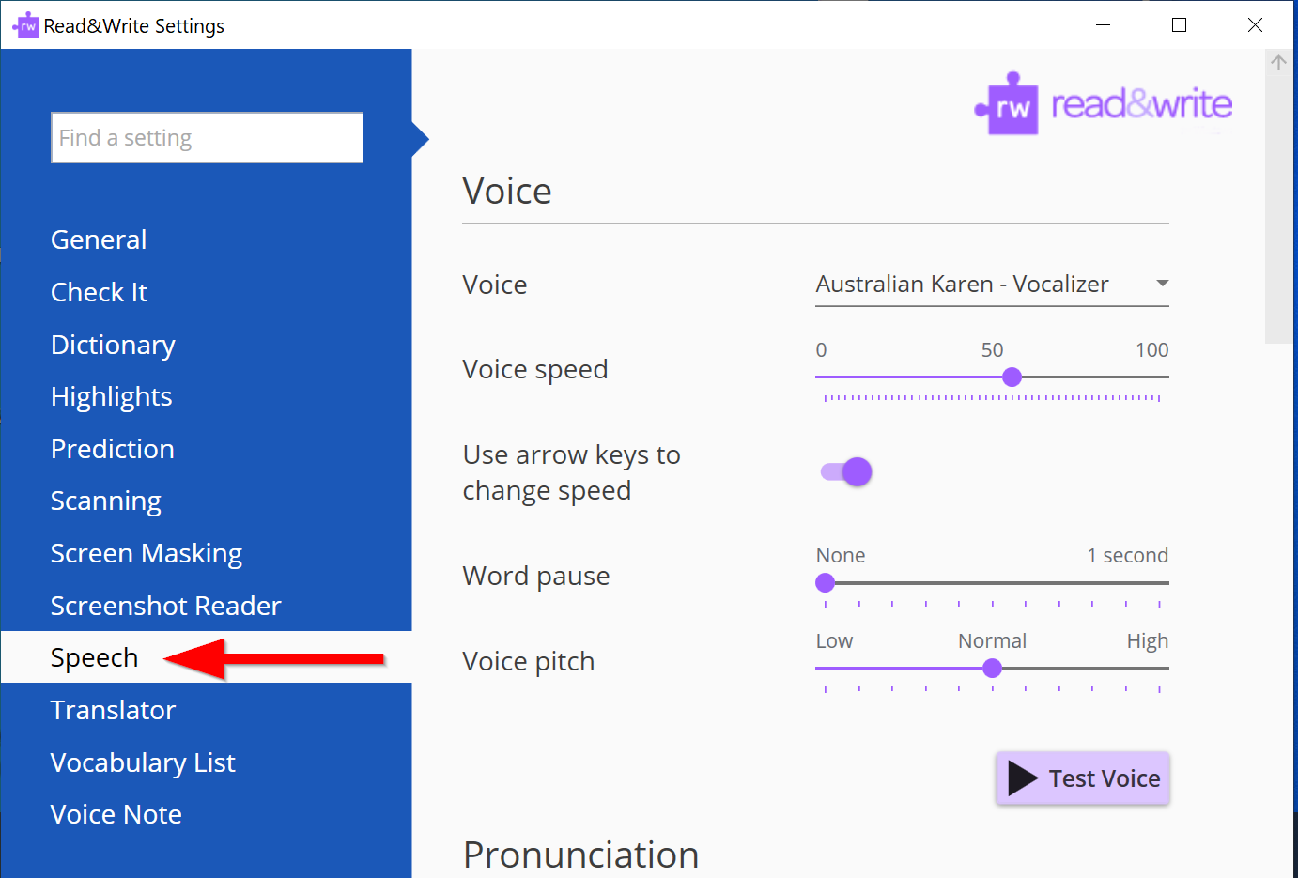
Some people find that choosing a voice with a different accent than they normally hear makes the text-to-speech sound less robotic and more pleasant to listen to. Test out different voices and settings to make playback sound most comfortable for you.

Advanced Features

Read the Web
Read&Write can read websites in addition to Word and PDF documents; however, depending on your browser, it may take some additional set-up. Firefox and Google Chrome each require that you install a plug-in/extension before Read&Write will be compatible with them, so follow the prompts on your browser to install the extension. Read&Write also works with Internet Explorer and does not require an additional plug-in for this browser.
To read websites, begin by selecting the menu button and switching on the “Read the Web” Function.
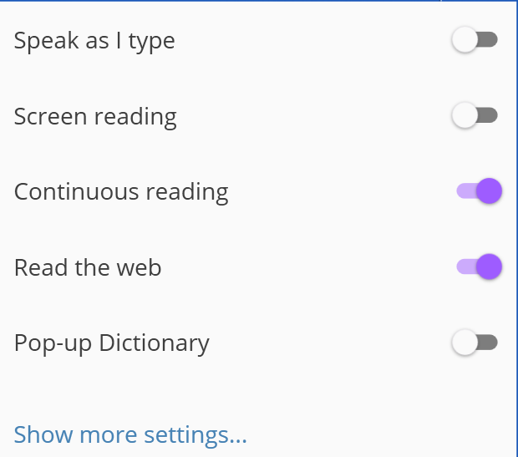
Then, when you open a website, simply hover your mouse over an area of text until you see it highlighted, and you will hear the text read aloud. Anything under your mouse will be read as you navigate through websites.

Highlighter Settings
You can change highlighter and export settings within the Highlights menu. Choose how many highlight colors you want Read&Write to collect and how you want them organized when you export them using the color wheel tool.
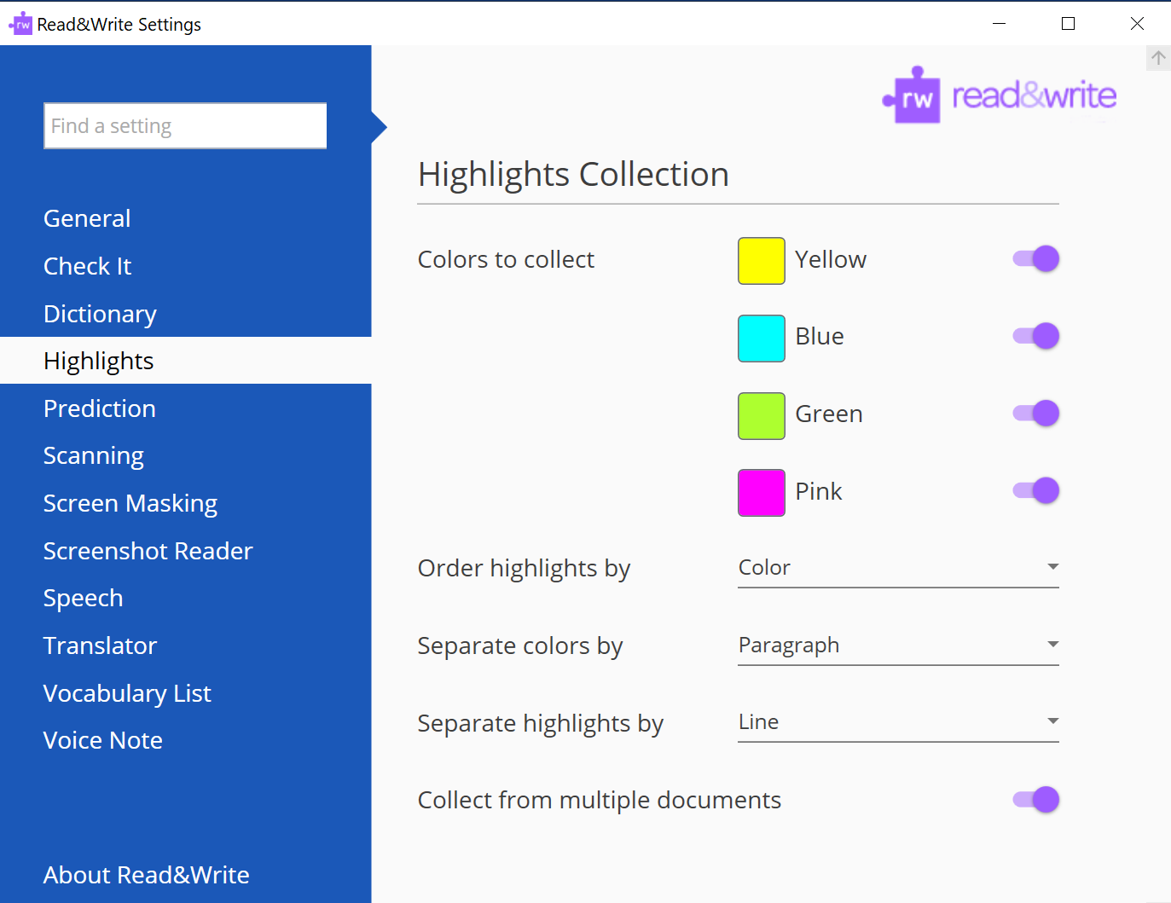

Screenshot Reader
Alter how you would like to capture screenshots within the Screenshot Reader menu. Here you can choose to select the screenshot area by drawing a rectangle, drawing freely, or hovering over the desired screenshot area.
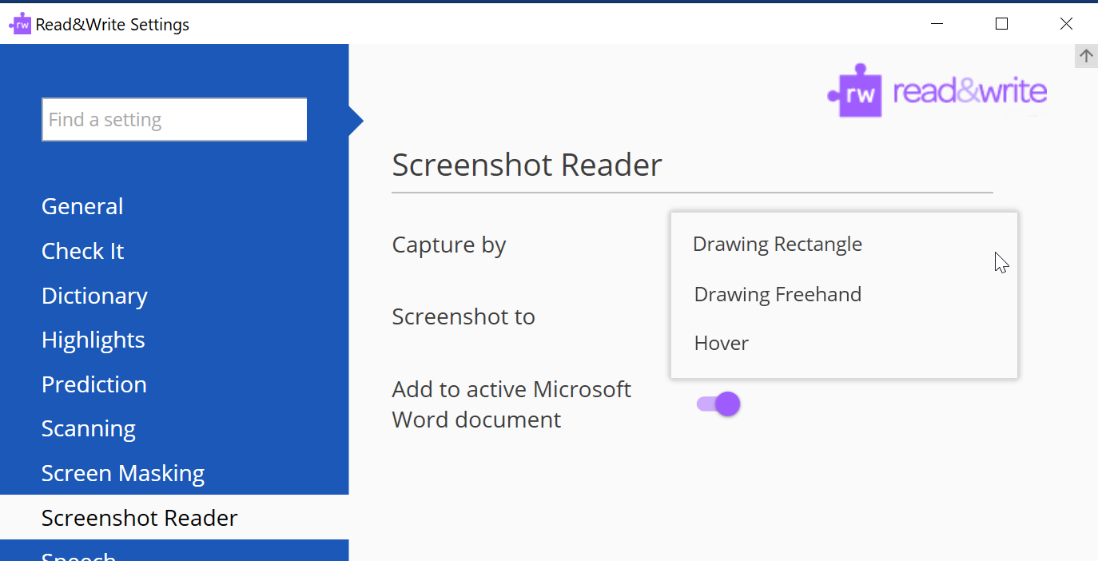

More Speech Settings
In addition to changing the way the reading voice sounds, you can customize the way Read&Write pronounces certain words, how much of the screen is read, and how you would like the highlighted sections to look while text-to-speech is activated.
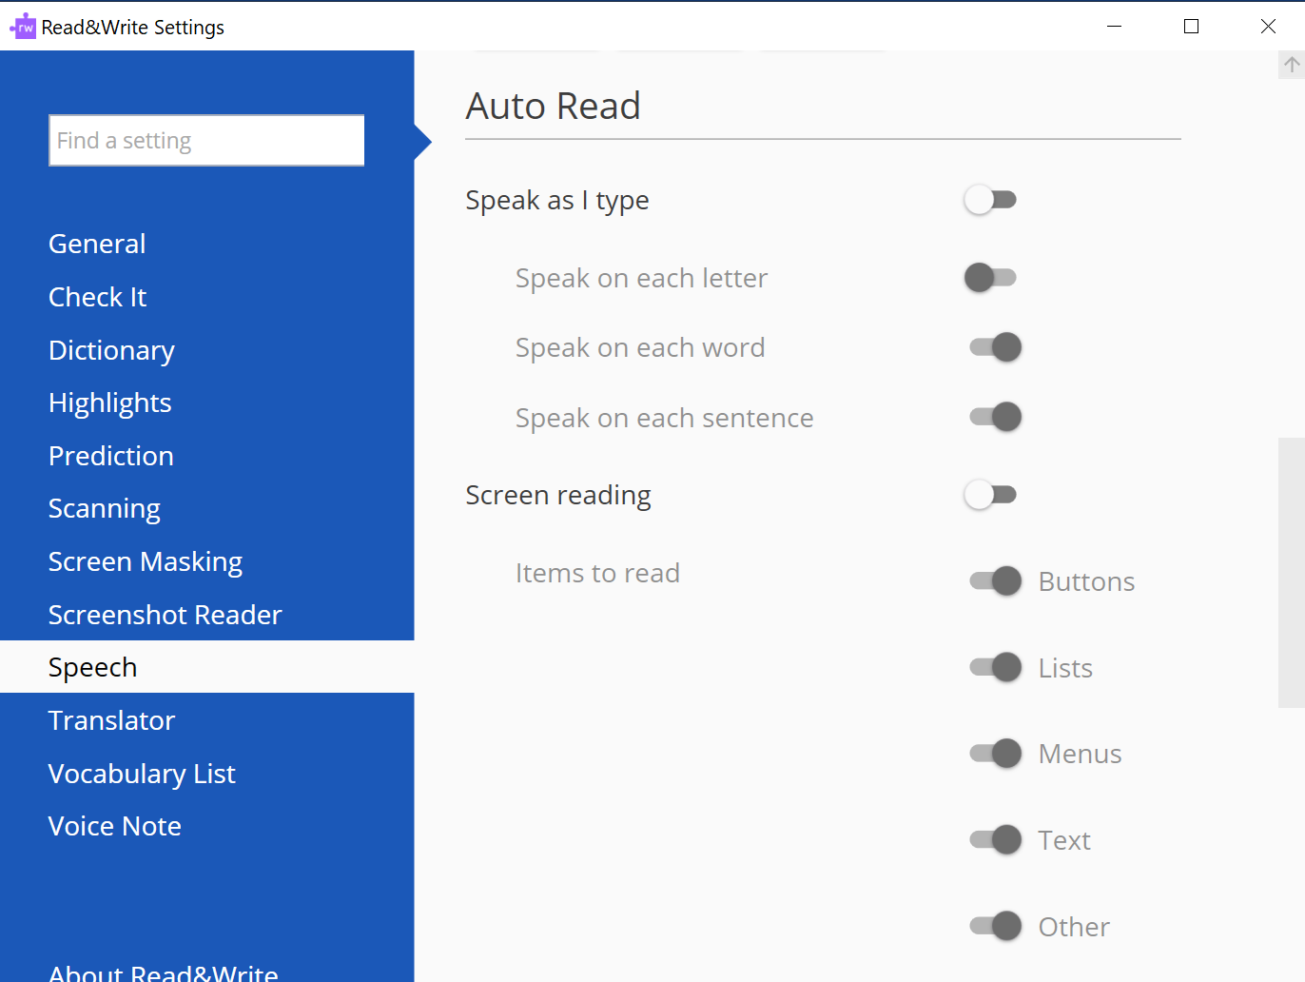
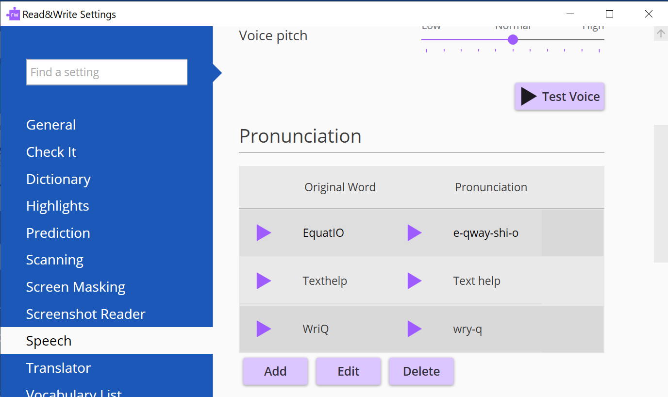

Read&Write Contact Information
Read&Write is a TextHelp product. To learn more, visit the Read&Write website at http://www.texthelp.com/en-us/products/read-write/.
Texthelp Inc.
500 Unicorn Park Drive
Woburn, MA 01801
Phone #: 888-248-0652
Fax #: 866-248-0652
Email: u.s.info@texthelp.com

