Reading e-Textbooks with AT

Overview
Increasingly, textbooks are being delivered online (Adaptive Courseware) or in a new file format (EPUB). This creates new challenges for users of Assistive Technology (AT):
- Online textbooks are often locked down by the publishers for copyright reasons, which unfortunately makes them inaccessible to many assistive technologies.
- Students often still need to request an accessible format through the Student Disability Center (SDC) in order to be able to utilize their AT.
- Accessible texts received through the SDC are now increasingly provided by the publishers in a new format (EPUB) rather than PDF.
- Not all assistive technology is capable of reading EPUB files, and not all features are fully available, although the hope is that the AT will improve in this area.
This guide shows how to read online textbooks and EPUBs with Kurzweil 3000 and Read&Write. The guide will also introduce VitalSource, a reading app that is required by some publishers to read their EPUB files.

Understanding Types of E-Textbooks

Adaptive Courseware / Online Textbooks
Adaptive Courseware is delivered on the web, often through a link from Canvas or a direct link from the publisher or bookstore when students purchase a textbook. These e-Textbooks are called Adaptive Courseware because they include not only the text, but also online assignments and other interactive aspects of a course.
- Often, Adaptive Courseware is not usable with AT such as Read&Write or Kurzweil 3000.
- In this case, students will still need to request an accessible format from the Student Disability Center, just as with paper textbooks.
- Students may also not be able to access the interactive assignments, so an alternative should be considered for how they can complete those assignments in an equivalent manner.

Accessible Texts Obtained through the SDC
Publishers are increasingly providing EPUB files instead of PDFs when students request an alternative format. Even if a student’s preferred format is PDF, the publisher may provide an EPUB file instead. The AT will look different if you get an EPUB file, and not all features will be available.
- Availability of specific features may depend on the EPUB file itself.
Below you’ll see how you can read EPUBs with Kurzweil 3000, Read&Write, and VitalSource Bookshelf.

Kurzweil 3000

Kurzweil Workarounds for Online Textbooks
- Image reader
  - The Image Reader is a tool that lets you select an image that you want to read. To select an image:
    - Open the image that you want to read (a web page, for example).
    - Choose Image Reader from the Kurzweil 3000 Read menu. The Kurzweil window closes and the cursor changes to crosshairs.
    - Use the crosshairs to select any text, including content that is not usually selectable.
    - The Kurzweil window reopens and displays the text for you to read.
    - Click the Read button to read the text. When you are finished, you can Close the text or Save it.
- Read the Web
  - Install the Read the Web extension for Firefox or Chrome.
  - Click the “Read the Web” button
    - In the address box of the “Read the Web” window, specify the desired Web site address then press return.
  - To read the web page, click the “Read” button in the Read the Web toolbar
  - To change reading settings, use the “Read Mode”, “Read By” and “WPM” menus
  - Note – if Read the Web does not work and the student has a Mac, try the Mac built in text to speech feature on the online textbook. This occasionally works.

Kurzweil for PC (EPUB)
- Log in to the software version of Kurzweil and go to “Open Existing File.” Choose the location of the EPUB file you want to open.
- Save the EPUB file as a kesi file and reopen.
Available features:
- Text-to-speech with highlighting
- Voice selection & speed adjustment
- Highlighting
- Voice notes
- Bookmarking
- Dictionary
- Picture dictionary
- Add/edit hyperlink
- Add a footnote
- Open column note
Concerns:
- Larger files may freeze
- Extract highlights was very buggy
- No thumbnail view

Kurzweil for Mac (EPUB)
- Kurzweil for Mac cannot currently open EPUB files
- Students can use the online version of Kurzweil instead (see next section)

Kurzweil 3000 Online (EPUB – Mac & PC)
The installed version of Kurzweil for Mac does not have EPUB capability yet, but you can upload documents to the cloud version of Kurzweil.
- Go to http://kurzweil3000.com and login
- Choose the location of the file you want to open (Google Drive, Bookshare or Computer) and upload the file into your folder
- Once loaded, click the link in your folder to open the file
- Save the file as a kesi and reopen
Not all features are always available, but these may be:
- Text-to-speech with highlighting (no color options)
- Voice selection & speed adjustment
- Table of Contents
- Highlight
- Collect highlights (buggy)
- Voice notes
- Background color options

Read&Write

Read&Write Workaround for Online Textbooks
- Use the Screenshot Reader to read inaccessible text:
  - Click on the screenshot reader icon.
  - Draw around the text that you would like to read. The text will then be read aloud.
  - Click on the play button in the lower right corner of the box to have the text read aloud again.
- Try the read the web feature
  - Install the “Read&Write for Google Chrome” extension (see below)
  - Note – if Read the Web does not work and the student has a Mac, try the Mac built in text to speech feature on the online textbook. This occasionally works.

Read&Write Google Chrome Extension (EPUB – Mac & PC)
The Google Chrome extension also requires Google Drive to work. Save EPUB files into Google Drive in order to read them.

Features Available
- Text-to-speech with highlighting (no color options)
- Table of Contents with navigation
- Voice options, including rate
- Highlight, collect highlights as a Google doc
- Font options
- No background color options
- Not screen reader accessible

Installing Read&Write for Google Chrome
In the Chrome web store, search for “Texthelp.” You should see two extensions. Both need to be installed.
- Install the “Read&Write for Google Chrome” extension
- Install the “Texthelp PDF Reader” extension
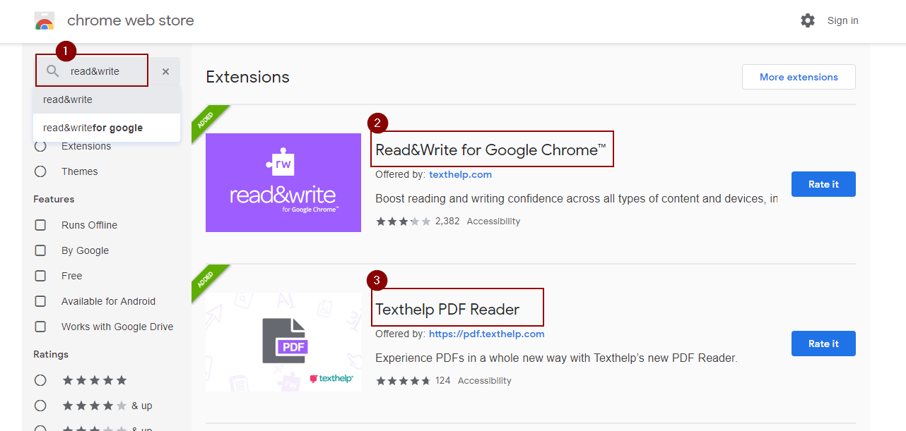
- Install the “PDF Reader App.” This allows you to open files directly from Google Drive:
  - Click on the “Texthelp PDF Reader” icon in the Chrome toolbar.
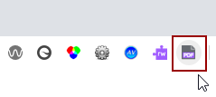
  - This should bring up a confirmation screen saying that you’ve installed the PDF Reader Extension. On this screen, click to “Install PDF Reader App.”
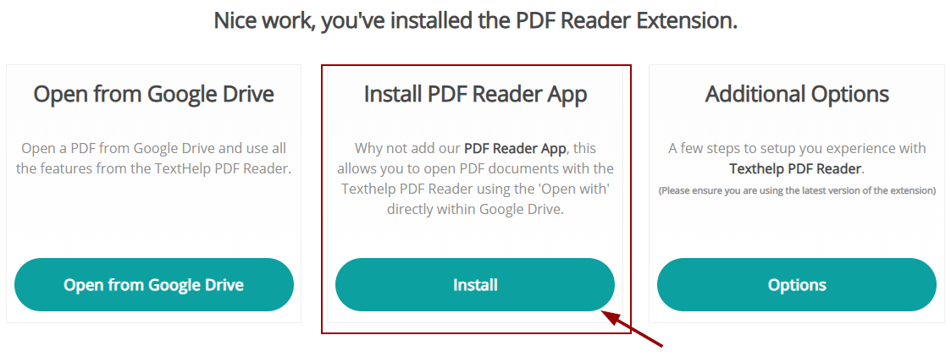

Opening Books with Read&Write for Google Chrome
- Upload EPUB files into Google Drive.
- Double-click on the EPUB directly from Google Drive.
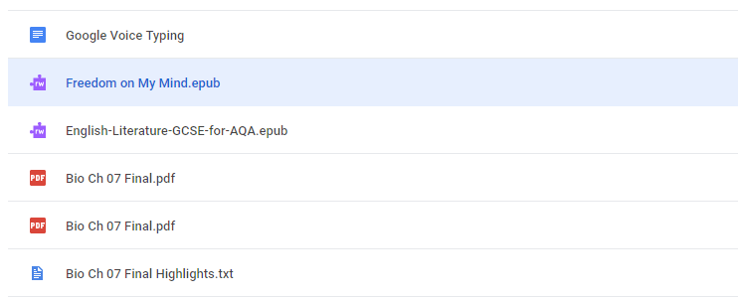
- This will give you the option to choose how to open the file. Click “Open with Read&Write for Google Chrome.”
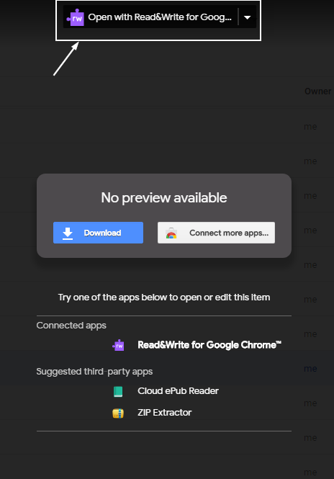
- Allow the app to access Google Drive documents.
  - You may be prompted by Read&Write to sign in with your Google account. Use a colostate account to gain access to the Read&Write license.

VitalSource Bookshelf (EPUB)
VitalSource Bookshelf is an app that Pearson requires students to use for their e-textbooks. There are PC, Mac and mobile versions of the app.
- Creating an account is free
- The app is only compatible with EPUB format files
- You can read books purchased through VitalSource directly
- You can open unrestricted EPUBs locally, such as those received from the SDC

Opening Local Books in VitalSource
- Create a free account on the VitalSource website. You will use this account to login on the app.
  - You can register VitalSource on 2 computers and 2 mobile devices.
- Download the installer / app here: VitalSource Downloads.
- Right-click on the EPUB book, select Open With, then VitalSource Bookshelf.

Read&Write & VitalSource Bookshelf (EPUB – PC Only)
Features available when used in combination with the Read&Write toolbar (PC):
- Text-to-speech with highlighting
- Change voice
- Change speed
- Highlighting & collecting highlights
- Dictionary
- MP3 creation
- Screen masking
- Screen reader accessible

VitalSource Bookshelf – PC Features
Built-in features of VitalSource:
- Text-to-speech using built-in Windows 10 Narrator (no highlighting)
- Table of Contents / Navigation
- Highlighting, collecting highlights (native to app)
- Copy & Paste with generated citations
- Screen reader accessible

VitalSource Bookshelf – Mac Features
Note: Read&Write does not work with the Mac version
- Text-to-speech with highlighting
- Voice selection & speed adjustment
- Table of Contents
- Highlighting, collecting highlights (native to app)
- Copy & Paste with generated citations

Extras: Mobile and Free Software for EPUBs

NaturalReader (Free) – Mac & PC
- Limited features, but provides a simple interface
- Text-to-speech (with highlighting – not the smoothest)
- Annotation (only with paid version)
- Background color options

iOS EPUB Readers
- Voice Dream Reader
- Kurzweil 3000 App
- Dolphin EasyReader (Free)
- NaturalReader (Limited features on free version)
- Claro Speak
- VitalSource Bookshelf

Android EPUB Readers
- Voice Dream Reader
- Kurzweil 3000 (Online Version Only)
- Dolphin EasyReader (Free)
- NaturalReader (Limited features on free version)
- AI Reader
- Aldiko Book Reader (Limited features on free version)
- VitalSource Bookshelf

