Microsoft Teams for Staff Quick Start Guides

Overview
Microsoft Teams is a chat-based collaboration tool that provides users with global, remote, and dispersed teams with the ability to work together and share information on a common platform. Users can create teams where they can hold meetings, have conversations (either one-on-one or group), and work on files together.

Contents
Microsoft Teams for Staff Quick Start Guides 1
Overview 1
To Use 2
How it is Organized 2
Turning on Notifications 3
Adjusting Status 4
Chatting on Teams 5
Team Chats 5
Individual Chats 5
Once in a Team 5
Creating a Video Call for ATRC Appointments 6
Joining Video Calls for ATRC Appointments or Classes 8
Once in a Video Call 11
Screen Sharing on Teams App 11
Screen Sharing on Teams Online 12
Turning on Live Captions 13
Recording a Video Call 14
Captions and Transcript in Microsoft Stream 16
Program Manufacturer Contact Info 17

To Use

How it is Organized
Users can access Microsoft teams Online (https://teams.microsoft.com/start) or on the Downloaded app (https://teams.microsoft.com/downloads).
** Disclosure: Let students know Microsoft Teams App will allow access to more features.
If students are on Microsoft Teams Online let them know they can easily download from the link or click the download button at the bottom of the page.
When Microsoft Teams App or Online is opened, users will navigate by using the Teams toolbar, located on the left.
Teams Toolbar will allow users to:
- View all activity from their teams
- Chat with individuals or groups
- Interact with their specific teams
- View their assignments
- Access their calendars
- Call individuals or groups
- Manage files saved to their OneDrive

Turning on Notifications
Users can manage their notification settings by clicking on their profile photo in the top left corner and then selecting settings from the menu that appears. In the pop-up box, select notifications and adjust as desired.
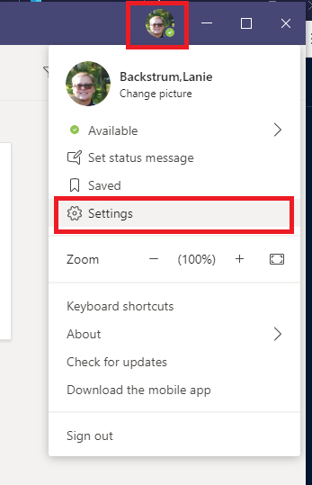

Adjusting Status
Users can manage their status by clicking on their profile photo in the top left corner and then selecting Status from the menu that appears.
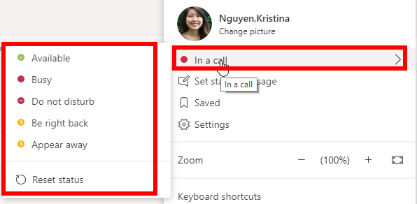

Chatting on Teams

Team Chats
To chat with all members of the team, post your message in your team’s Posts section. All team members will be notified when a message is posted.
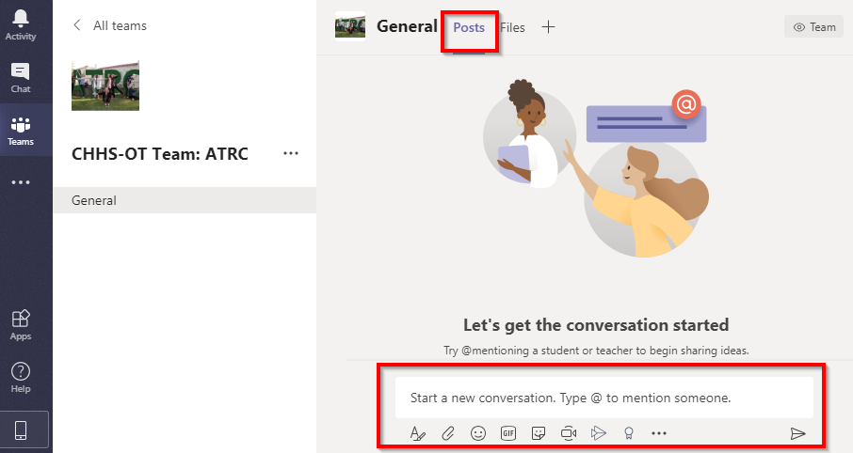

Individual Chats
To create an individual chat with someone,
- Find the new chat icon by the ‘search or type a command’ bar.
- Add an individual to the new chat
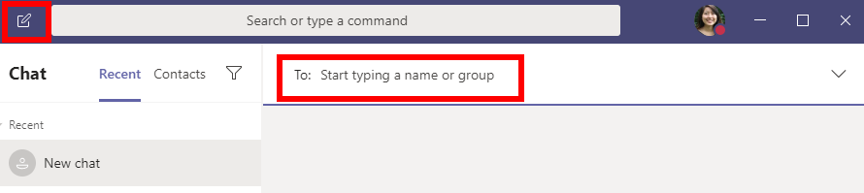

Once in a Team
Team owners can create and manage multiple channels within the team. Channels can be found under each team.
Within each channel, team members can access posts, files, and additional tabs
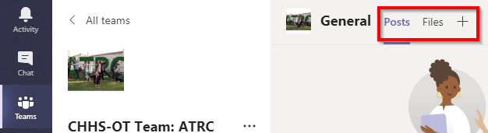
- Posts allows team members to start conversations with other members in the team which are visible to all team members

- Files allows team members to access and share folders and documents with other members in the team

Creating a Video Call for ATRC Appointments
There are three options staff can use to create a video call.
Option 1 via Outlook App:
- On the calendar tab of Outlook App, create an appointment as usual.
- At the top of the toolbar, select Teams Meeting.
  - **Note: if you do not have the Teams app downloaded, you may not have this option
- Once selected,
  - Your pop out window may change to include options to send meeting to required attendees and a link to join the Teams Meeting in the body of the email.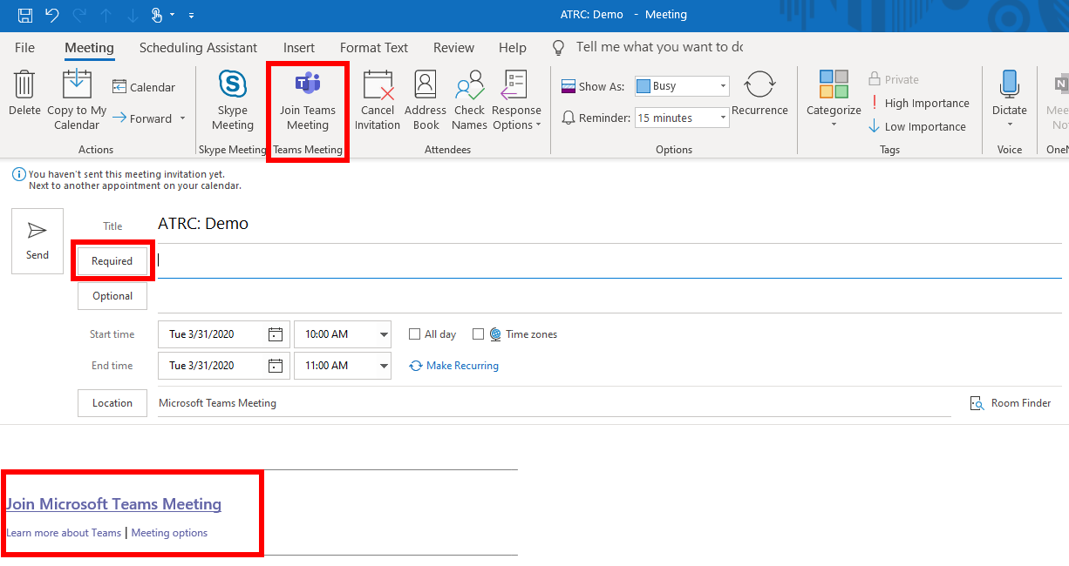
  - OR You will get a notification at the top of the window that says ‘Teams meeting details will be added after you send the invitation’.
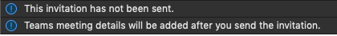
- If you are creating the invite from the ATRC shared email, when adding required attendees, be sure to add your student and yourself to have the meeting pop up on your Teams Calendar.
  - If you are creating it from your personal outlook account, when adding required attendees, be sure to add your student, yourself, and the ATRC share account (chhs-ot_atrc@colostate.edu).
- Once the meeting is sent to attendees, all should get an email to accept and the meeting will be placed in both the Outlook App Calendar and Teams Calendar.
  - ** disclosure, once meetings are accepted, they will be removed from email inbox
- Staff will get an email when the student accepts the meeting.
Option 2 via Outlook Online:
- On the calendar tab of Outlook App, create an appointment as usual.
- Add ATRC shared email so it also populates ATRC calendar.
- Click Add online meeting in the Search for a room or location section and select Teams meeting.
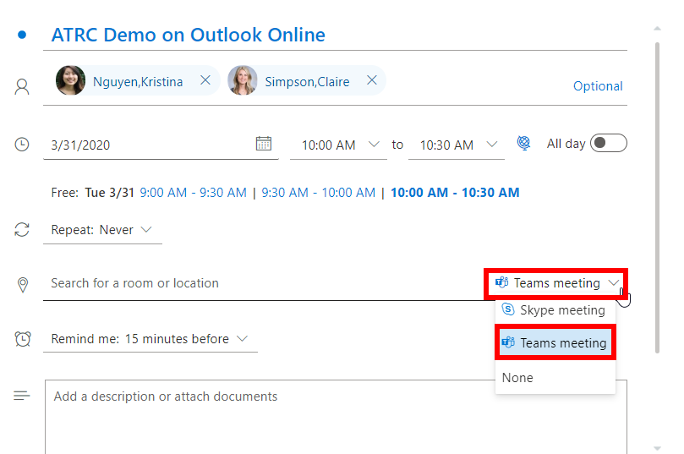
- Once the meeting is sent, it will appear on both the Outlook Online Calendar and the Teams Calendar.
- An email to accept will only be sent to the student. Once the student accepts, staff will be notified via email.
  - ** disclosure, once meetings are accepted, they will be removed from email inbox
- Additionally, members of the meeting can access the link to join meeting via Meeting information in the Calendar tab of either Outlook or Teams.
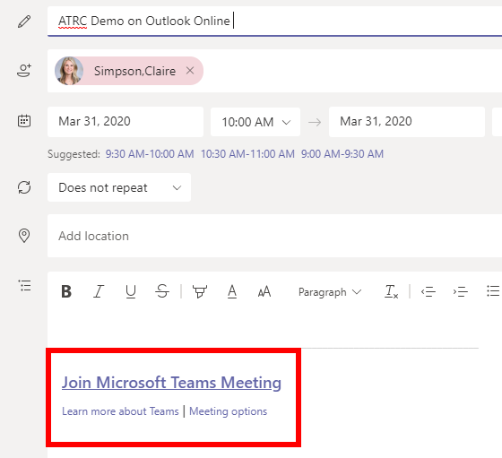

Option 3 via Teams:
- Create a New Meeting in the Calendar tab of Teams.
- Invite your student.
- The meeting will may only show up in the Teams Calendar so double check and you may have to refresh your outlook calendar.
- An email to accept will only be sent to the student. Once the student accepts, staff will be notified via email.
  - ** disclosure, once meetings are accepted, they will be removed from email inbox
- Additionally, members of the meeting can access the link to join meeting via Meeting information in the Calendar tab of Teams.

Joining Video Calls for ATRC Appointments or Classes
ATRC staff will create meeting times. When the meeting time is created, users will receive an email to their outlook account/ CSU email requesting to either accept or decline meeting. Once accepted, the email will go away and users will have to view meeting times via the Calendar Tab on Microsoft Teams.
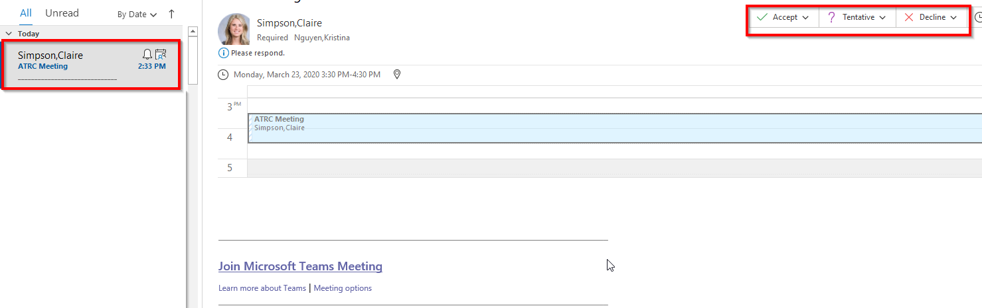

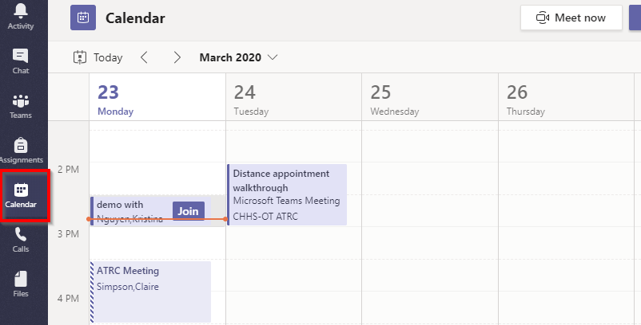
During the specified meeting times, users may be able to join the video call in the Calendar tab.
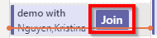
Other times, users may have to go into the calendar event and click the link to join.
Users will get a notification when other members have started joining the meeting and have the option to join the meeting as well.
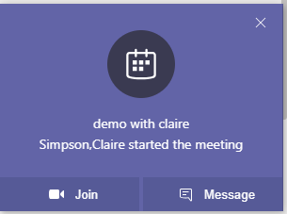
Staff can invite students to join the meeting call by:
- Clicking on the participants button on the video call toolbar
- Invite a student to a meeting OR
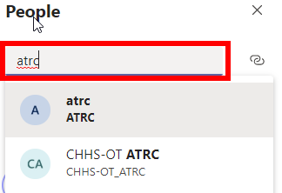

- Copy the Join info and teams chat or email students the link OR
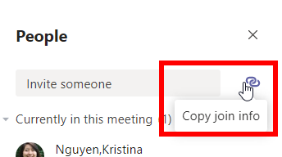
- Ask the student to Join
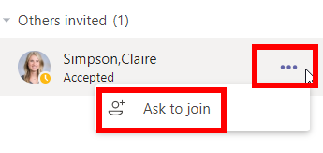
What students will see when you invite them
Teams App notification to join meeting:
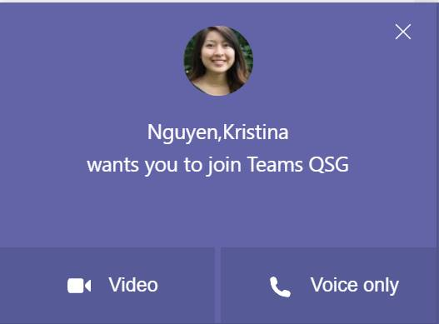
Teams Online notification to join meeting:

Once in a Video Call
Once in a video call, users can access additional features via the video call tool bar.

Screen Sharing on Teams App
Users can share their screen with other members in their call by:
- Clicking on the screen share tool
- Selecting to share the desktop, window, or PowerPoint
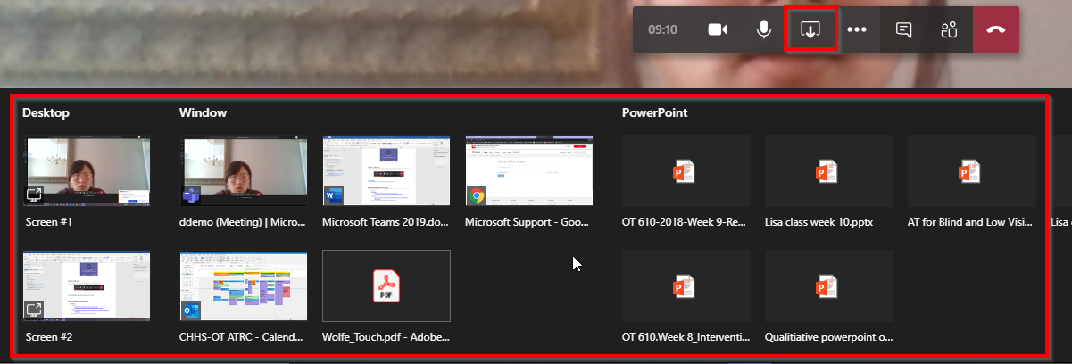
- Once screen is selected, a red box will surround the selected screen indicating that you are sharing your screen
- Make sure to enlarge shared screen by:
  - Click more action in the video call toolbar
  - Select Full Screen
- Make sure to include system audio if working with programs that require audio (ex. Text to speech)
- Additionally, a presenter toolbar will appear at the top of your screen, users presenting can have the option to give control to other members in the meeting. This will allow ATRC staff or professors to access your screen and help with installs or accessing materials.
  - ATRC Staff members also have the option to Request control which will appear on the right of their video call toolbar.
- Make sure that when the user gives control, they select the option to share the whole desktop

Screen Sharing on Teams Online
Users can share their screen with other members in their call by:
- Clicking on the screen share tool
- Select between screenshare, PowerPoint or Whiteboard
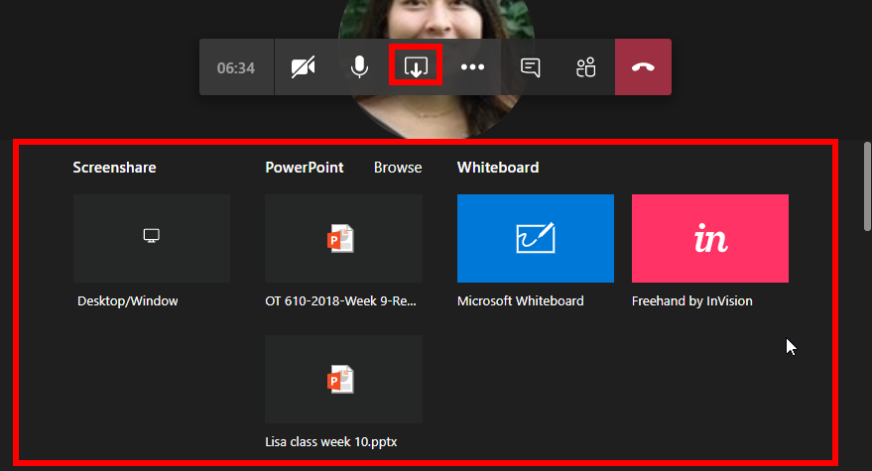
- If screen share is selected, an additional pop out will appear, select between entire screen, application window, or chrome tab
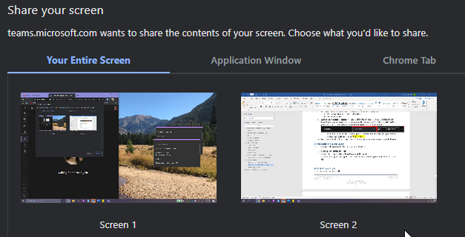
- Make sure to include system audio if working with programs that require audio (ex. Text to speech)
- Additionally, a presenter toolbar will appear at the top of your screen, users presenting can have the option to give control to other members in the meeting. This will allow ATRC staff or professors to access your screen and help with installs or accessing materials.
  - ATRC Staff members also have the option to Request control which will appear on the right of their video call toolbar.

- Make sure that when the user gives control, they select the option to share the whole desktop

Turning on Live Captions
- After joining a meeting, click on the “...” for “More actions”. 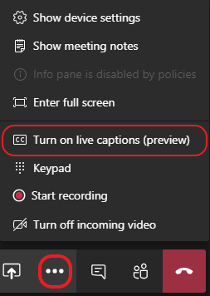
- In this menu, select “Turn on live captions (preview)”.
- After turning on live captions, click “Start recording” in the same “More actions” menu.
To maximize accuracy of live captioning, speak clearly and minimize background noise.
The live captions will be associated with the recorded meeting once it is finished rendering and is automatically uploaded to Microsoft Stream.
Note: Live captions will only be displayed to meeting members who have turned on the live captioning feature for the meeting. The closed captions and transcript that are created will be available to everyone who has access to the recording.

Recording a Video Call
Users can record the video call by:
- Clicking on additional actions and selecting Start Recording
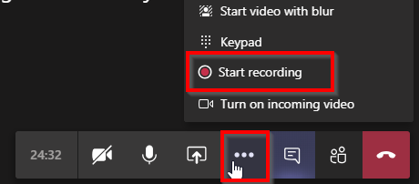
- Users will know recording has started when a red dot appears by the timer
- To stop the recording, Uses click on additional actions and select Stop Recording
- The recording can be accessed through the Meeting Chat
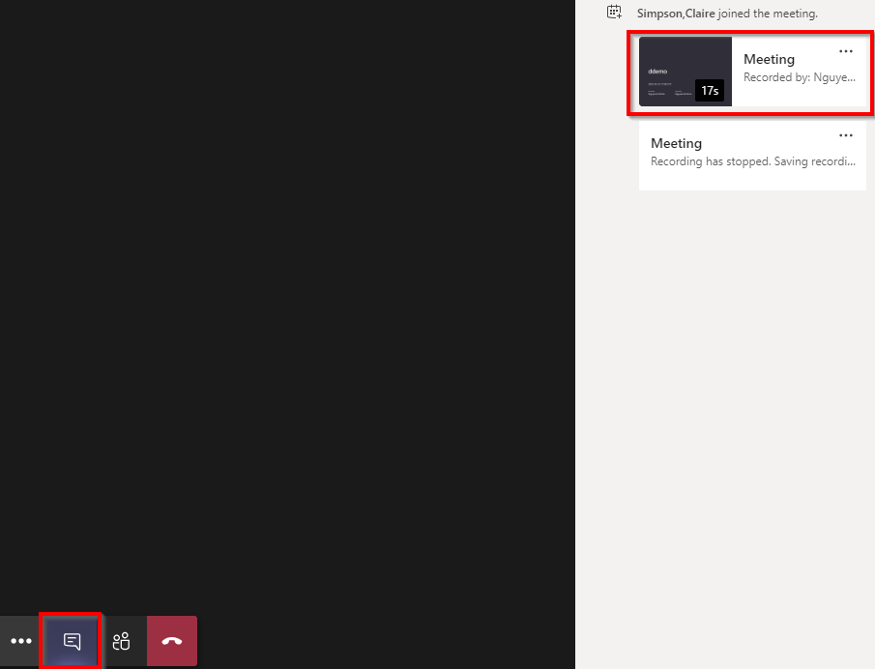
After the video call has ended, users can still access the recording by:
Option 1:
- Accessing the email sent from Microsoft Stream
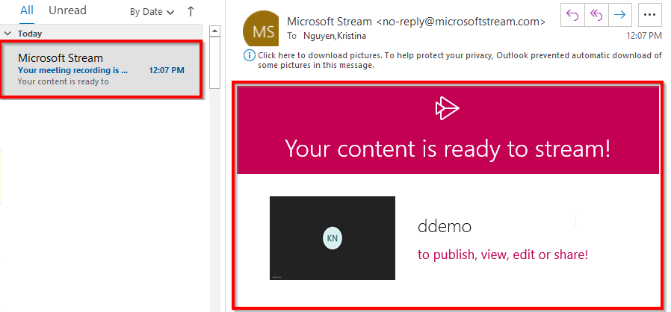
Option 2:
- Going to the Calendar Tab and clicking on the scheduled appointment time
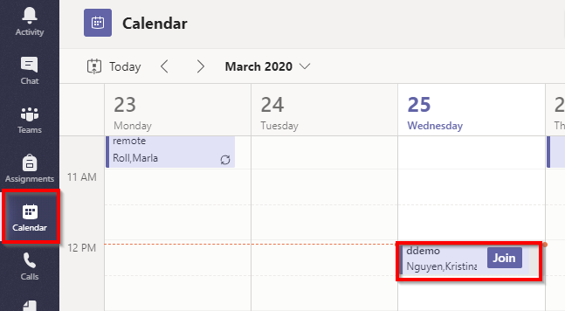
- Locate Chat at the top of the page and view recorded video
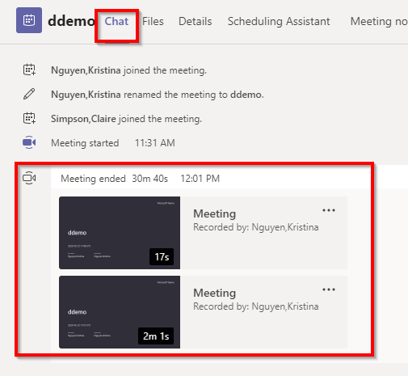

Captions and Transcript in Microsoft Stream
In Microsoft Stream, you can view and edit the captions and transcript associated with the meeting. To view the closed captions, click the “CC” in the toolbar on the video. The transcript will be automatically displayed to the right of the video.
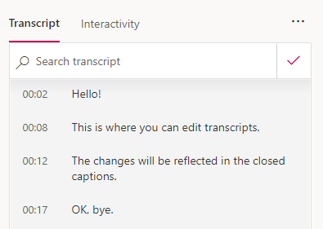
In the transcript panel, you can view, search, and edit the transcript and closed captions. You can also enable or disable transcript auto-scroll.
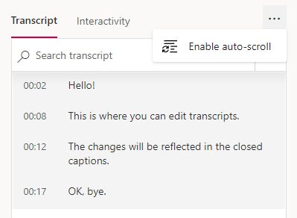

Program Manufacturer Contact Info
- Microsoft
- Contact info:
  - Contact Microsoft Website (https://support.office.com/en-us/home/contact?contactUsExperienceEntryPointAssetId=S.HP.teams)
- Website:
  - Microsoft Teams Website (https://products.office.com/en-us/microsoft-teams/group-chat-software)
- Cost: Free for all CSU students through the CSU Outlook Email.

