Writing Tools Guide
This is a brief overview of various writing supports that anyone can use. This guide should be used as a starting point and not a comprehensive guide for any of the listed options, nor an exhaustive list of all writing supports available.

Table of Contents for this Guide
- Built-in writing and dictation tools
- Computer-based writing tools and software
- Mobile/tablet applications

Built-In Writing and Dictation Tools
Built-ins are accessibility tools that are free and available to you through your operating system or the software you are using. Popular built-in reading tools for various platforms are described below.

Microsoft Word
Word has built-in spelling and grammar check tools that may assist users with writing. To adjust settings for the spelling and grammar check, go to File>Options>Proofing and customize the settings according to your preference. In these settings, you can also set up text expansion or replacement by clicking on “AutoCorrect Options”:
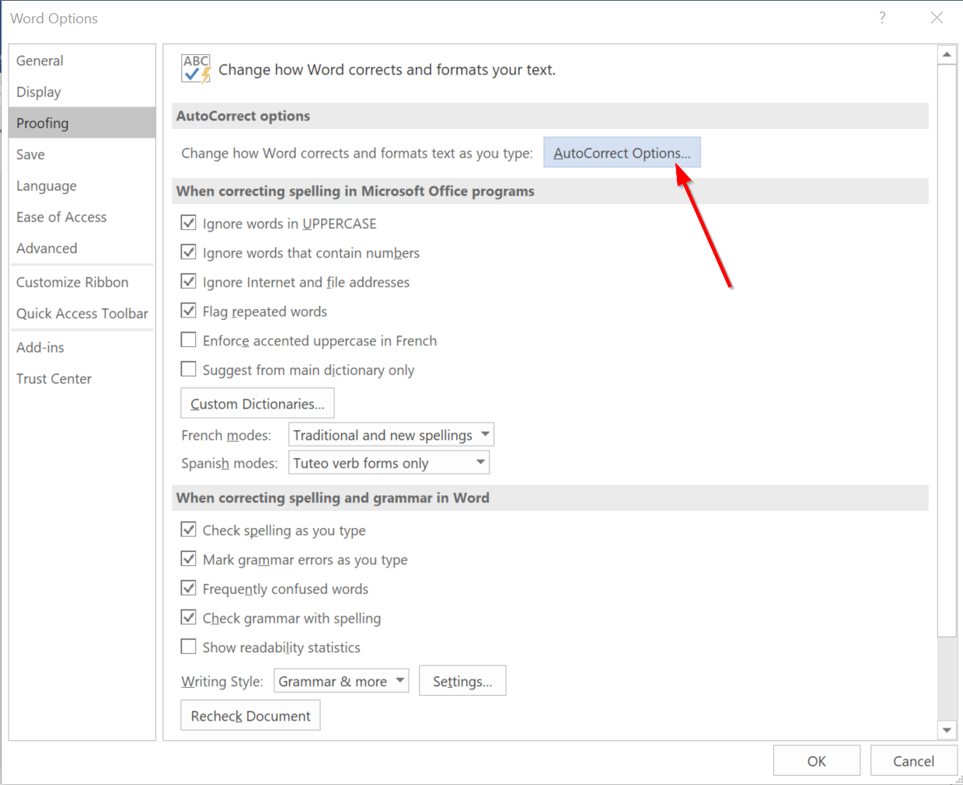
Then click to activate “Replace text as you type” and add custom text expansion to the dictionary. You can set up shortcuts for commonly-used words. For example, you might enter “acm” into the “Replace” field and “accommodate” into the “With” field. When your options are saved, every time you type “acm” into a document, it will be automatically replaced with the word “accommodate.”
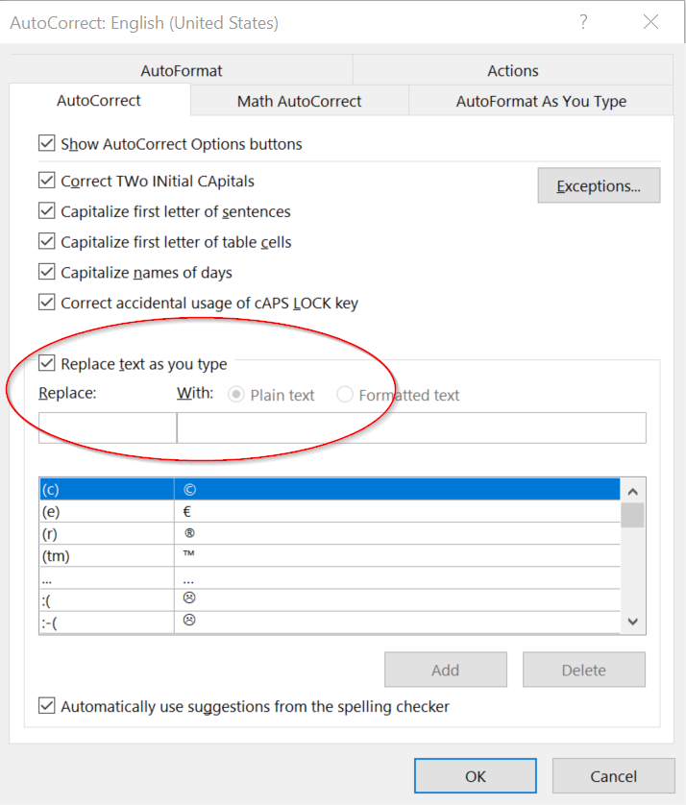
Word also has built-in dictation, available through the Microsoft 365 online portal. (Some desktop versions of Word also have Dictate built in.) To use Dictate, click on the microphone that appears in the Home ribbon. It will walk you through permission to use your preferred microphone. From there, Word will transcribe your voice as you dictate the document. To stop recording, click the microphone icon again.

Google Docs
You can also dictate into Google Docs using a tool called Voice Typing. To access this, log into Google Docs from a Chrome browser (this is the only browser that supports Voice Typing). Open a document, then click on Tools>Voice Typing.
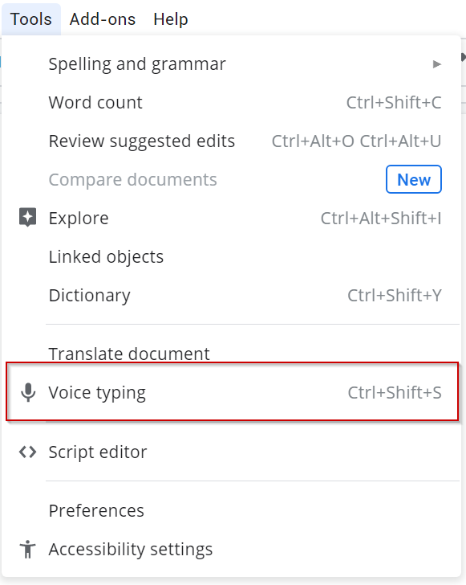
This will open a small microphone icon 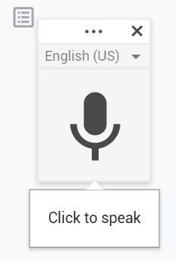on your screen. When you click it the first time, it will ask for your permission to use your computer’s microphone.
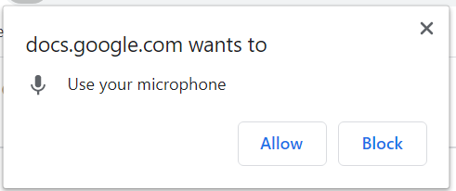
From there, click on the microphone icon. It will turn red and begin listening for your voice to speak directly into the document. To stop recording, simply click the microphone again.

Mac System
For those who use a Mac computer, dictation is a built-in feature of the accessibility menu. To access, go to System Preferences, then click on Keyboard and select Dictation from the top ribbon menu.
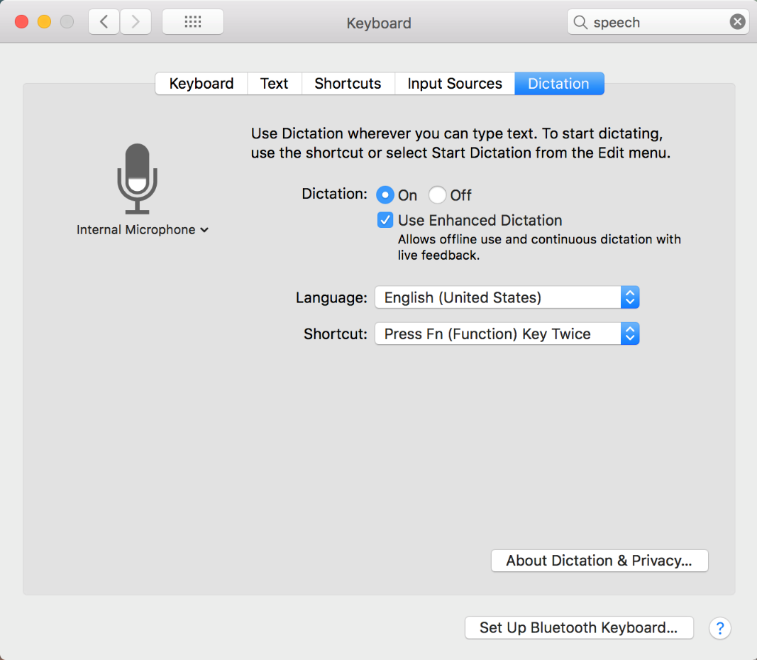
This allows you to use dictation at any time when you need to input text. Set up the keyboard shortcut of your choice or select Start Dictation from your Edit menu. When you activate dictation, a small microphone icon will appear:
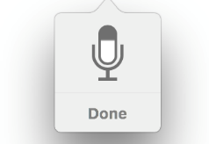
When you are finished, simply click “done” to stop dictation.

Computer-Based Writing Tools

Grammarly
Grammarly provides additional writing supports through tools like grammar checking and proofreading. It's AI-powered, and can give more detailed feedback than generic grammar and spell-checking tools. For example, it can give tips on conciseness, clarity, and appropriateness for a certain audience. The free version of Grammarly includes several of these tools, or users can upgrade to a premium account to unlock advanced features such as a plagiarism checker and tailored suggestions for adjusting tone.
To begin using Grammarly, go to Grammarly's Website (www.grammarly.com) and create an account with a preferred email address. Within the online account, users may type text directly into the web page or upload documents to check their writing. A side menu appears, showing several writing metrics:
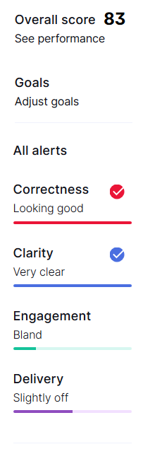
These provide live updates as the user adds text to a document, automatically adjusting to provide feedback.
Grammarly can also be accessed in other ways. Users can install browser plug-ins, which will correct text entered into a variety of websites including Gmail, Facebook, and LinkedIn. Grammarly can also be downloaded as a desktop application or added as a Microsoft Word plug-in so users can work on documents without having to copy the text into another place.

Mobile/Tablet Apps

SimpleMind
SimpleMind is an app for mind mapping, which can be useful for organizing notes, outlining research papers, and brainstorming ideas. There are free versions of SimpleMind for iOS and Android phones and tablets as well as a paid version for $7.99 that offers increased functionality including exporting or syncing maps with other applications and websites. SimpleMind also offers desktop applications at a higher price that may be used for Windows or Mac computers.
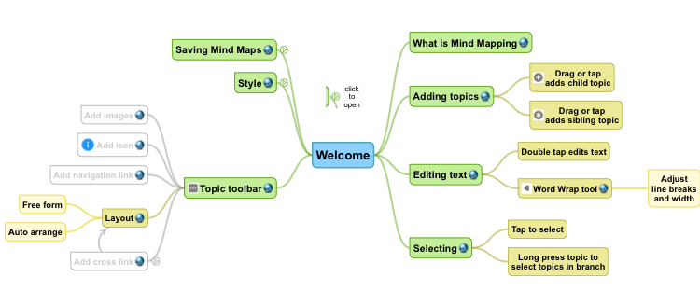

Xmind
Xmind is another mind-mapping application with several different customization features and layouts. There are 30 built-in templates to start from, so users can choose one that fits their purpose and aesthetic preference best. Xmind is available for free on iOS and Android devices, with a premium subscription available to unlock advanced features and functions such as inserting photos, audio notes, file attachments, or hyperlinks into the mind map. It can also be downloaded for desktop use on Windows, Mac, or Linux computers.
