Otter.ai – Quick Start Guide
Table of Contents
Otter.ai – Quick Start Guide 1
Overview 1
How to Use Otter.ai 2
Getting Started and Basic Features 2
Settings for Easier Viewing, Listening, and Organization 9
Advanced Features / Other things to know / Paid version features 12
Program Manufacturer Contact Info 14

Overview
Otter.ai is a software that transcribes speech into text, turning voice conversations into notes. Otter creates captions for live speech, including prior recordings, and makes a written transcription of the speech. The written transcription can be searched by key terms and shared by email or link. Users can record a class lecture or meeting (virtual or in-person) including class discussion. Otter can be used on your computer or mobile device.
The user may take and select photos during the recording to be inserted in line with the transcript. After the transcript is created, the user can listen to the recording while the transcript highlights each word as it is played back. There are options to export the text and audio transcriptions. Otter will detect multiple speakers for you to tag in your transcript, create a space in the transcription when the speaker pauses, and uses time stamps throughout the transcription.
The Otter Basic plan is free. You can record up to 600 minutes per month, including 3 imports, at 40 minutes per recording. After 40 minutes, you may continue by beginning a new recording. Otter Pro is the paid version that allows you to import, record, and sync with Zoom Cloud (a paid service) up to 6000 minutes per month with 4 hours per recording.

How to Use Otter.ai

Getting Started and Basic Features
- To begin, go to https://otter.ai/ and click on “Sign Up” to create a free account. If you have the paid version, you will go to https://otter.ai/ and click “Log in.” If you choose “Continue with Microsoft” you can link to your CSU email.
- Or download “Otter Voice Meeting Notes” for Android or iOS. Accounts will be linked by email. 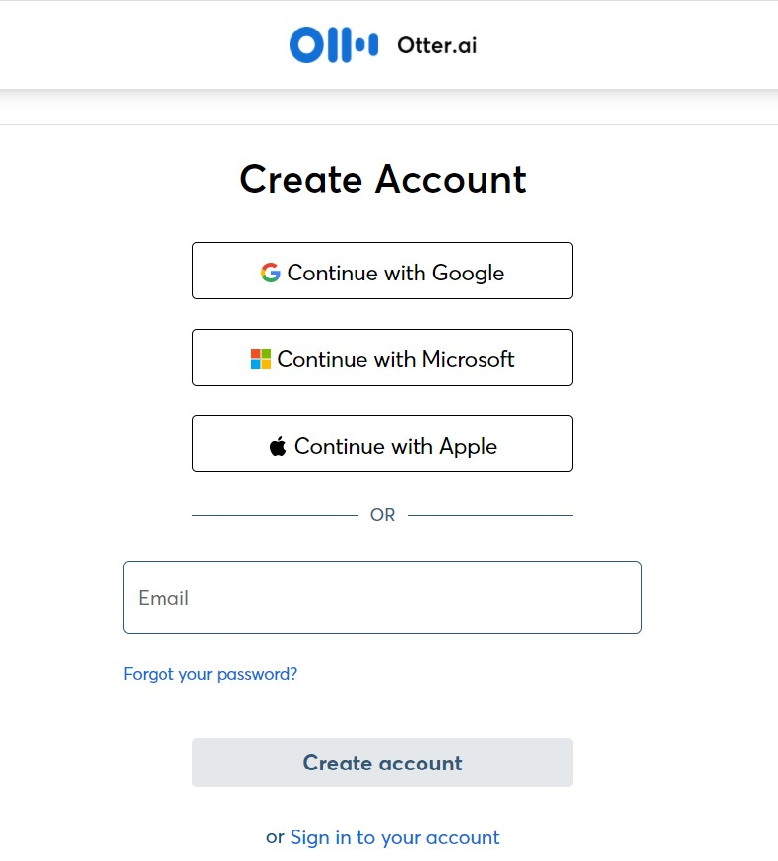
- Click next to reach the home page. You will see a menu bar and options to record or import. 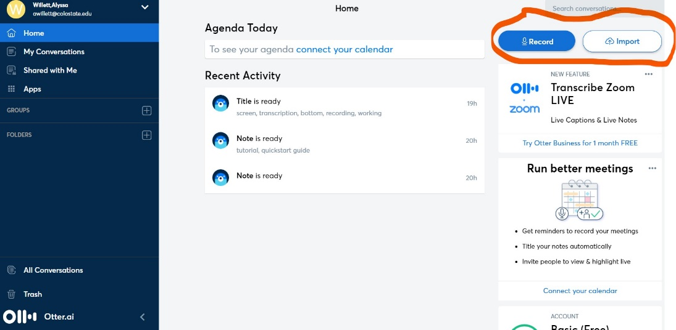
- To begin recording notes, you can click on “record” from the home page, or you can choose “Start recording” on the “My Conversations” page.

- You will know that Otter is recording by the timer at the bottom of the screen. You may pause the recording with the pause button. 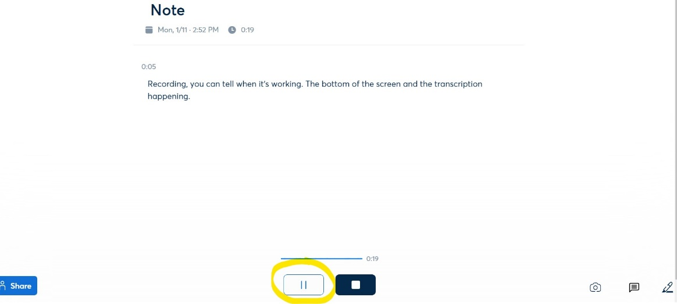

- Resume recording by clicking the microphone icon. 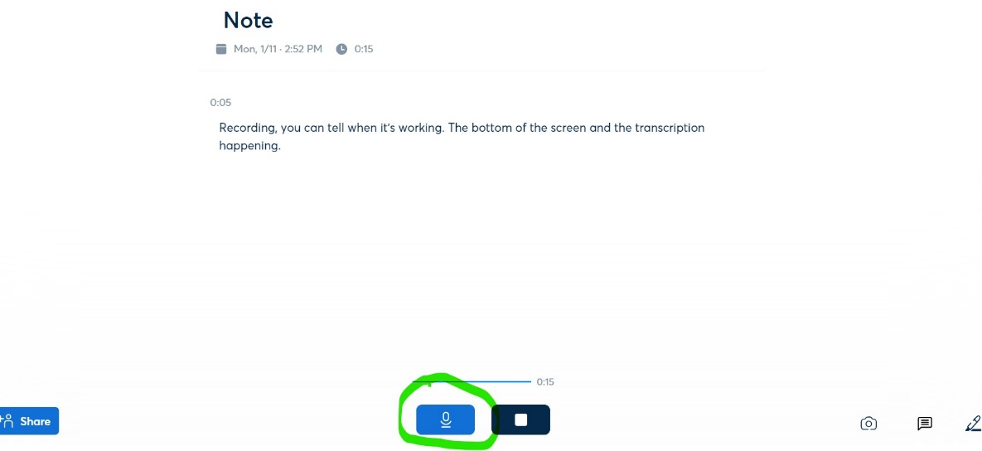

- Otter allows the user to insert a photo during transcription by clicking the photo icon and choosing an image from your device. 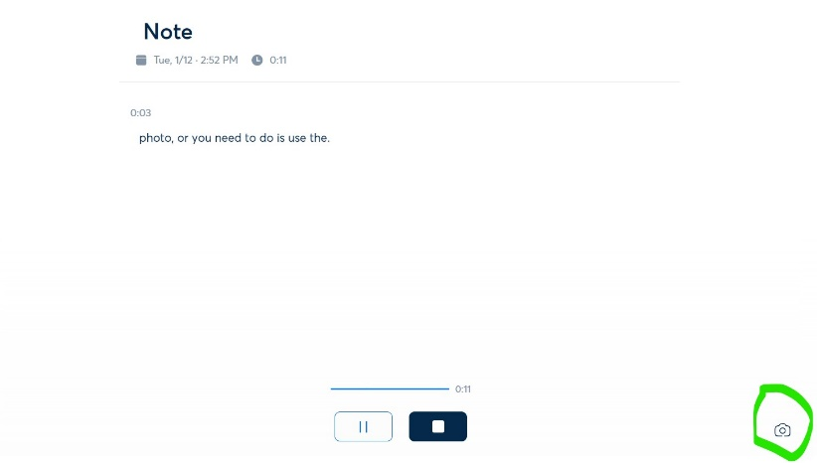

- Browse your device for the image, select, open, and the image will appear inline with the transcription text. 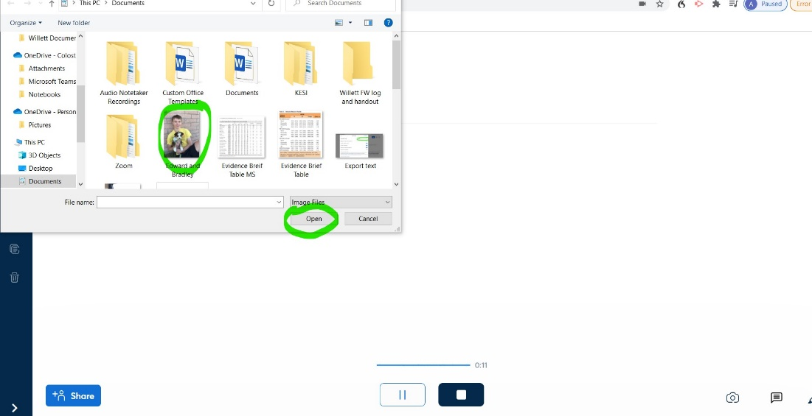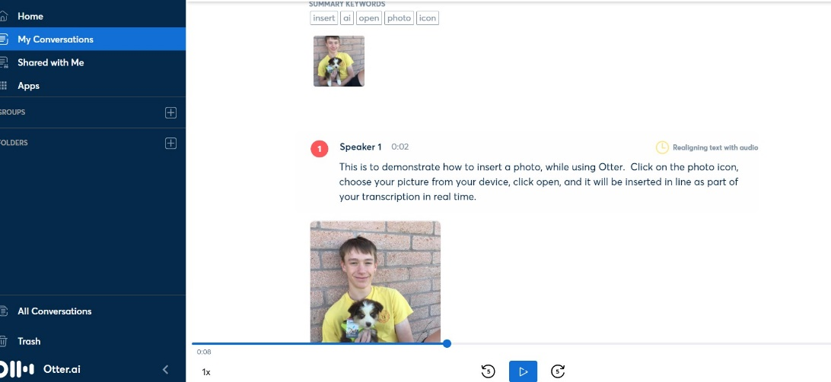

- Stop the recording by clicking the stop icon. Once you stop the recording the note will be transcribed. This may take a few minutes depending on the length of recording. You are notified when your “note is ready” on your home page.

- If you want to transcribe a file that is already on your device, click “Import.” This will allow you to browse your device for the file. The Basic Free version only allows 3 imports.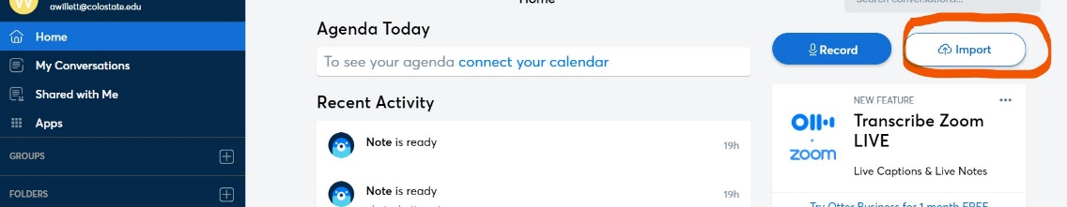
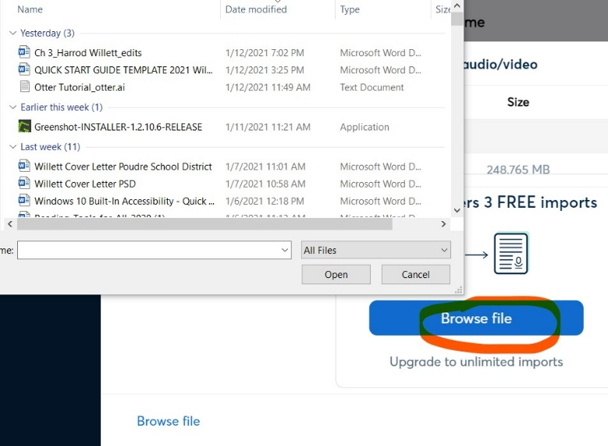
- Locate the file, select, and click open. Once you have selected the file, Otter will show that the transcription is in process under “Progress.”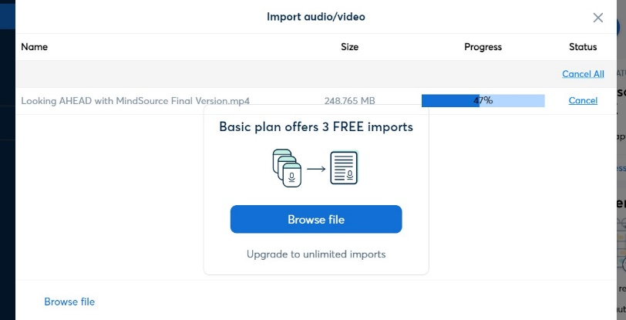

- You will find your transcribed note under “My Conversations” in the menu. Each conversation is automatically labeled “Note” and contains the date and time of the recording. 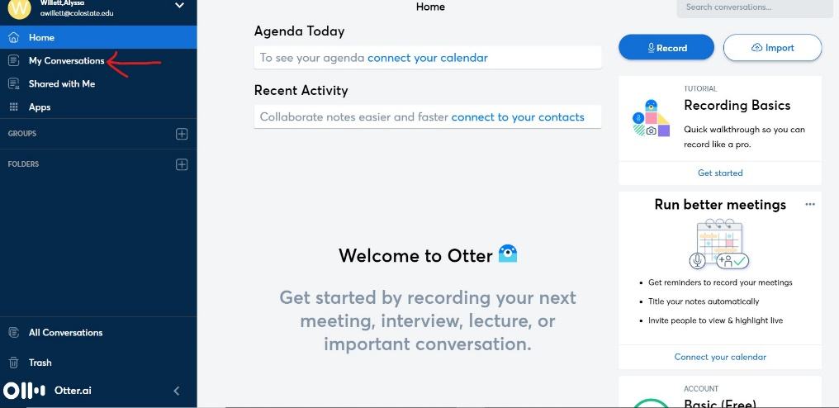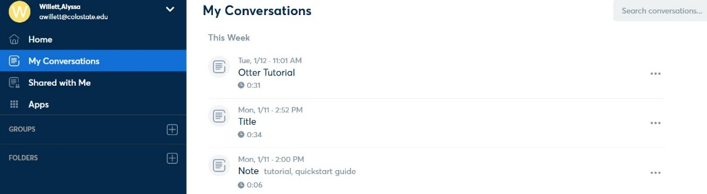
- You can listen to your note while reading the transcription by clicking the play button at the bottom of the screen. Otter will highlight each word of the transcription as it is played back. You can check for accuracy. 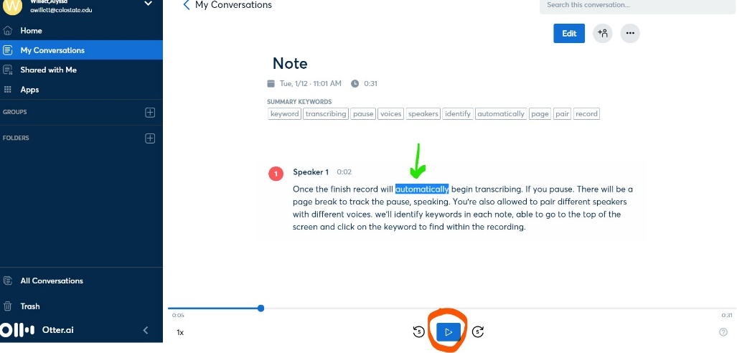
- After checking the note for accuracy, you can edit the title and content of your transcription. 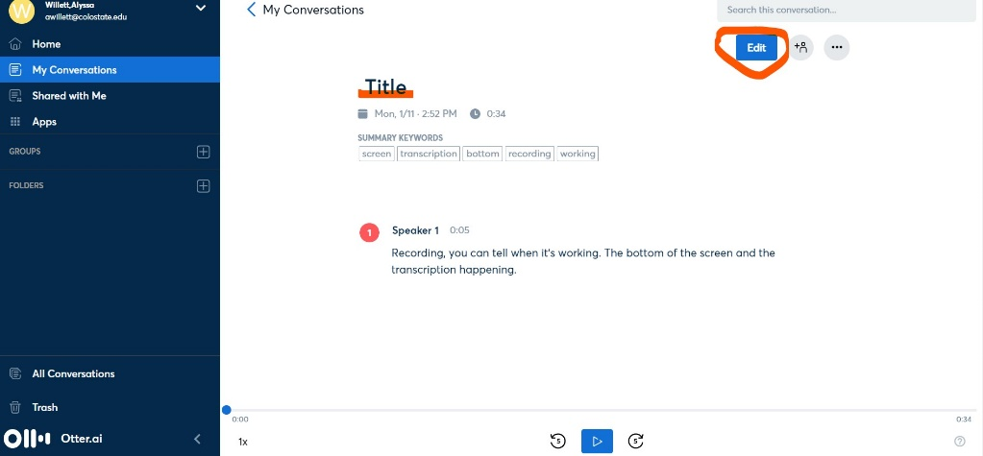
- Use “Search the Conversation” option to search the transcription for keywords. If a word appears multiple times, use the arrows to move through your transcription. 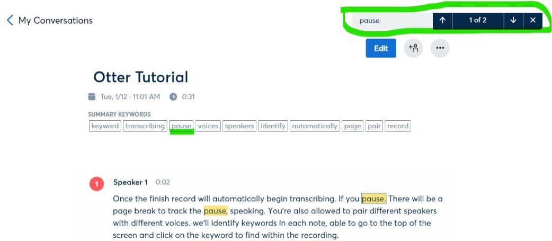
- After reviewing and editing, you can export the transcription or audio by going to the more options icon and choosing “export text” or “export audio.” 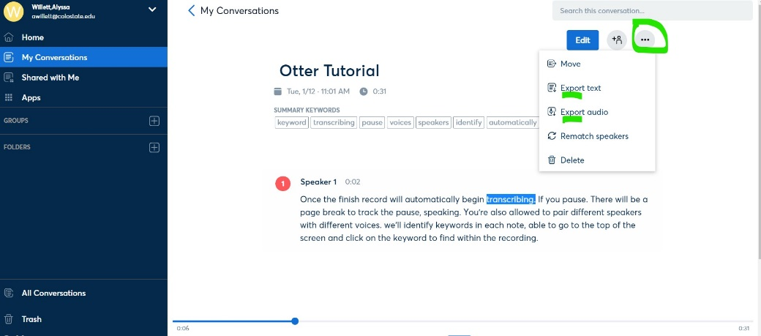
- Choose “export text.” A window will appear with options for text format. The free version allows you to export and save as a text document or to “copy to clipboard.” The paid version allows DOCX, PDF, and SRT file types.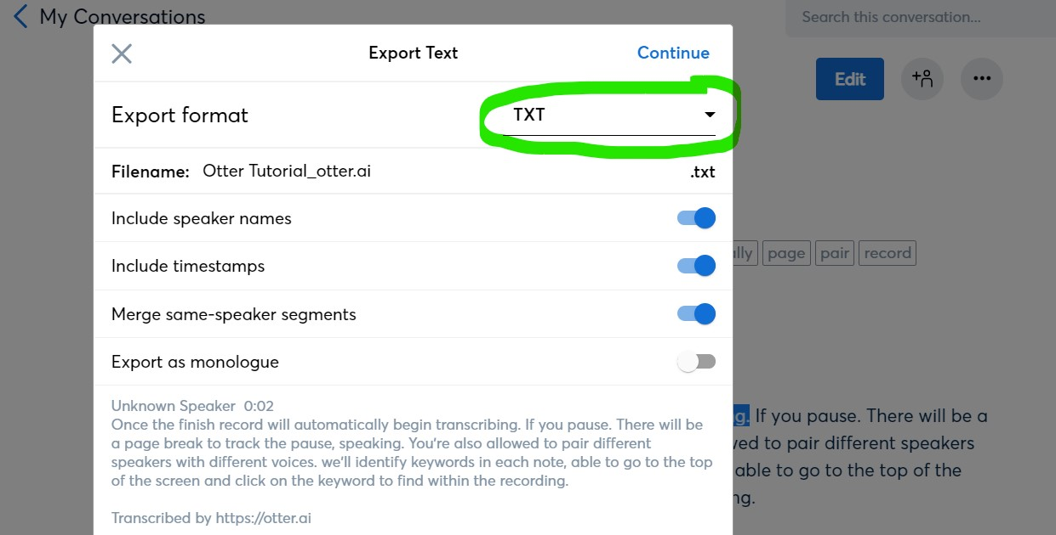
- To share your notes, click on the share icon, either type the contact in the “share with people and groups” box, or choose to “enable link” then copy the link and share it. You can choose where the transcription will begin so that you may share all, or just part of the notes by clicking on “Start at” then typing in the time where you want the shared portion to begin.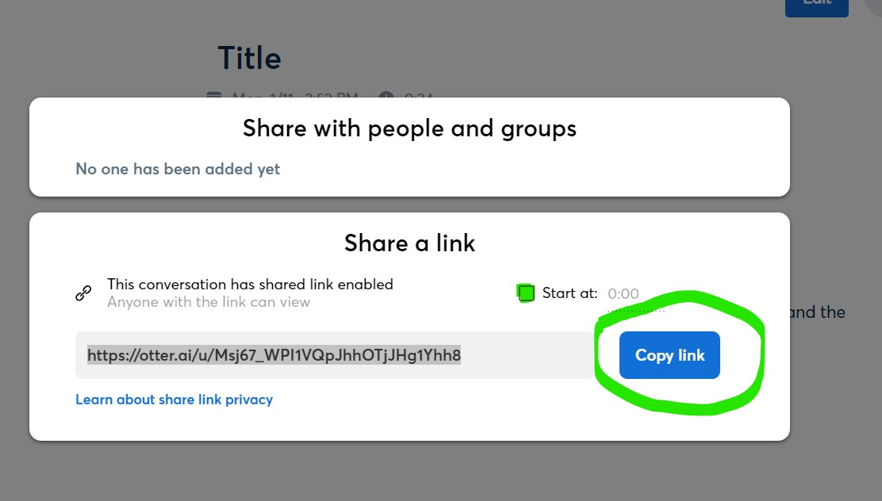

Settings for Easier Viewing, Listening, and Organization
- Collapse the sidebar by clicking the arrow next to the Otter logo at the bottom of the menu. 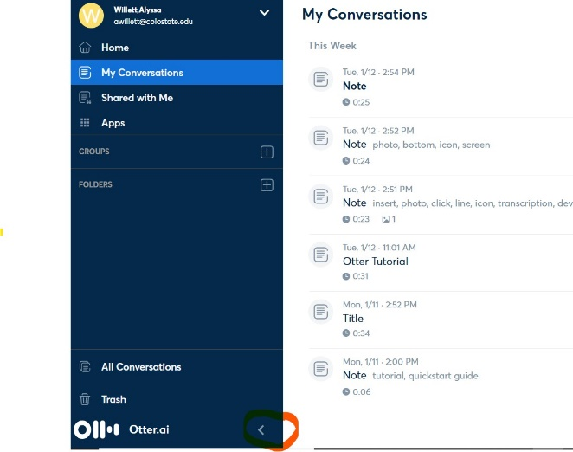
- Listen at your own pace by adjusting the playback speed. Click “1x” to open the Playback Options menu and choose your playback speed.
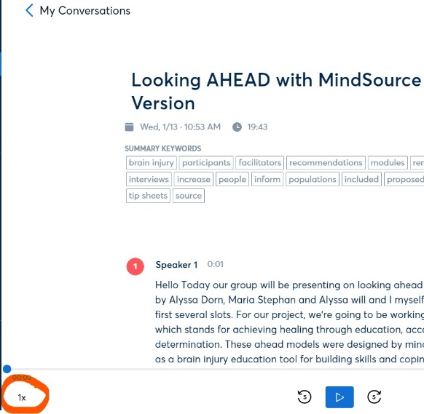
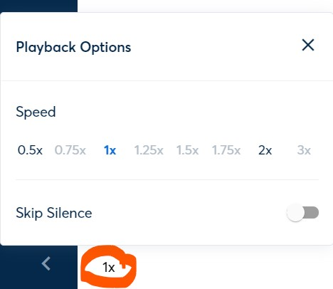
- Pair speakers to identify who is talking by clicking on the number beside “Speaker.” You can also click on the “more options icon” and choose “rematch speaker.”
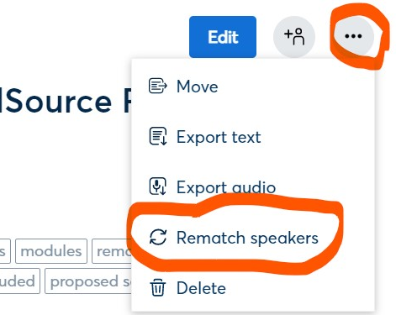
- Organize your notes by using folders. Select “Folders” from the menu bar, then “New Folder,” then “Create a folder” by naming the folder and clicking “Create.”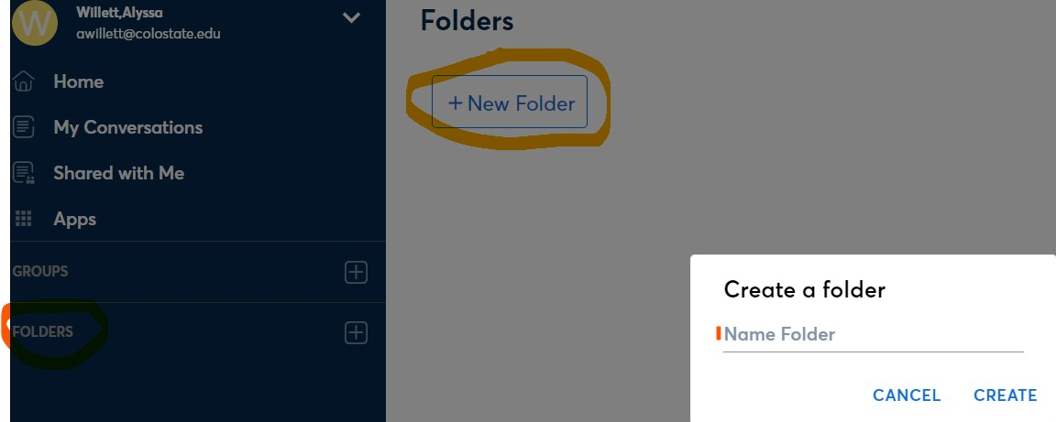

Advanced Features / Other things to know / Paid version features
- Apps. Otter can sync Zoom Cloud Recordings automatically when enabled. Zoom Cloud is a paid service. If you have Zoom Cloud and want to sync your recordings with Otter, go to “Apps” in the menu and select “connect” for Zoom and follow the prompts. Otter will also sync to your calendar. While in “Apps,” select “Connect calendars and contacts.”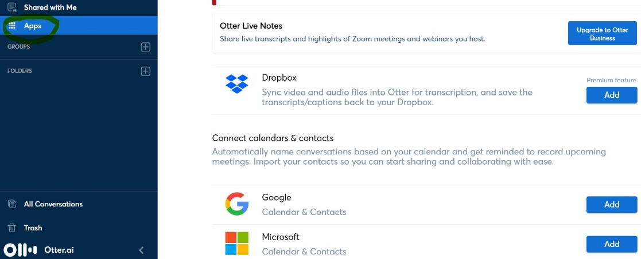
- Keyboard Shortcuts for Audio Playback and Editing Transcription
Action | Mac | Windows
Play or Pause | Esc | Ctrl Space
Rewind 5 Seconds | Left Arrow | Ctrl R
Slow Down | F3 | Ctrl 3
Speed Up | F4 | Ctrl 4

Action | Mac | Windows
Insert a Paragraph Break | Return | Enter
Delete Paragraph Break | Backspace or Delete | Backspace or Delete
Undo an Action | Command Z | Ctrl Z
Redo an Action | Command Y | Ctrl Y

- Premium versus Paid
  - The Premium (paid) version of Otter comes with 6,000 minutes per month of recording, including imports. The Basic (free) version comes with 600 minutes of recording per month and 3 imports total.
  - The Premium version of Otter can sync with Dropbox.
  - The Premium version allows you to export transcriptions as PDF, DOCX, and SRT files. The Basic version exports as a text file or to your clipboard, which can be copied to a Word document.
- For more explanation of features, check out this Otter.ai Tutorial (https://www.youtube.com/watch?v=GYCAqtgyUyY), or find additional tutorials in Account Settings.
- Help can be found by clicking the arrow by your name, then “Help Center.”
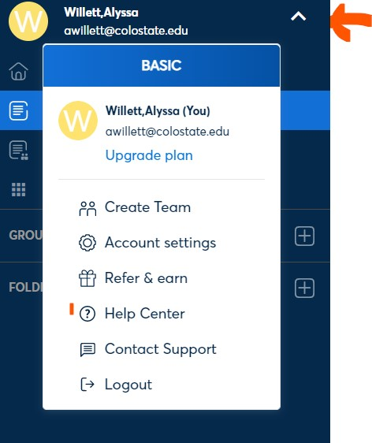

Program Manufacturer Contact Info
- Company Name: Otter.ai
- Email: support@otter.ai
- Website: https://otter.ai/about
- Cost
  - Basic Plan: Free
  - Premium Plan: $9.99 per month

