Microsoft 365 Online Built-Ins – Quick Start Guide
Table of Contents
Microsoft 365 Online Built-Ins – Quick Start Guide 1
Overview 2
To Use 2
Logging into Microsoft 365 Portal 2
Logging into Desktop Applications 3
Accessibility Features of Office 365 5
Dark Mode 5
Dark Mode for Desktop 6
Dictate 7
Search 7
Immersive Reader 8
Tools 8
Read Aloud 8
Text Preferences 8
Grammar Options 8
Line Focus 9
Other Reading Preferences 9
Accessing Immersive Reader 10
Word, PowerPoint, and OneNote 10
Teams Chat 10
Outlook 11
Contact & Pricing Info 11

Overview
Microsoft 365 Online is a one-stop portal providing in-browser versions of software in the Microsoft suite (e.g. Word, Excel, PowerPoint, Outlook, etc.). CSU students, staff, and faculty have free access to Microsoft 365, and several accessibility features and tools are built directly into the online portal. These built-in tools are usually also available in the desktop applications, depending on the version; however, this QuickStart guide focuses primarily on the tools and features available within the online applications.

To Use

Logging into Microsoft 365 Portal
Access the online portal by navigating to Microsoft 365 (http://portal.office.com). The login screen will appear as shown below:
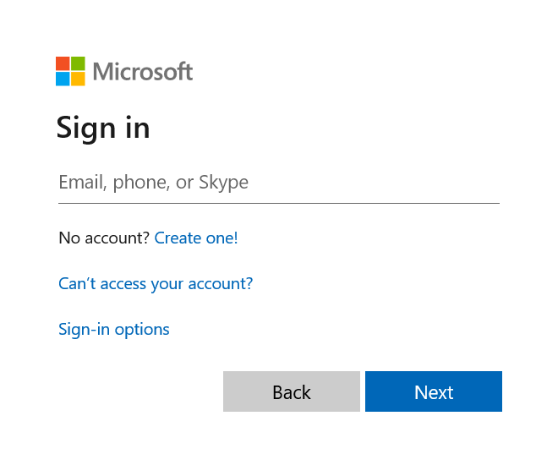
Log in using your ename@colostate.edu email address. Upon logging in, you will see the 365 home page:
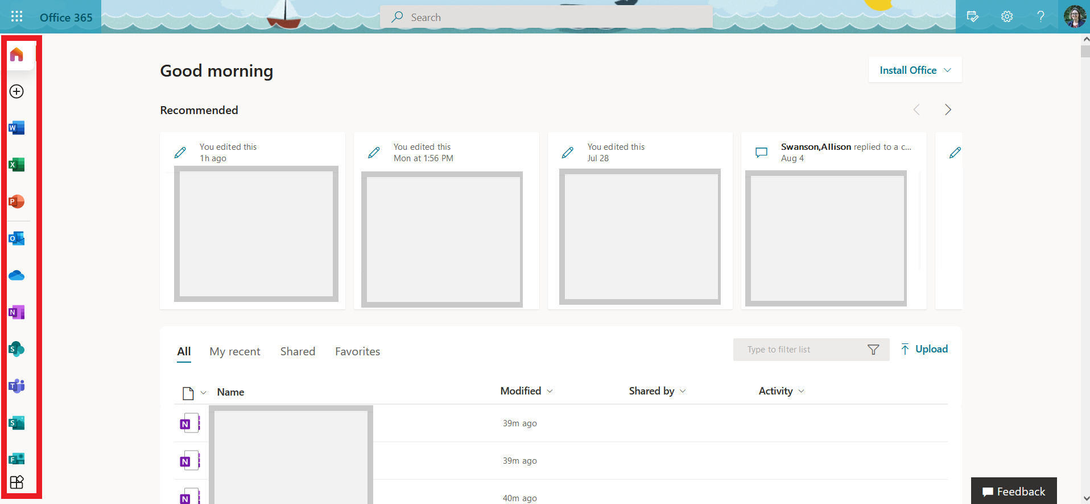
From the toolbar on the left-hand side of the screen, you can access the online versions of Office 365 applications such as Word, Excel, PowerPoint, Outlook, and more. Simply click on the application you would like to use and create new documents, emails, notebooks, calendar items, and so forth. Documents are stored in the cloud on OneDrive. If you are collaborating on a document with other people, it may be stored on SharePoint so that everyone has live access to it.

Logging into Desktop Applications
When you use Microsoft 365, documents and notes can be stored on the cloud and accessed online through OneDrive or SharePoint. Those documents may also be opened from within Microsoft’s desktop applications (Word, Excel, OneNote, etc.) and synced live as you work on them.
To log into your 365 account from a desktop application such as Microsoft Word or Excel, open the application and click the Sign In button in the top right-hand corner of the screen. (In Microsoft OneNote, the sign-in screen pops up automatically when you open the desktop application.)
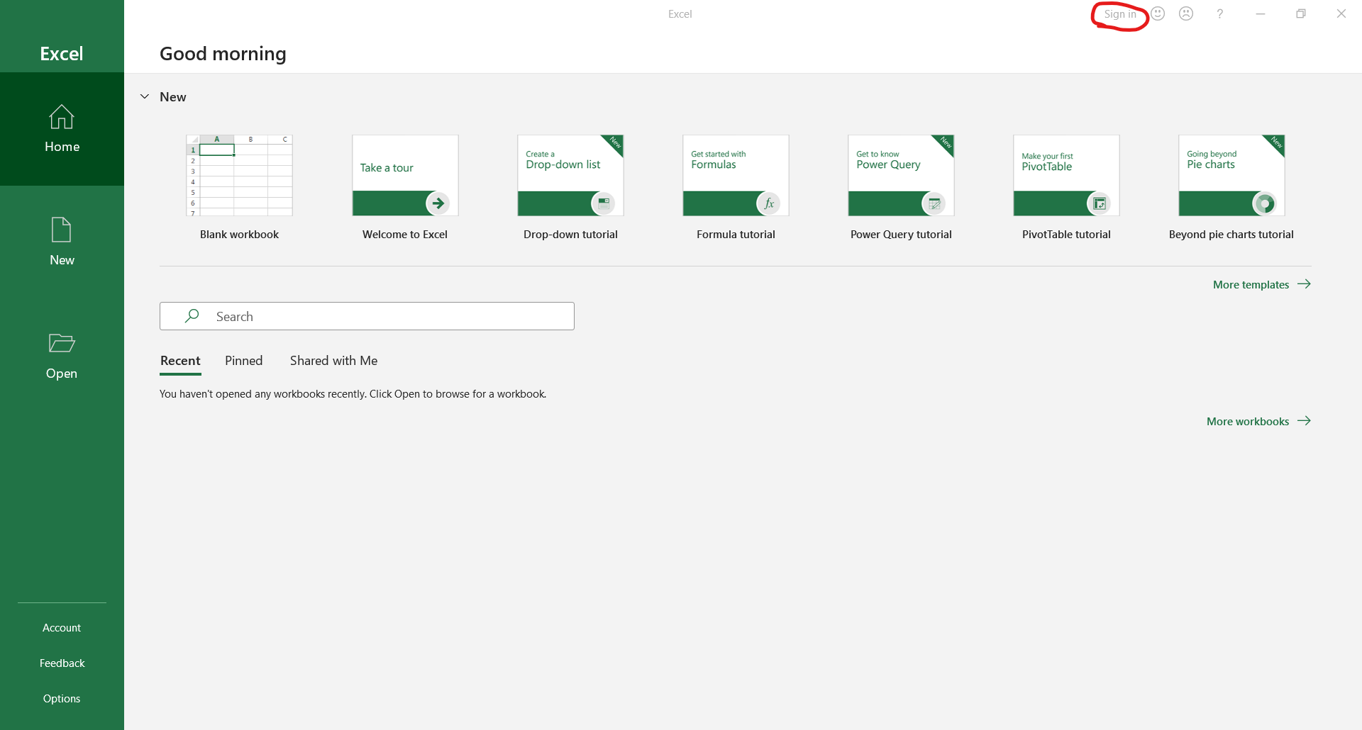
From there, sign in using your ename@colostate.edu email address.
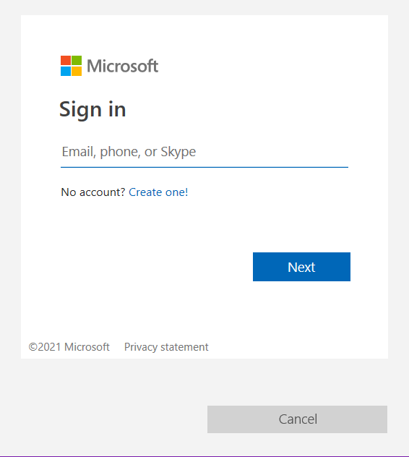
When you are logged into the desktop applications, you will be given the option to open documents directly from OneDrive and SharePoint locations (“Sites”) as well as documents that are saved locally.
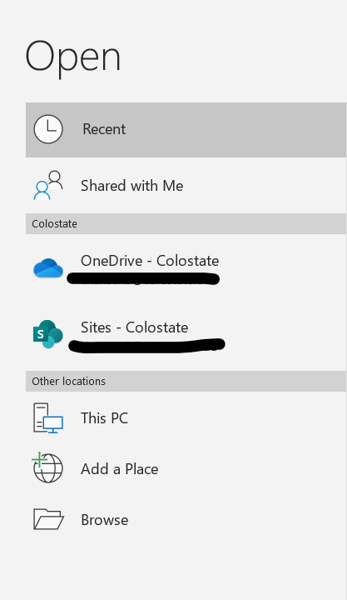

Accessibility Features of Office 365

Dark Mode
Dark Mode reverses the color scheme for users who prefer to work with light text on a dark background rather than dark text on a white background.
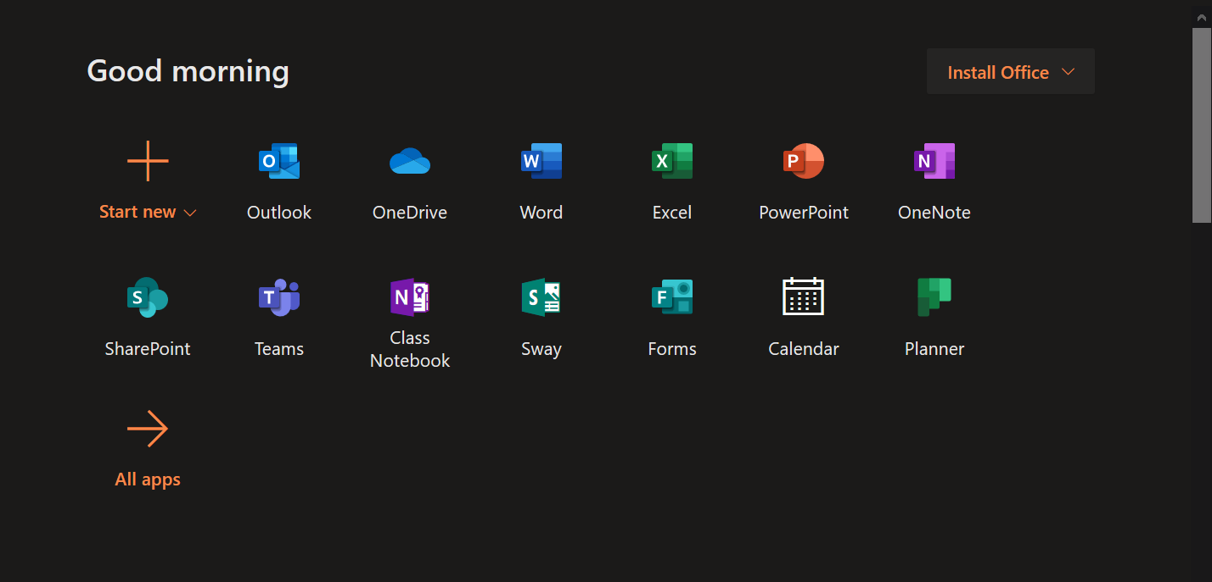
To activate Dark Mode, click on the settings icon in the upper right-hand corner of the Office 365 homepage. Within the Settings menu, toggle the switch labeled Dark Mode:
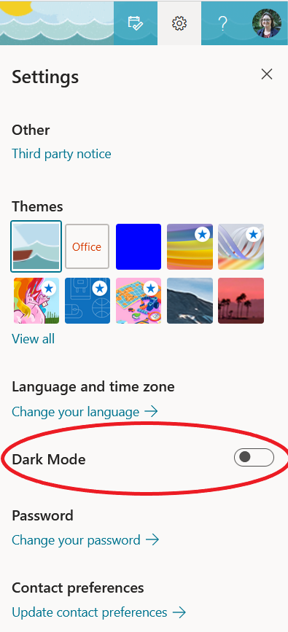

This setting may reduce eye strain and make it easier for users who are prone to migraines or light sensitivity to use the computer. However, it should be noted that Dark Mode only applies to the home page of 365 and doesn’t carry over to the online applications. To use dark themes in 365 desktop applications, see the below “Dark Mode for Desktop” section.

Dark Mode for Desktop
Microsoft’s desktop applications can have dark mode or other color contrast themes activated. Click on the File tab in the upper left-hand corner of the screen, then click on Account in the left-side ribbon.
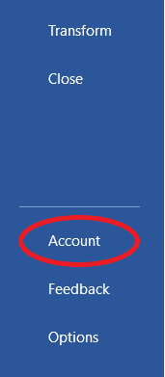
Choose between four Office Themes: colorful, dark gray, black, or white.
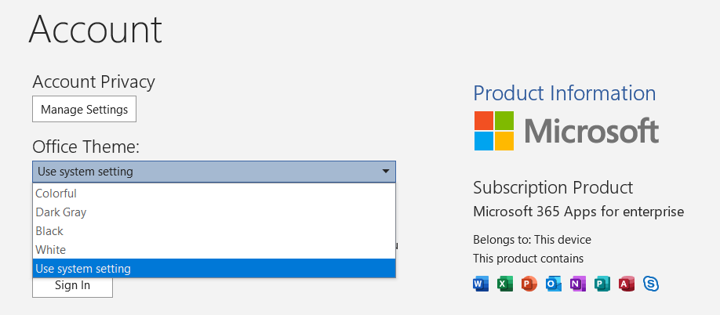
Note that when this theme is changed, it applies to your entire 365 account, not just to that particular application. The change will occur across all Microsoft desktop applications that you are signed into. For example, if you change the theme in Microsoft Word, it will also carry over to PowerPoint, Excel, etc. Here is an example of the Dark Gray theme in Microsoft Word:
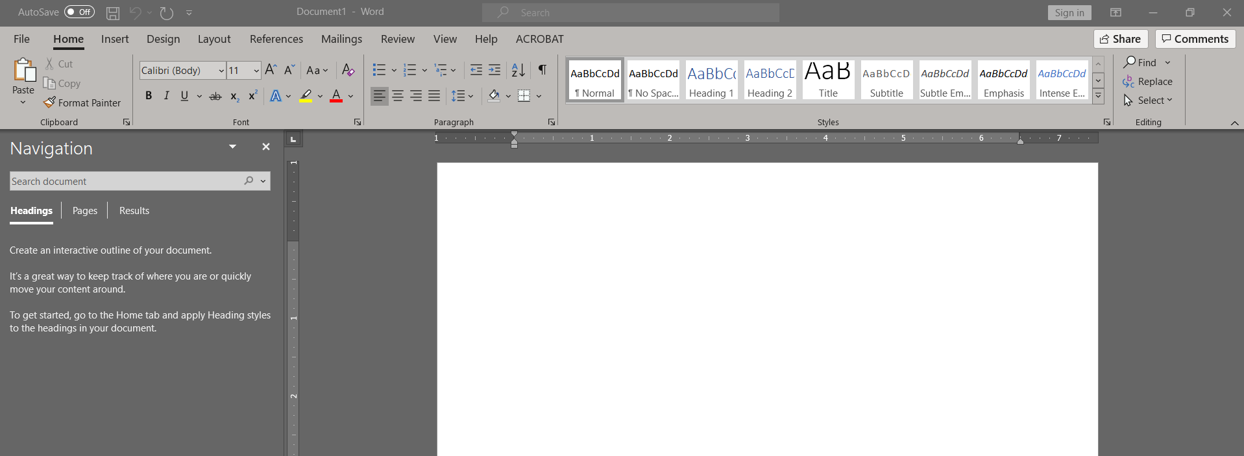

Dictate
Dictate allows users to input text by speaking rather than typing. This tool is available in applications such as Word, OneNote, and PowerPoint.
To use Dictate, click on the microphone that appears in the Home ribbon of the application you’re using. As you speak, Dictate will transcribe your speech directly into the document. To stop recording, simply click the microphone icon again.

Search
The Search bar (formerly “Tell me”) is available across all online and desktop applications in Microsoft 365. It appears as a small text input bar at the top of the page.
Type requests directly into the search bar, and it will show a drop-down list of functions and help topics.
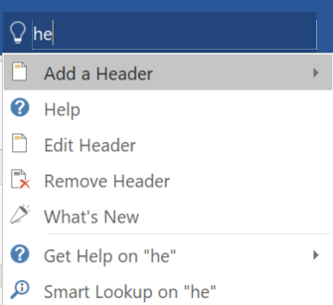

Immersive Reader

Tools
Immersive Reader is a feature of Microsoft 365 applications that includes tools to read text aloud, change the spacing and color scheme of a document, and more. It is built into the web versions of Word, OneNote, PowerPoint, Teams, and Outlook as well as their desktop applications.

Read Aloud
Documents may be read aloud by clicking on the teal play button at the bottom of the screen. It automatically begins reading from the top of the document. Click on text anywhere in the document to skip to that point, or click the button again to pause. Adjust the reading speed and voice by clicking the Voice Settings icon.

Text Preferences
In the Text Preferences menu, adjust the text font, size, spacing, and color contrast theme for your document.
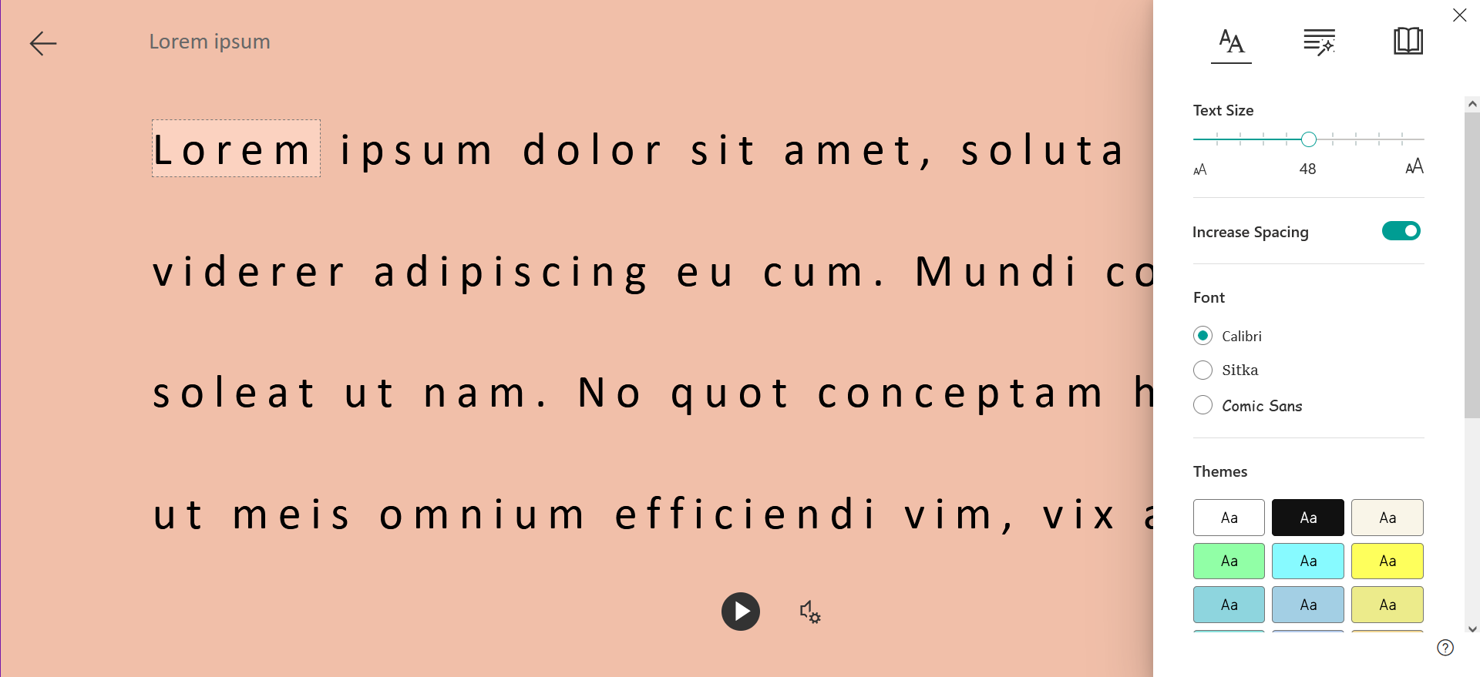

Grammar Options
In the Grammar Options menu, toggle the Syllables switch to show words broken up by their syllables. Or select parts of speech to display in custom text colors, with the option of showing part-of-speech labels above the text.
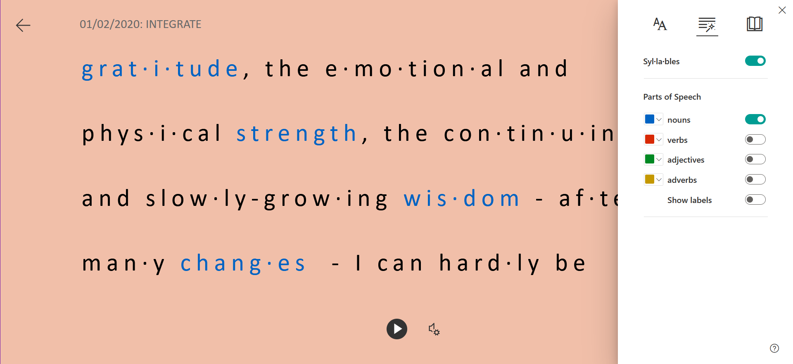

Line Focus
In the Reading Preferences menu, toggle the line focus option to narrow the reading window. Users may opt for the document to show one, three, or five lines of text at a time, depending on the text size and spacing that has been previously selected under the text preferences menu.
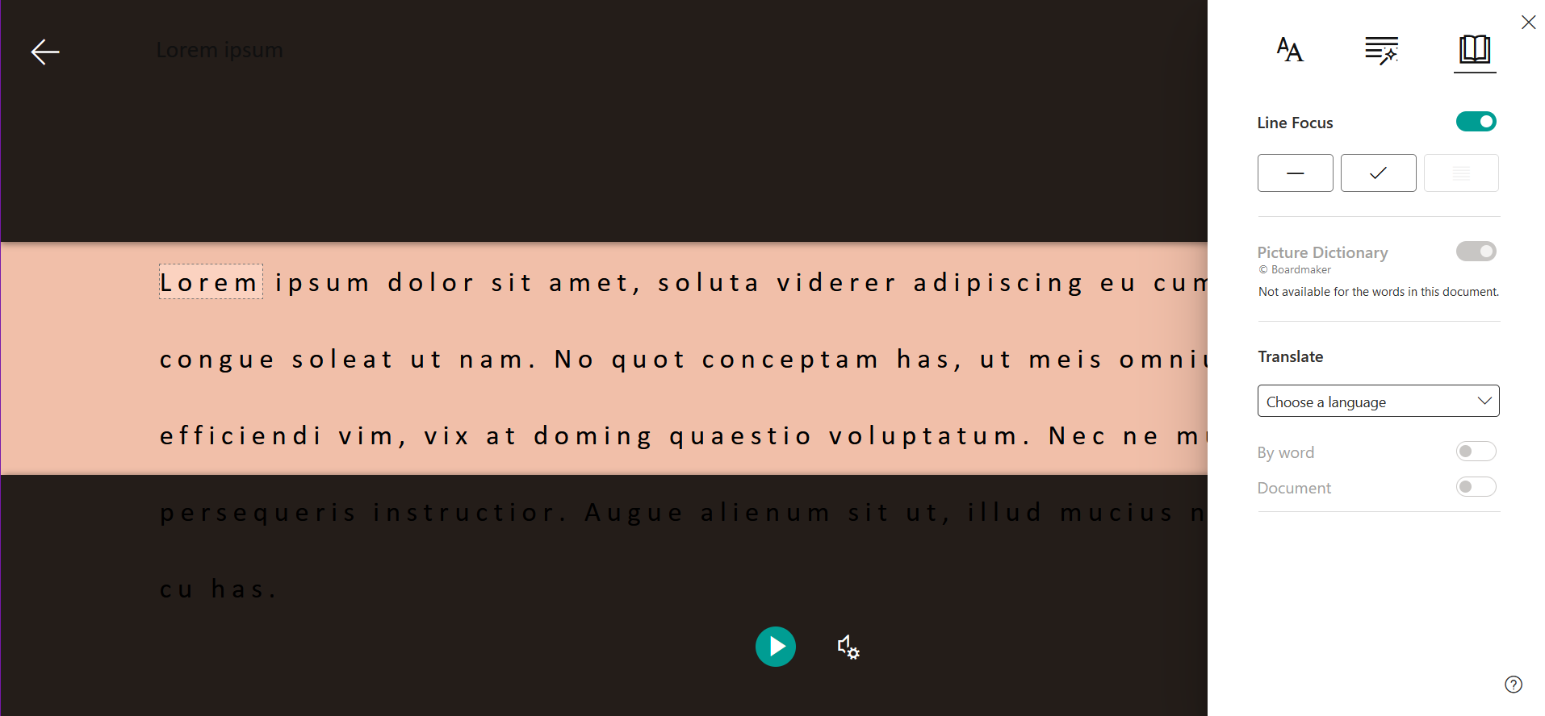

Other Reading Preferences
In the Reading Preferences menu, there are two tools besides line focus: Picture Dictionary and Translate. If the Picture Dictionary toggle is on, you can click on words within the document to display a few sample pictures for what that word means. In the Translate menu, select a language and whether you would like the document to be translated word-by-word (by clicking on words within the document) or in its entirety.
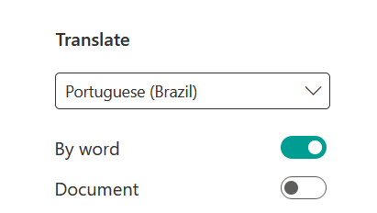

Accessing Immersive Reader
Instructions for opening Immersive Reader within each Microsoft application are listed below. For the sake of simplicity, this guide is limited to the online versions accessed through the Microsoft 365 portal on a browser.

Word, PowerPoint, and OneNote
Immersive Reader is accessed the same in Word and OneNote. Simply navigate to the View tab when you are working within a document and select Immersive Reader. 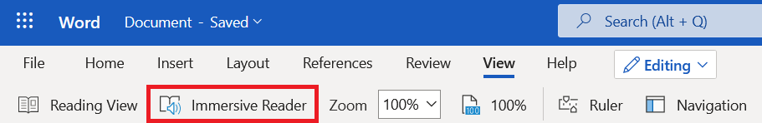

Teams Chat
In Teams, chat messages can be opened in Immersive Reader. Click on the chat button located on the left-hand toolbar. Or, while you are in a meeting, select the Show conversation icon:
From there, hover your mouse over a message within the chat. A series of emoji reactions, along with a three-dot menu expansion button, will appear. Click the three-dot menu button and select Immersive Reader from the drop-down list that appears.

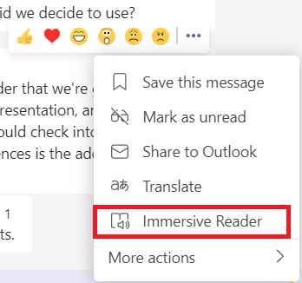

Outlook
In Outlook, right-click on a message within the inbox. From the drop-down menu, hover your mouse over View and then select Show in immersive reader.
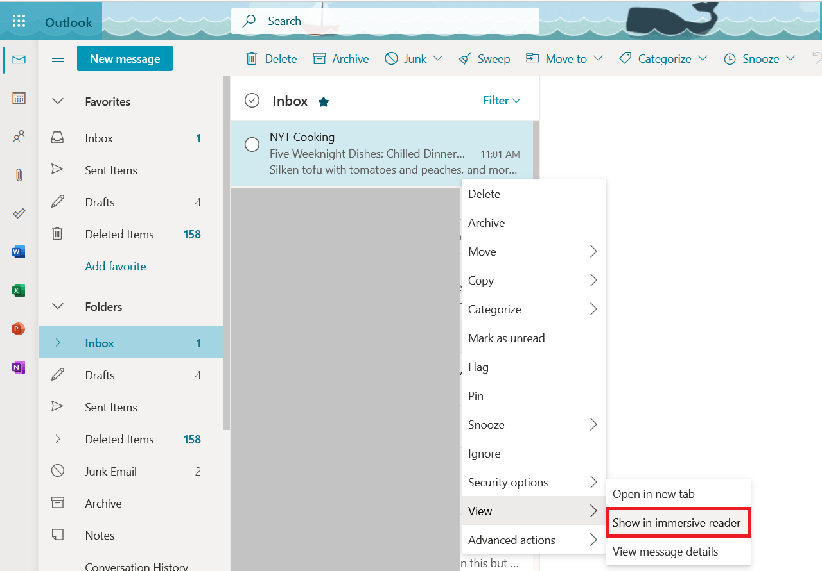

Contact & Pricing Info
Contact Microsoft Website
More information about accessibility features and tools can be found online at the Microsoft Accessibility website (https://www.microsoft.com/en-us/accessibility). This site links out to a blog that periodically updates with the latest features, articles on accessibility features for specific disabilities, instructions for how Microsoft products integrate with various assistive technologies, and more. To report accessibility issues or receive more specific help, contact Microsoft’s Disability Answer Desk.
Cost: Free for all CSU students and staff.

