WordQ4 - Quick Start Guide

Overview
Word Q is a software tool to help with writing. This program offers word prediction and spoken feedback to help people find mistakes in their writing. WordQ considers creative spelling when making predictions. People who want to increase independence in their writing should use this program. WordQ can interface with most computer software programs (including Microsoft Office) and the internet.

To Use

Open WordQ
- Click the WordQ icon to get started.
- Click the “options” icon.
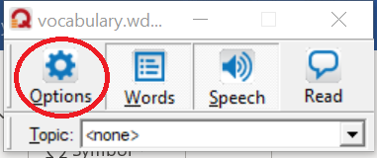

Create a User File
- Select the New User option.
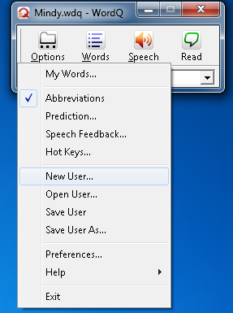

- This will pull up a new dialogue box which will prompt you to select a language (English, Spanish, or French) and vocabulary level (beginner to advanced). 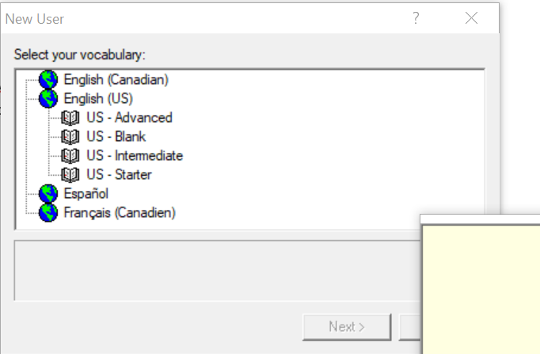

- The Save As menu will appear. Create a file name by inserting your name where the * is before. wdq. Select Save to save your user profile. Note: make sure the asterisk is replaced, otherwise it will not save the user profile.
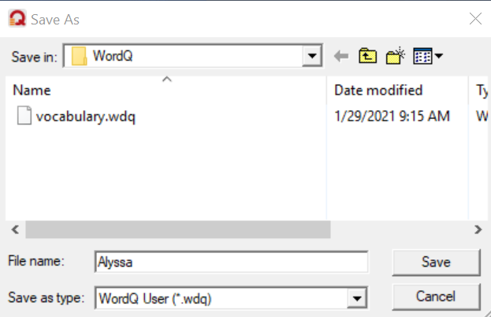

How it is organized (including important hotkeys):

WordQ Button-bar
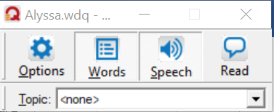
- WordQ contains Words, Speech and Reading features. Each feature is represented by a button on the button bar. Just select the icon or type the hotkey to deactivate and reactivate each feature. The options icon is used to set preferences for words, speech, and reading features.

Words (F9 hotkey)
- To begin, click on the Words Icon and open writing software such as Microsoft Word. Begin typing and words will appear in a prediction box. Select a predicted word by highlighting it and pressing enter or press the number key which correlates to the word.
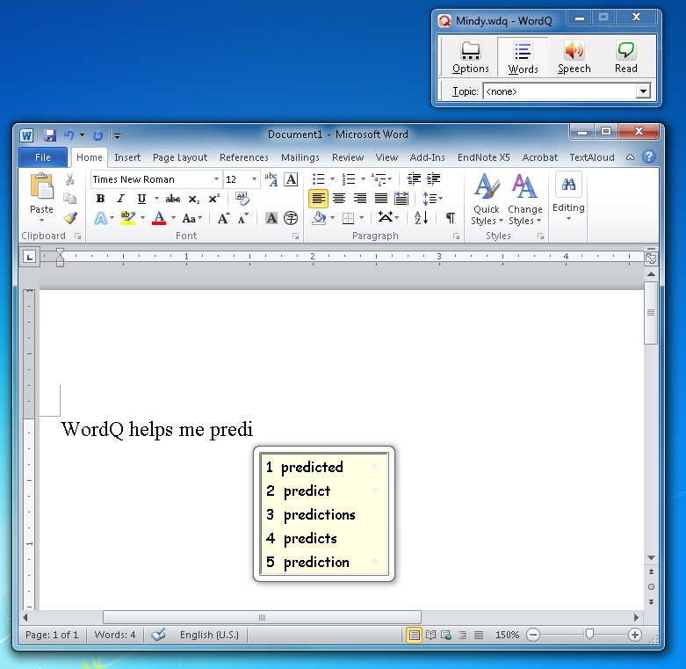
- The word prediction box follows your cursor to any other program you are working in.
- Word prediction gives usage examples to distinguish between confusing words (homophones). An arrow will appear to the right of the word if there is an example sentence. Move your cursor above the word and the sentence will appear to the right and be read to you.

- To expand vocabulary, WordQ will show words that are related. A carrot will appear next to the word if there are stored words related to a predicted word. Select the word by clicking the mouse or using arrow keys for the related words to appear.
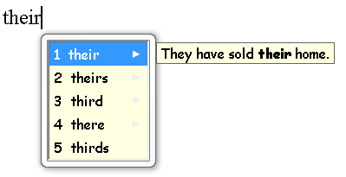
- If a word ending is not in the predicted word list, select the partial word, then click DELETE to find alternate word endings. Word predictions are made based on the letters before the cursor.
- After completing a sentence WordQ will automatically add a space and capitalize the next word.
- If you select the wrong word by mistake, press ESC to delete and then select the correct word.
- Double click or highlight a word to spellcheck.
- You can move through your document using the arrow keys. The word prediction box will temporarily disappear while you arrow through the document.
- If you would like to turn the word prediction box off, click the Words Icon or press F9. Click the Words icon again to turn the prediction box back on.
- The word prediction box will follow the cursor to the save option. 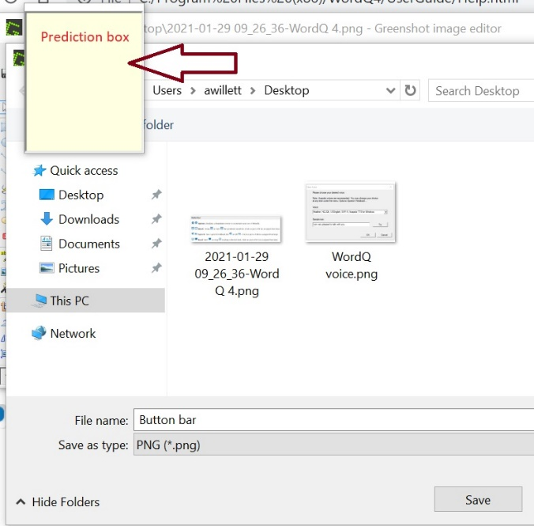

Speech (F10 hotkey)
- The Speech button is turned on by default. If you would like to turn it off, click on the Speech icon.
- When the speech feedback is turned on, you can hear words as you are typing,
hear words in the prediction box by pressing the down arrow or using the mouse, and
hear your sentence read back after you type a period.

Read F11
- This function allows you to hear sentences, paragraphs, or a whole document read aloud.
- Place cursor at the beginning of the document or sentence. Select the “Read” button, then space bar. Press ESC to resume writing.
- To read a block of text, highlight, and press the “Read” button.
- To read the internet, select text and press the “Read” button.

Proofread
- WordQ has a proofreading mode that works in many Microsoft applications including MS Word, Notepad, Wordpad, and Outlook.
- To proofread a sentence:
- Position the cursor anywhere in the sentence.
- Click Read
- The sentence will be highlighted, and the prediction box will go away.
- Use the SPACEBAR to begin reading, pause, and resume reading.
- Use the ARROW keys to move from word to word.
- Press the ESC key or click on the text to make corrections or keep writing.
- Move to the next sentence by using the SPACEBAR. Use the UP or DOWN arrow to move to the previous or next sentence.

Advanced Features

Vocabulary
- Add personal words or phrases like names to your WordQ vocabulary.
- Select My Words from the Options menu.
- Type the new word or phrase in the New Word box and click Add.
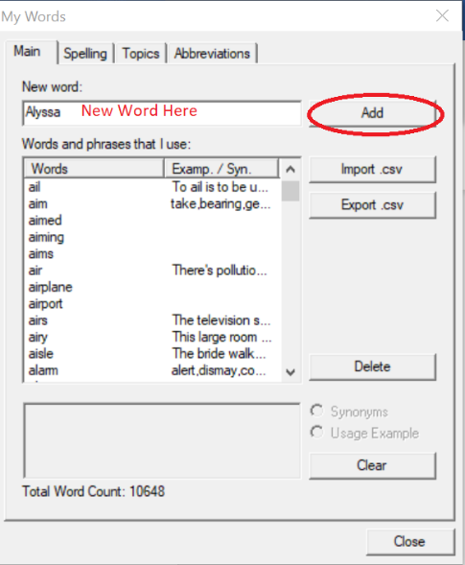

- Add words as you type.
- Select Prediction from the Options tab and make sure “Predict new words that I use” is checked.
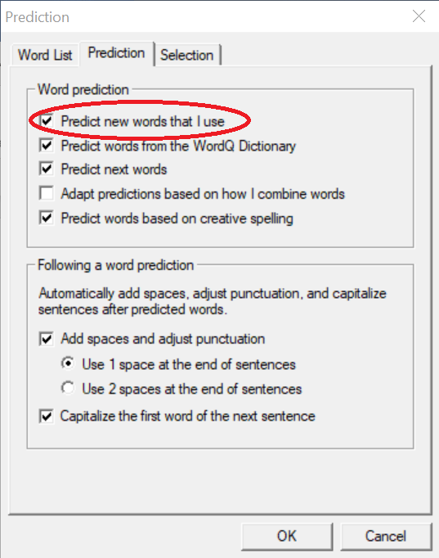

My Words Menu
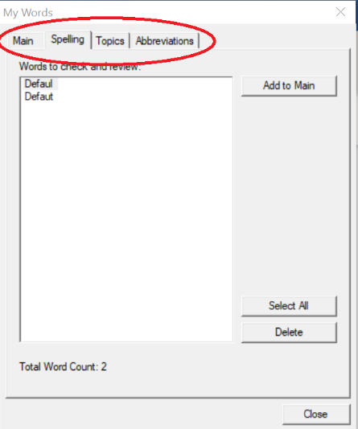

Main Tab:
Add a new word to your vocabulary list.
Expand your vocabulary by selecting Learn and importing a text file (txt) document.
Export words into Microsoft Excel for viewing and editing and Import them.
Change word examples by selecting desired word, writing an example and pressing close.

Spelling tab:
View your misspelled words.

Topics tab:
Create a topic list: click new, type in name, and OK, then add words one by one or import a text file (.txt).

Abbreviations Tab:
Create lists of abbreviations for WordQ to recognize. When you type an abbreviation you have stored in the abbreviations tab followed by the SPACEBAR or ENTER key the abbreviation will expand.

Customizing Hotkeys
To customize hotkeys, click on the “Options” button and scroll down to the “Hotkeys…” button. Hotkeys can be programed to correlate with basic actions.

Speech Feedback
To adjust the speech settings, click the “Options” button and scroll down to speech feedback. This will allow you to adjust the voice, volume, speed and read back features.

Program Manufacturer Contact Info
GoQ software
- Cost is $199 per desktop copy
- The “iWordQPro” is a one-time purchase for $24.99 per iPad
The “wordQ for Chrome” is a one-time purchase for:
- $14.99 per device.

Website: http://www.goqsoftware.com/products/
Contact Information:
ST⁴Learning
P.O. Box 646
Morrison, CO 80465
Toll Free Phone:(877) 674-7687
Toll Free Fax: (888) 908-4765
order@goQsoftware.com
Technical Support:
In the U.S. (877) 674-7687, option 3
In Canada (866) 629-6737, option 4
support@goQsoftware.com

