OneNote for Windows 10* - Quick Start Guide (*most features work in OneNote for Mac)

Overview
  - This guide explains OneNote, a note-taking application through Microsoft Office, allowing an individual to create multiple digital “notebooks” to develop and organize notes, audio recordings and clippings.

To Use

Understand the Setup of OneNote
- There are three essential columns in OneNote: Notebooks, Sections and Pages, respectively. This guide will refer to these columns throughout.

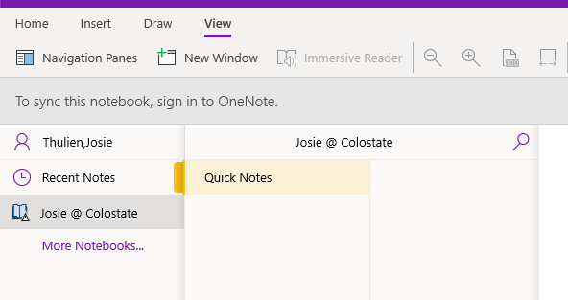
Sections Column
Pages Column
Notebooks Column

Setup: Create Notebooks
- The first time OneNote is used, a default Notebook will open and be named automatically according to whatever account you are using to launch the program.
- To add additional Notebooks, right click in the Notebook column and select New Notebook
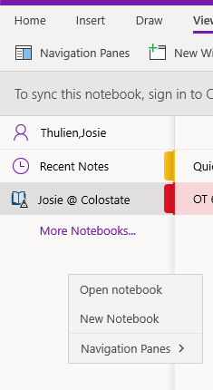
  - Alternatively, click the (+) Notebook button at the bottom of the Notebooks column to add Notebooks.

Setup: Add and Manage Sections
If one thinks about a Notebook in OneNote as a true book, the Sections would be representative of the chapters of a book. Unlike a printed book, however, these chapters can be added, deleted, and moved with ease.
- To add a Section, right click in the Sections column and select New Section from the drop-down menu that appears
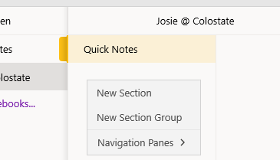
  - Alternatively, click the (+) Section button at the bottom of the Section column to add Sections.
- Name the Section (i.e. course name or number) in the textbox that appears, then press Enter
- You can later rename this Section by right clicking on the name of the Section you wish to rename and selecting Rename Section in the drop-down menu that appears
- Continue to add Sections as desired
- To rearrange the order of your Sections, click on the name of the Section you wish to promote or demote in the list, and Drag-and-Drop it to where desired in the list
- To delete an unwanted Section, right click on the name of the Section you wish to remove and select Delete Section in the drop-down menu that appears; a confirmation window will appear; select Yes if you are sure you want to delete this Section. Please note, all information (pages) contained in this section will be deleted.

Setup: Add and Manage Pages
To continue with the metaphor from above, the Pages are the pages to the chapter!
- To add a Page, right click in the Pages column and select New Page in the drop-down menu that appears
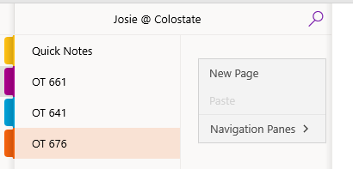
  - Alternatively, click the (+) Page button at the bottom of the Page column to add a new Page
  - Continue to add as many pages as needed
- To name the Page, begin typing where the cursor appears on the Notes Pane (the large white space of the screen)
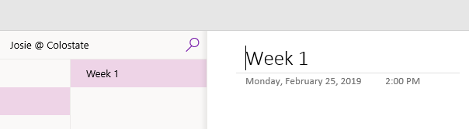
- To delete a Page, right click on the name of the Page you wish to delete, and select Delete Page from the drop-down menu that appears.
- To change the page order, click on the name of the Page you wish to move, and Drag-and-Drop it to the desired position in the list
- To create a subpage (a page indented below another page), add a new Page as directed above, move the new Page to the location desired, right click on the Page name (i.e. Untitled page) and select Make Subpage from the drop-down menu that appears; name the page as described above.
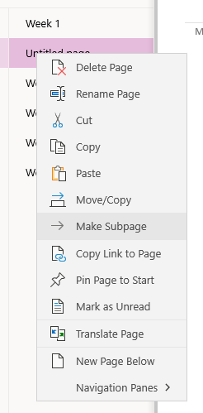

Setup: Navigation Panes
Utilizing the Navigation Panes enables you to collapse the Notebooks, Sections, and Pages columns in order to free up room on your screen.
- To access the Navigation Panes:
  - Click on the View tab at the top of the screen
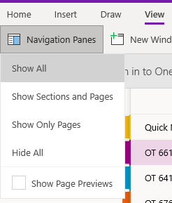
    - Select desired option from drop-down menu that appears
  - Alternatively, right click in either the Notebooks, Sections, or Pages columns, and select Navigation Panes from the drop-down menu that appears
    - Select the desired option from the drop-down menu that appears
- To show hidden Notebooks, Sections, and/or Pages:
  - Click on the Gray Arrow (to the left of Home) in the upper-left hand corner of the screen; this will unhide all columns.
  - Alternatively, click on the View tab at the top of the screen
    - Click on Navigation Panes in the toolbar
    - Select the desired option from the drop-down menu that appears (NOTE: In this snip, the Hide All option is highlighted, because all of the pages are currently hidden)
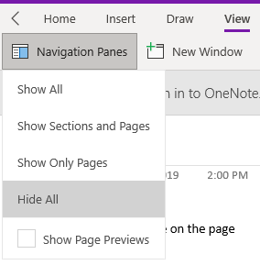

Take Notes

Text (Typed) Notes
- To take notes, click anywhere on the page and Begin Typing, a gray contour box will appear which contains that typed text
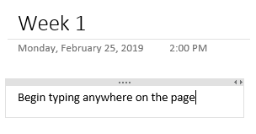
  - This contour box can be moved anywhere on the page simply by clicking on the gray contour area and dragging and dropping it to the desired location
  - This box will grow to any size needed to accommodate the text (or pictures) with in it
  - To begin a new contour box, click elsewhere on the page (outside of the existing contour box) and begin typing.
  - To edit text, click inside a contour box and make any changes needed to text color, font, size, highlights, etc. using the tools under the Home tab
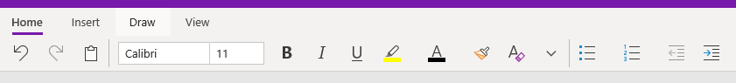

Draw Notes
- Click on the Draw tab at the top of the screen
- Make a selection from the available tools and begin drawing on the Page (NOTE: This feature works best with touchscreens)
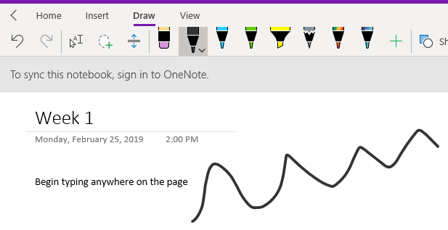
- Explore Features:
  - Use the drop-down arrow next to each pen to change its color or thickness
  - Click on Lasso Select (looks like a white ring with a plus sign superimposed on it) and Drag the Circle around information on the Notes Pane that needs to stay together; a box will appear around the information and this box can then be moved anywhere on the screen
  - To add a math equation:
    - Click Math on the Draw toolbar
    - A new menu will appear on the right-hand side of the screen
    - Follow the directions in the new menu (or see below):
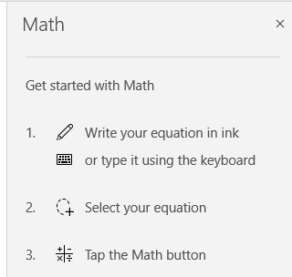
  - To erase a drawing:
    - Click the Eraser (near the pen options)
      - Click on the Eraser again to select the desired options (NOTE: Stroke Eraser will delete entire strokes, while the other Eraser options delete just selected parts of each stroke)
    - Click on the drawing(s) or portions of drawings you wish to erase
  - To select objects or return to typing text, click on the 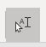 icon

Dictate Notes
NOTE: This option will only work if a microphone is built-in and enabled on your laptop or enabled and plugged into your device.
- Click on the Dictate in the Home toolbar (NOTE: If it is absent, you will need to set up your microphone); a red dot will appear in the microphone next to the word Dictate
- Begin speaking and using dictation commands to write on the Notes Pane. (NOTE: For more information on speech recognition and dictation, please see the “Windows 10 Built-In Accessibility Features Quick Start Guide”)
- When you have said what you need to, click on Dictate again; the red dot will disappear indicating the microphone has shut off.

Audio Record Notes
NOTE: This option will only work if a microphone is built-in and enabled on your laptop or enabled and plugged into your device.
- Click on the Insert tab near the top of the page
- Click the Audio icon on the Insert toolbar; the recording will start shortly after
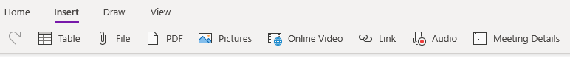
- A new toolbar will appear with the word Recording appearing in purple and a new icon will appear in the Notes Pane
- While the audio is recording, you can type notes in the Notes Pane that will be automatically time-paired to your recording
- To stop recording, Click Stop in the toolbar.
- To access your time-paired recordings, click on a line of text, a play button icon will appear to the left of the line, click this Play icon
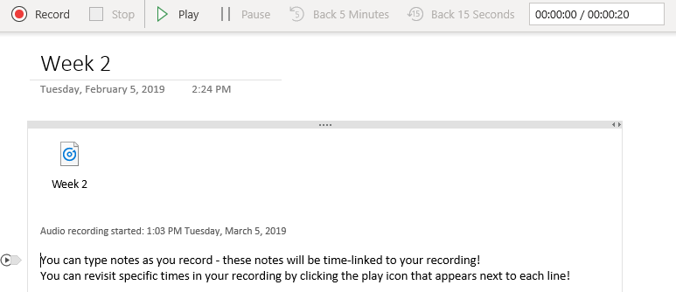
- To play your entire recording, click Play at in the toolbar
  - Use the controls in the toolbar to access other points in your recording (Pause, Back 5 Minutes, Forward 15 Seconds, etc.); this options will work whether you typed additional notes or not.

Add a Table to your Notes
- Click the Insert tab on the toolbar
- Click the Table tab on the toolbar that appears
- Designate the number of rows and columns for your table and left click
- You may move the table to any location by clicking on the gray contour box and dragging-and-dropping it to the desired location

Add Pictures or Videos to your Notes
- For Pictures:
  - Click the Insert tab on the toolbar
  - Click the Pictures tab on the toolbar that appears
  - Select the desired option (From File, From Camera, or From Online)
  - You may move the picture to any location by clicking on the gray contour box and dragging-and-dropping it to the desired location
- For Videos:
  - Click the Insert tab on the toolbar
  - Click the Online Video tab on the toolbar that appears
  - Copy and Paste the weblink from your desired video in the textbox that appears
  - Click Ok

Add/Attach Files to your Notes
- For Files
  - Click the Insert tab on the toolbar
  - Click the File tab on the toolbar that appears
  - Select the desired file and click Open
- For PDF
  - Click the Insert tab on the toolbar
  - Click the PDF tab on the toolbar that appears
  - Select the desired file and click Open

Add a Snip or Screenshot to your Notes
- Open Snipping Tool
- Click New
- Draw a box around whatever you would like to include on Notes Pane using the Snipping Tool
- On the Notes Pane, Press Ctrl + V to paste the snip

Print to OneNote
- This feature allows you to print Word documents, PDFs, PowerPoints, etc. directly into OneNote.
- Open the file (i.e a Word doc, a PDF file) you wish you print to OneNote (NOTE: this should occur from outside of OneNote, DO NOT use the OneNote Insert toolbar to open the file)
- Click File
- Click Print
  - Click the arrow to open the drop-down menus under Printer
  - Select “Send to OneNote”
    - NOTE: If there is an option that says “OneNote” do not select this option, it will not work
    - NOTE: if there is an option that says “Print to OneNote 2016” do not select this option, it will not work
  - OneNote will open (if it’s not already) and ask you where you would like to put the printed file; select the desired location and Click Ok

Tag Notes
Use this feature to prioritize points within your notes, make To-Do lists, etc.
- Click on the Home tab near the top of the screen
- Click on Tags in the Home toolbar; a drop-down menu will appear
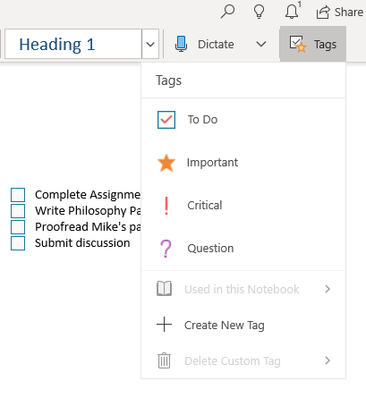
  - To create a “To Do” list, highlight a list of items in your Notes Pane and select To Do from the drop-down menu
    - Click inside the box to mark an item as complete; a small checkmark will appear
  - To mark an item as important, Click the Star icon in the drop-down menu
  - To mark an item as critical, Click the Exclamation Point in the drop-down menu
  - To mark an item an item you have a question about, Click the Question icon in the drop-down menu
  - Create customized tags by clicking Create New Tag

View Toolbar
In addition to adjusting your Navigation Panes, you can adjust many features using the View Tab! This section briefly describes the features of the View Toolbar
- New Window – opens your Notes Pane in its own separate window
- Immersive Reader – when enabled, opens Notes Pane in a new window with text-to-speech features (NOTE: It will only read text typed directly into Notes Pane, not files that have been printed to or inserted in Notes Pane)
  - Press Play icon near the bottom of the screen to hear the words aloud
  - Click the Speaker icon to change voice settings
  - Click the Text icon (AA) to alter text options (i.e. size, font, theme)
  - Click the Lines icon to alter grammar options (i.e. color code parts of speech)
  - Click the Book icon to change reading preferences and create a spotlight on selected lines
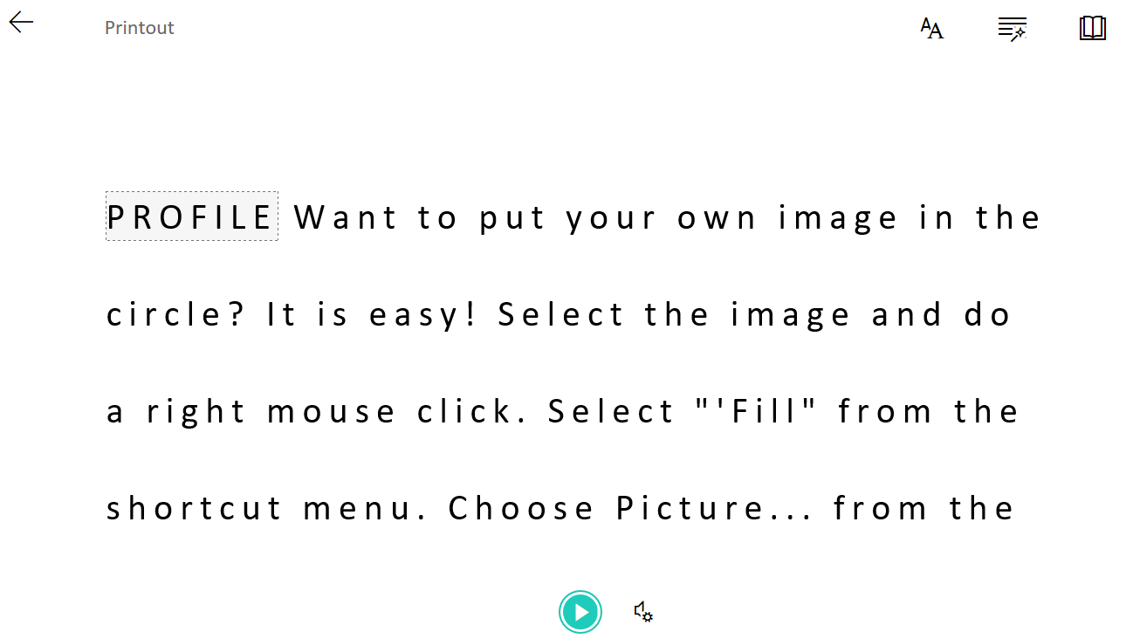
- Adjust what you see on the page by using the Magnifying Lenses and Page Width icons
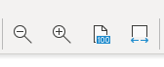
- Change the background of the page with the Page Color and Rule Lines drop-down menus
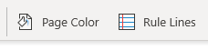
- Translate your selected text with the Translate icon:
  - Highlight the text you would like to translate
  - Click the Translate icon; a new menu will appear on the right-hand side of the screen
  - Select the “From” and “To” languages desired
  - Click Insert

Share Notes
This feature allows you to share your Notebook with others; ideal for working on group projects.
- Click the Share icon near the top right-hand corner of the screen; a new menu will appear on the right-hand side of your screen
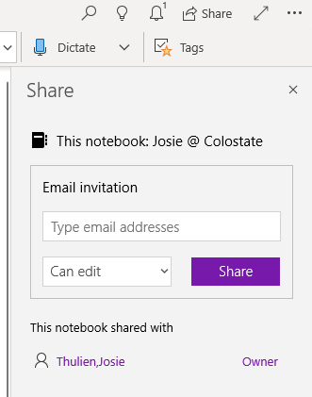
- Type in the email addresses of those you would like to share your Notebook with and adjust edit settings as desired
- Click Share

Print Notes
This allows you to print your entire Notebook or selected parts of it.
- Select the More Options icon from the upper right-hand corner of the page
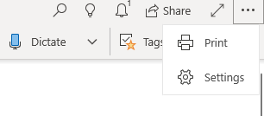
- Click Print
- Ensure correct printer is selected
- Edit Pages drop-down menu to change whether Current Page, Current Section or Current Notebook is printed; Current Page is the default

Program Manufacturer Contact Info
Microsoft Office OneNote
For more information, visit the OneNote website: onenote.microsoft.com
Cost: Free
For PC: Download Here or visit: https://www.microsoft.com/en-us/p/onenote/9wzdncrfhvjl
For Mac: Download Here or visit: https://itunes.apple.com/us/app/microsoft-onenote/id410395246?mt=8

