Top Apps for Workplace Success - iOS

Built-In Tools

- Calendar
- Reminders
- Notes
- Mail
- Dictionary
- Voice Memos
- Auto Correct
- Text Shortcuts
- Speak Selection
- Speak Screen
- Check Spelling
- Reader View
- Large Text
- Zoom
- Predictive Text Entry
- Dictation
- Siri
- Color Filter/Tint

Reading

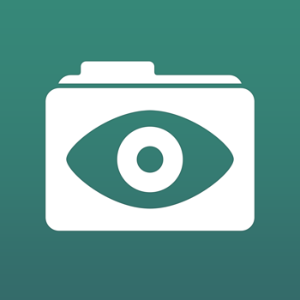 Good Reader
Price: $4.99
Description: This is a PDF reader app with advanced annotating capabilities, such as highlights, sticky notes, text boxes, drawings, and more. You are able to manage, transfer, edit, sign, and organize files. This app also supports MS Office, text files, HTML, pictures, audio, and video. Now has basic text to speech capabilities!

Audiobooks from Audible
Price: Free
Description: This Audible app allows you to access your audiobooks and navigate chapters, bookmark, change narration speed, and play as you download the book. You can transfer books from your library to your device. Browse books through Audible.com.

Flash Reader
Price: Free
Description: Read through your texts quickly with this speed reading app. Flash Reader lets you speed read through PDFs, Word files, websites, and more. Words per minute, words per flash, themes, font, and font size can be customized.

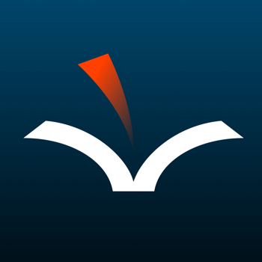 Voice Dream Reader
Price: $14.99
Description: This app reads aloud PDF files, Word files, DAISY eBooks, Bookshare books, and webpages, and allows the user to view the files while the text being read is highlighted. Adjustments can be made to the speed of playback, voices, and colors and size of the display. Users can also annotate and export annotations for later review.

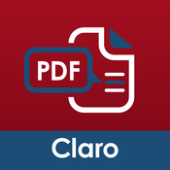 Claro PDF Pro
Price: $6.99, free lite version
Description: This app can be used to read aloud and annotate PDF documents including highlighting and note taking features. The app had customizable voices, speaking rate, and background colors.

Note Taking

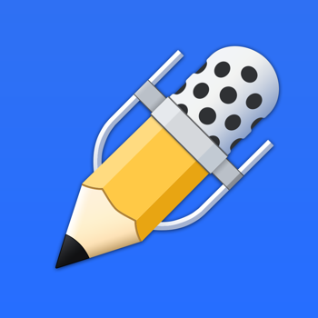 Notability
Price: $11.99
Description: Integrates handwriting, PDF annotation, typing, recording, and organizing of notes. Handwriting features allow for easy annotation and you can even prevent unwanted marks with a palm rest. Includes advanced word-processing and you can link audio recordings. Additional features include auto-syncing media inserts, and library organization. Share notes via email, Dropbox, iTunes File Sharing, AirPrint, and more.

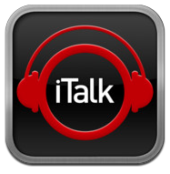iTalk Recorder
Price: Free
Description: Recording app that has an easy to use interface. Has a big red button to record, you can email recordings straight from iTalk, use with iTunes, has auto-noise cancellation features, search feature to locate recordings, and choose between sound quality options.

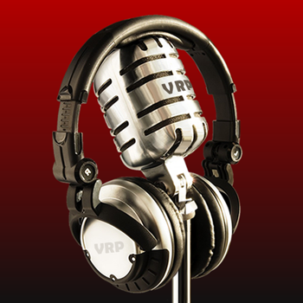 Voice Record Pro
Price: Free
Description: Full-featured recording app that allows users to bookmark, add notes to recordings, add color tags, adjust playback speed, and select recording format (MP3, WAV). Recordings can then be exported to email, Google Drive, Dropbox, OneDrive, and many more options.

Writing

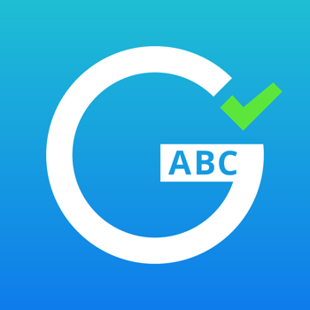Page – Grammar & Spell Checker
Price: $4.99
Description: This app allows you to write emails, texts and other original content and then checks your grammar, making suggestions for spelling and word choice as you go. Other features include advanced rephrasing, text reader, predictive text, and translation capabilities of more than 40 different languages.

Time Management and Organization

Evernote
Price: Free
Description: This app allows you to keep track of files across devices, take text notes, dictate audio notes, capture pictures, create to do lists, record voice reminders and audio notes, share notes easily, and index these notes by searchable key words.

Google Keep
Price: Free
Description: Create notes and lists, check off completed tasks, set time and place reminders, dictate your thoughts, add pictures, and color code notes with this app.

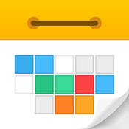Calendars 5
Price: $6.99, free version available – Calendars (doesn’t include tasks)
Description: Calendars 5 offers day, week, month, and year views of your calendar. You can color code appointments with alerts, notes, location, and repeat events. This app also includes a task manager with alerts, notes, priority, and repeat tasks.

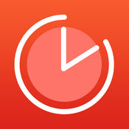 Be Focused
Price: Free
Description: Be Focused helps you stay on track by breaking up tasks and using a timer to count down study time and breaks. The app also includes goal and progress tracking.

Productivity

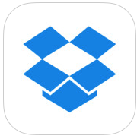 Dropbox
Price: Free
Description: Dropbox lets you save and share all your documents, photos, and videos. Dropbox automatically syncs files on your phone, tablet, laptop, and desktop for easy access. You get 2 GB of space for free.

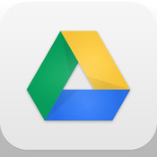 Google Drive
Price: Free
Description: This apps lets you view and save documents, PDFs, photos, videos, and more. You can easily share files and folders with others, and quickly access recent files. All files are backed up safely so you can’t lose them.

