Kurzweil 3000 Online

Overview
Kurzweil 3000 Online is a web-based version of the Kurzweil 3000 software program. Kurzweil 3000 Online offers integrated features that promote and aid students in Reading, Studying, and Writing. Based on Universal Design for Learning principles, it provides users with multiple ways to access information and curriculum, and with tools to help them accomplish tasks independently, practice active learning skills and demonstrate acquired knowledge. Additionally, Kurzweil 3000 Online allows users to access limited features of Kurzweil 3000 remotely from any computer with an internet connection.
The following quick start guide has been adapted from the original product user guides from Kurzweil 3000, available from the following website link:
Website for Kuzweil 3000 Product Guilde (https://www.kurzweiledu.com/products/product-guides.html)

Table of Contents
- Overview
- To Use
  - Opening Kurzweil 3000 Online
  - How it is organized
  - Reading Features
  - Writing Features
  - Accessing EPUB
- Additional Features
  - Read the Web
- Program Manufacturer Contact Information

To Use

Opening Kurzweil 3000 Online
To access the features of Kurzweil 3000 Online complete the following steps:
- Go to the website for the Kurzweil 3000 Online login (https://www.kurzweil3000.com/KLogin.php)
- Login to site with your username and password.
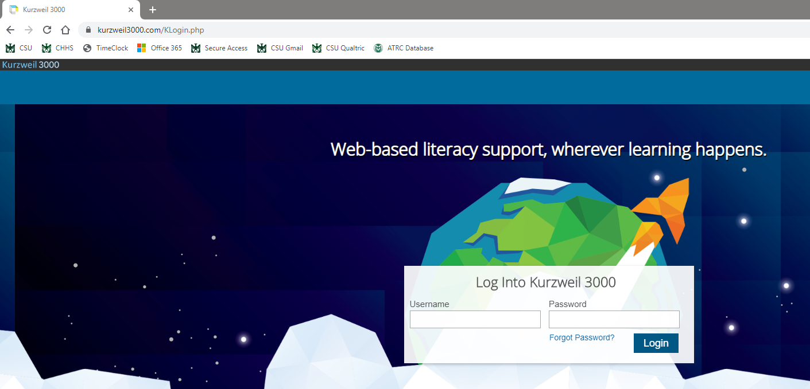

How it is organized

Universal Library
Once logged into Kurzweil 3000, users will be taken to the Universal Library. On this page, users can upload and open documents.
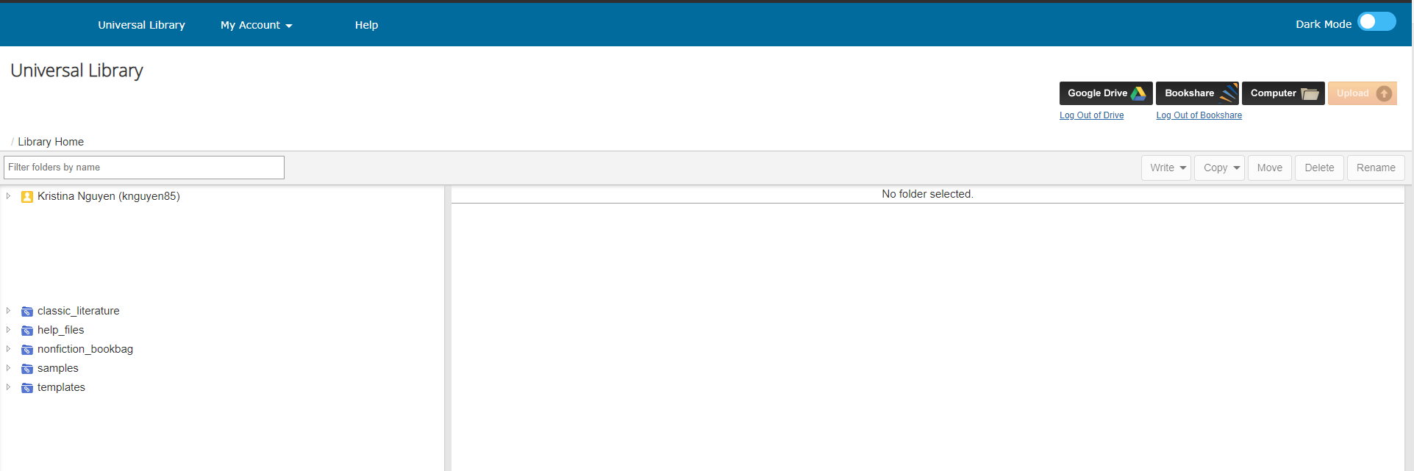

Upload and Open Documents to then Access Reading Features
To upload new documents to then access reading features:
- To upload documents utilize the Universal Library
- Select to either upload/open a file from your Computer, Google Drive, or Bookshare.
- New documents uploaded will be converted to KESI files
To open documents previously opened in Kurzweil:
- To open an existing Kurzweil document, use the Universal Library.
- Navigate to saved documents (private, public, or recently opened local files) under your username on the left side of the window (see picture below).
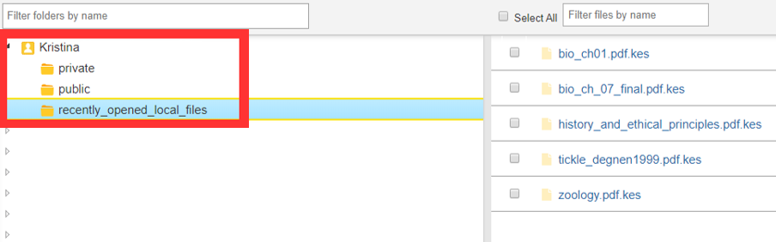
- Click on desired document.

Access Writing Features
To access Kurzweil 3000 Online Writing Features:
- In the Universal Library page, click your name on the left side of the window, then select the location where you want to keep the document you will create (private, public, or recently opened local files).
- Locate the write tab

- Select between New Brainstorm, New Outline, New Draft, And New Column Notes File.
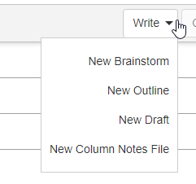

Reading Features

Main Toolbar
The Main Tool Bar of Kurzweil 3000 Online appears at the top when a document is opened.
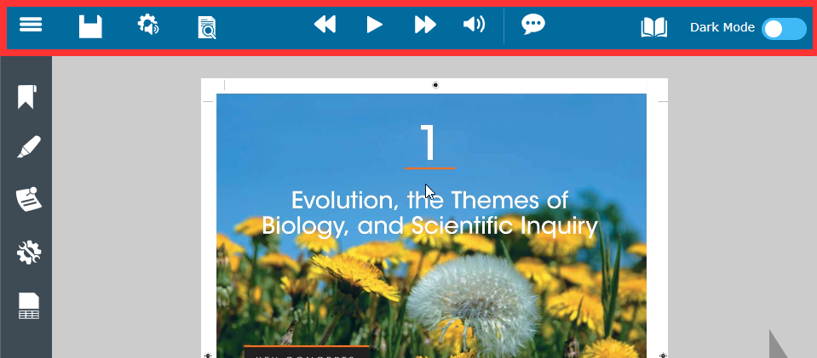
The Main Toolbar includes the options to:
- Open new documents

- Go back to Universal Library, My Account, and Help

- Save highlights and notes in the document

  - Be sure to save the document after highlights and notes are added or changed.
- Adjust audio options

  - Users can adjust the voice, reading speed, reading unit, reading mode, and speak as typing
- Adjust view options
  - Users can use thumbnail view, document zoom, page rotation, and change the background color.
- Begin reading features and go backward or forward one reading unit
- Turn on or off audible reading
- Enable speech to text

- Enable Dark Mode

Study Skills Toolbar
The study skills toolbar of Kurzweil 3000 Online appears on the left when a document is opened.
The study skills toolbar includes the options to:
- Bookmark specific pages
- Highlight
  - Users can choose from six highlighting colors, two circling colors, and a strike out
  - Users can erase highlights, circles, or strike outs by selecting the eraser button
  - Users can extract highlights, notes, and bookmarks from the document into a study guide
- Insert notes
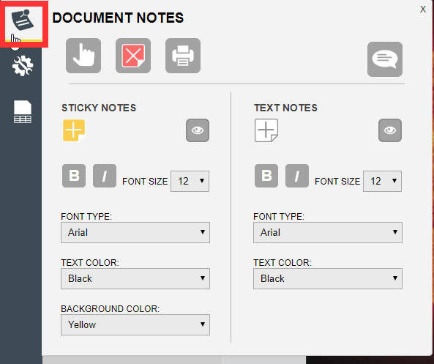

  - Users can insert a sticky note, text note, or bubble note
  - Users can delete notes by selecting the red X button
- Access additional tools
  - Spell check
  - Word prediction
  - Open zone editor
  - Open edit underlying text
  - Tag text with a language
- Insert column notes
  - Users can open a new column notes or existing column notes
  - Users can extract highlights to column notes
  - Users can extract highlights to a vocabulary study guide

Navigating a Document
To navigate to the previous page or next page, click the large Left Arrow or Right Arrow button on either side of the page display. To go to a specific page, enter the page number in the Go to page box at the bottom of the window, and then click the Go button or press Enter.
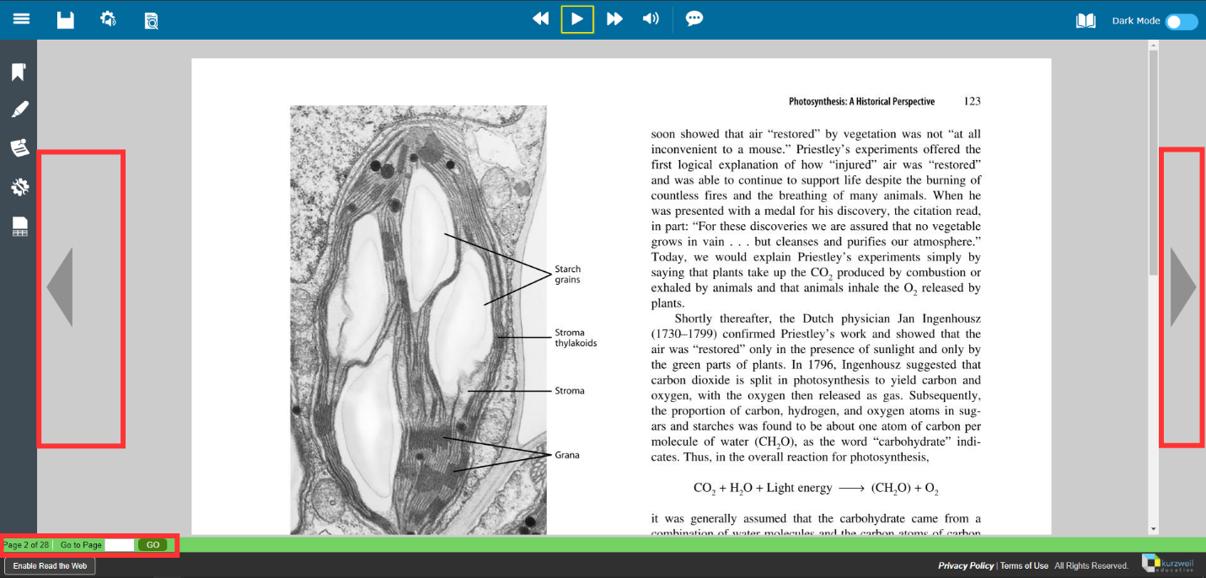

Writing Features
When opening a writing feature (new brainstorm, outline, draft, or column note) users will be prompted to name the file using only letters, numbers, and underscores.
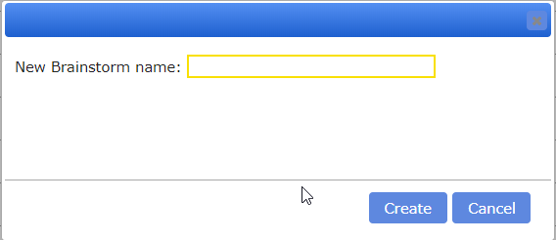
All the writing features will include:
- A main toolbar that is similar to the reading feature located at the top of the page.
- A writing toolbar, located under the main toolbar, that includes options to bold, italicize, underline, change alignment, change font, change font size, undo, and redo.

New Brainstorm
Once created, users will be taken to the New Brainstorm page. On the brainstorm page, users will be able to create a visual map/diagram of what they are writing.
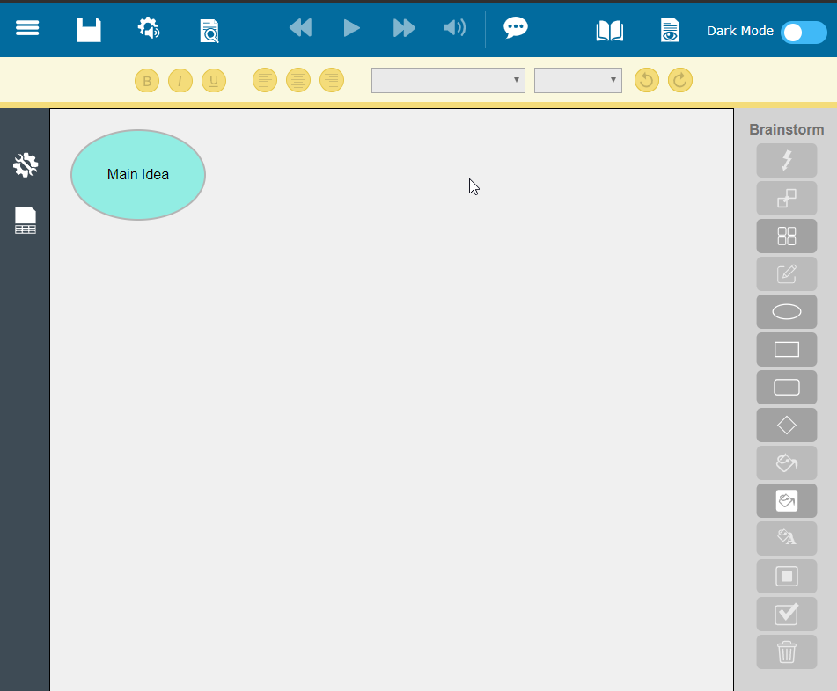

Brainstorm Toolbar
On the new brainstorm page, the brainstorm toolbar is located on the right side of the page.
The Brainstorm Toolbar includes the following tools:
- Quick Takes
  - This tool allows users to create a subtopic
  - First click on the topic you want to create a subtopic from, then click the Quick Takes button to add your subtopic
- Link tool
  - This tool allows users to create connections between topics
  - First click on the topic you would like to link from, then click to Link button to add a link to a different topic or subtopic
- Arrange tool
  - This tool allows users to organize topics into hierarchical order
- Note tool
  - This tool allows users to create a side note
  - When the side note is created, click on the page icon that will appear on the top right corner of you topic to show or hide your side note
- Options to select different shapes of brainstorm ideas
  - Shapes include Oval, Rectangle, Rounded Rectangle, and Diamond
- Fill color tool
  - This tool allows users to fill in their brain storm bubbles with different colors
  - Select brain storm bubble, then click on fill color button and select a color
- Background color tool
  - This tool allows users to change the color of the brainstorm screen
- Text color tool
  - This tool allows users to change the color of the text for the brainstorm idea
  - Select brain storm bubble, then click on text color button and select a color
- Default tools
  - This tool allows users to set, apply, and revert back to default settings
- Delete tool
  - This too allows users to delete an idea

New Outline
Once created, users will be taken to the new outline page. . On the outline page, users will be able to create an outline of what they are writing.
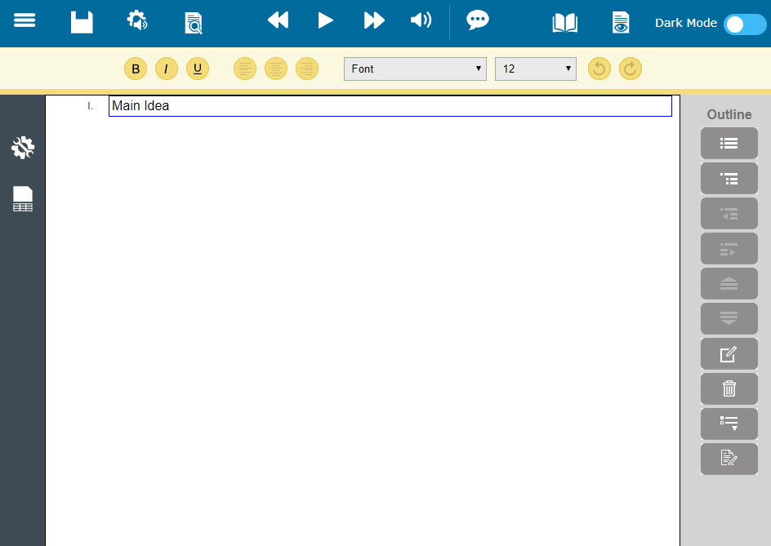

Outline Toolbar
On the new outline page, the outline toolbar is located on the right side of the page.
The Outline Toolbar includes the following tools:
- Add topic
- Add Subtopic
- Move to the Left/Promote
- Move to the Right/Demote
- Move Up
- Move Down
- Insert a Note
- Delete a topic
- Prefix label to select the bulleting format
- Create a Draft when finished with the outline

New Draft
Once created, users will be taken to the new draft page. When writing a New Draft, the Kurzweil writing environment is similar to other word processing programs for changing font style and basic page formatting.

New Column Note File
Once created, users will be taken to a new draft page with column notes on the bottom of the page. Here users have the options opening existing column notes or create new column notes that will be helpful for the writing process.
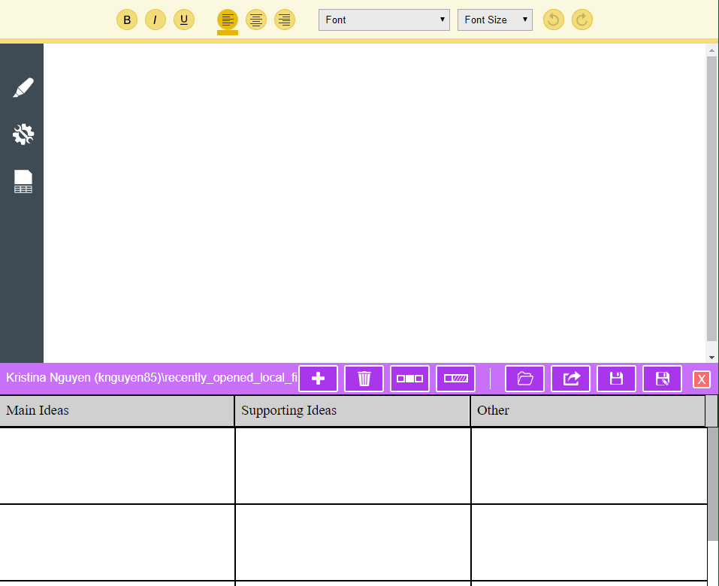
By default, the column notes are broken into 3 columns for main ideas, supporting ideas, and other. Within those columns, users can add information from readings, notes, and web links to help support their writing.
Additionally, the column note toolbar includes options to:
- Insert rows
- Delete rows
- Cover second column
- Hide third column
- Open existing column notes
- Extract column notes to outline
- Save/save as
- Close column notes

Accessing EPUB
- Go to Kurzweil 3000 Online website (http://kurzweil3000.com) and login
- Choose the location of the file you want to open (Google Drive, Bookshare or Computer) and upload the file into your folder
- Once loaded, click the link in your folder to open the file
- Save the file as a kesi and reopen
Not all features are always available for EPUBs, but these may be:
- Text-to-speech with highlighting (no color options)
- Voice selection & speed adjustment
- Table of Contents
- Highlight
- Collect highlights (may be buggy)
- Voice notes
- Background color options

Additional Features

Read the Web
The Kurzweil Read the Web feature lets users read Websites using Kurzweil 3000 on either Chrome or Firefox. While reading the Web, users will have access to Kurzweil 3000 reading and reference tools.

Download and install Read the Web
- Go to the Chrome Web Store or click on this link: Chrome Web Store Website (https://chrome.google.com/webstore/category/extensions)
- In the search bar search Read the Web
- Select Kurzweil Read the Web offered by kurzweiledu.com
- Select Add to Chrome and follow prompts to add extension
- When the extension is added, the Kurzweil Symbol should appear on the right side of your search bar

Turning on Kurzweil Read the Web
When Kurzweil is grey, it indicates that Kurzweil Read the Web is offline.
To turn on, follow the following steps:
- Locate the Read the Web icon located next to the search bar

  - If you do not see the Read the Web icon in your search bar, click on the more icon, find More tools and then select Extensions
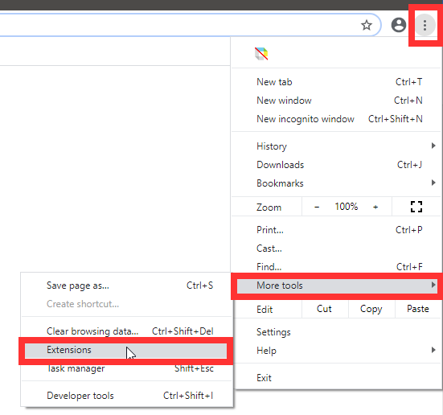
  - When taken to the extensions page, turn on Read the Web
- When the Read the Web icon is located, click on the icon and it should turn colorful
- Users will be prompted to log into their Kurzweil 3000 account
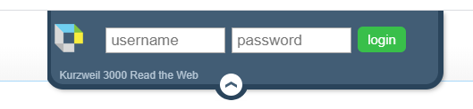

The Reading Toolbar
Once logged into Kurzweil Read the Web, the reading toolbar should appear at the top of the browser
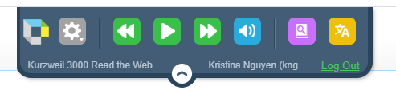
Components of the reading toolbar allows users to:
- Access Kurzweil 3000 Online website by clicking on the Kurzweil icon
- Adjust options to modify reading features and toolbar placement
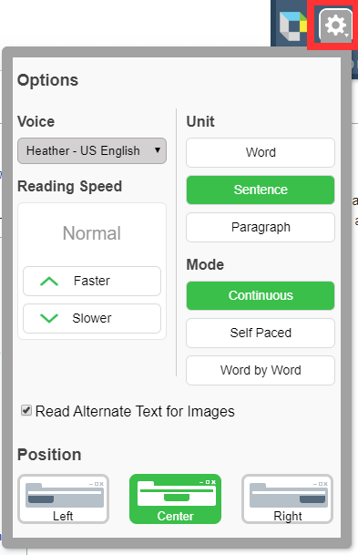
- Access reading features of Read the Web
- Turn on and off audible reading
- Access the dictionary features of Read the Web
- Access the translation features of Read the Web

To read Website content
To begin reading a webpage, select where you want to begin reading on the page. A large green cursor should appear
If there is a red slash through the Read the Web icon, it means the extension cannot read the webpage

Workarounds for Online Textbooks
For using Kurzweil 3000 features on Online textbooks, two options can be used:
- Read the Web
- Click the “Read the Web” button
  - In the address box of the “Read the Web” window, specify the desired Web site address then press return.
- To read the web page, click the “Read” button in the Read the Web toolbar
- To change reading settings, use the “Read Mode”, “Read By” and “WPM” menus

- Using Image Reader
- The Image Reader is a tool that lets you select an image that you want to read. To select an image:
  - Open the image that you want to read (a web page, for example).
  - Choose Image Reader from the Kurzweil 3000 Read menu. The Kurzweil window closes and the cursor changes to crosshairs.
  - Use the crosshairs to select any text, including content that is not usually selectable.
  - The Kurzweil window reopens and displays the text for you to read.
  - Click the Read button to read the text. When you are finished, you can Close the text or Save it.

Program Manufacturer Contact Info
- Cambium Learning Technologies
- Phone Number: 800-894-5374; Outside the United States and Canada: +1-508-315-6600
- Website: Kurzweil 3000 Website (https://www.kurzweiledu.com/default.html)
- Cost: $500 for a one year subscription
  - Students registered with the ATRC may be able to use Kurzweil 3000 Online on their personal computers through our site license while they are students at CSU

